Characterization and Calibration of Lamination Stratigraphy of Cores Recovered from Lake Linné, Svalbard Norway

Independent Study
Emily Pratt
May, 2006

ABSTRACT

The lamination stratigraphy of cores recovered from Lake Linné have been characterized and correlated to modern process data, instrumental weather records, and recent glacier mass balance data. The purpose of this work is to calibrate the top 25 cm of cores to records of environmental change during the past 50 years to serve as a calibration in order to understand environmental change during the late Holocene. Sediment cores recovered from glacier-fed Lake Linné contain varved millimeter-scale silt/clay laminations offering annual records of past conditions. Four short cores (<0.5 m long) and four long cores (approximately 2.3 m long) were recovered from three different locations in Lake Linné in August 2004 and May 2005. Cores contain millimeter to centimeter-scale laminations, which are best studied in thin section. Color and grain size changes define silt and clay couplets between 0.5 and 11 mm in thickness. Distinctive laminations can be correlated between cores from locations 0.5 km apart indicating lamintation stratigraphy represents basin-wide depositional events.

Cores were studied for magnetic susceptibility, bulk density, loss on ignition (organic content, and carbonate content) and grain size in order to allow intrabasin correlations between cores, as well as correlations with cores that were recovered in the 1980s (Svendsen and Mangerud, 1990; Werner, 1988 and Snyder et al, 1994.) Qualitative assessment of the lamination stratigraphy suggests that Little Ice Age laminations are overall thinner and exhibit clay-rich laminations. Based on Cs dating, the last 40 years have experienced a sedimentation rate of 4.5 mm per year, consistent with sediment trap data for the ‘04/’05 depositional year. Based on an inferred chronology from previous work, sedimentation rates have varied from 1.03 mm per year to the present rate of 4.5 mm per year since 1200 years before present. Lamination thickness can be loosly correlated to annual average temperature and totally annual precipitation.

OUTLINE / CONTENTS

Abstract

- Introduction
  - Climate Change in the Arctic
  - Lamination Stratigraphy as a Proxy for Climate Change
  - Project Objective
- Setting
- Previous Work
  - Previous work on Linné
  - Glacial Mass Balance work from Ny-Alesund, Linnébreen
  - Weather records
  - REU modern process studies
- Methods
  - Field Methods
    - Core Locations
    - Core Recovery
    - Transportation
  - Laboratory Methods
    - Core Splitting
    - Photo Documentation
    - Magnetic Susceptibility
    - Loss on Ignition
    - Sub Sampling
    - Thin Sections
    - Thin Section Scanning
    - Image Processing
- Results
  - Cores F1-04 and F2-04
    - Visual Stratigraphy Description
  - Cores E1-04 and E2-04
    - Visual Stratigraphy Description
  - Core G1-05
    - Visual Stratigraphy Description
    - Magnetic Susceptibility
    - Bulk Density
    - Loss on Ignition Organic Carbon
    - Loss on Ignition Carbonate
  - Core GL-05
    - Visual Stratigraphy Description
    - Magnetic Susceptibility
    - Bulk Density
    - Loss on Ignition Organic Carbon
    - Loss on Ignition Carbonate
  - Core D1-04
    - Visual Stratigraphy Description
    - Magnetic Susceptibility
    - Bulk Density
    - Loss on Ignition Organic Carbon
    - Loss on Ignition Carbonate
  - Core CL-05
    - Visual Stratigraphy Description
    - Magnetic Susceptibility
    - Bulk Density
    - Loss on Ignition Organic Carbon
    - Loss on Ignition Carbonate
  - Core C2U-04
    - Visual Stratigraphy Description
    - Magnetic Susceptibility
    - Bulk Density
    - Loss on Ignition Organic Carbon
    - Loss on Ignition Carbonate
    - Cs 137 chronology
    - Image Processing Results
    - Lamination Counts
- Interpretations
  - Correlation of Cores
    - Long and Short Cores
    - Inter-basin Correlation
    - 1985 and 2005 Correlation
  - Lamination Counts -- Varves
  - Correlation of glacier mass balance and weather records
  - Correlation of lamination changes to weather and mass balance records
  - Linné chronology
- Conclusions

1. INTRODUCTION

1.1 Climate Change in the Arctic

The earth has warmed approximately 0.6°C in the last century and models indicate that the climate will continue to warm well into the future (Ruddiman,2001). Rising temperatures are not only felt in Arctic regions, but amplified. Records show temperature increases in most arctic regions exceeding those of the northern hemisphere as a whole, incurring significant glacial retreat, sea ice and permafrost melting, and ecosystem alterations (Overpeck, 1997). Based on models, projected warming in the Arctic could be as much as 4°C in the next 50 years, more than double the expected warming for the world (IPCC). While most current global warming is attributed to the result of rising concentrations of greenhouse gases in the atmosphere, primarily the result of human activity over the past 100 years, the climate is also subject to natural variations (Ruddiman, 2001). The need for climate research in the arctic begins with a need to understand amplified warming causes and effects, and the need to understand natural climate variability independent of human influence.

1.2 Lamination Stratigraphy as a Proxy for Climate Change

Sediment records have been widely used as a proxy for climate change (i.e. Pike and Kemp, 1996). Since the work of De Geer (1912), varves, or annual sedimentation couplets, have been proven valuable chronologies of past environmental and climatic conditions (Ashley, 1972; Lamoreux, 1994; Lotter, 1990). Most commonly varves are found in deep pro-glacial lakes, where seasonal variations and minimal biota cause couplets of differential lamina to be deposited undisturbed. Color, composition, grain size, and thickness are among characteristics of lamination stratigraphy that change with environmental conditions and can tell the inter-annual story of climate change in a given region for the length of the sediment record (Pike and Kemp, 1996).

1.3 Project Objective

The purpose of this study is to understand the Linnévetnet sediment response to the past 100 years of weather and climate changes in order to calibrate and interpret Holocene environmental changes recorded in the top 2.5 meters of the lake’s laminated sediment. To accomplish this, 16 short and 4 long cores were recovered from Linnévatnet and sub-sampled for cesium 137 dating, grain size analysis, bulk density organic matter content, and carbonate content. As the lamination stratigraphy was best seen in thin section, sections were made for the length of each core. These underwent gray-scale image analysis, lamination counts, and lamination thickness measurements. All of these parameters were used to characterize down core changes and relate them to previous work and instrumental weather records. The main questions proposed for this study are: Is there annual sedimentation (varves) in Linnévatnet? How does the lamination stratigraphy relate to instrumental weather records, glacier mass balance records, and previous work? How have sedimentation rates changed in the past? What does the stratigraphy suggest about past climate conditions in the past 2000 years?
This project is in conjunction with the NSF funded Svalbard Research Experience for Undergraduates modern process studies in Linnédalen, and is part of an NSF funded research collaborative to synthesize climate variability of the last 2000 years from Arctic Lakes.

2. SETTING

The Linné valley is located at 78°N latitude, on the west coast of Spitsbergen, the largest island of the Svalbard archipelago. The region receives residual warmth from the Atlantic Gulf Stream, but maintains an artic climate with temperatures above freezing only 3 months of the year (Boyum, 1978). Lake Linné is 4.6 km long and 1.3 km wide, and just over 40 m deep in the main basin. It receives melt water and sediment from the Linné glacier, located about 6 km up-valley, and is the largest glacial-fed lake in the archipelago. Since 1912, weather observations and instrumental weather data have been recorded in the town of Longyearbyen (ca. 50 km east of Lake Linné.) Glacier mass balance data for the Linné Glacier is only available for the past two years however, modeling (using records of two glaciers located about 150 km to the north) allow a theoretical mass balance to be inferred back to 1968 (Jack Kohler, pers. comm.).

3. PREVIOUS WORK
3. 1 Previous Work on Lake Linné
Glacial History
Previous work in the Lake Linné basin indicate that the oldest sediments located above bedrock were the result of a late Weichselian glaciation, which filled the Linné valley and eroded down to the bedrock, erasing sediment evidence of past glaciations (Mangerud and Svendsen, 1990.) Marine sedimentation began accumulating about 12,500 years BP marking deglaciation. Isostatic rebound, largly caused by a Barent’s Sea glacier that spread over Spitsbergen, isolated the lake around 9600 years BP (Snyder, et. al. 1994.) Lacustrine sediments began accumulating at this time. Linnédalen glacial moraine records and radiocarbon dated proglacial lake stratigraphy have indicated that the onset of Neoglaciation occurred at 4000 years BP, and that the Little Ice Age (~1350 – 1900) as major glacial events in the valley (Snyder, 2000). Previous work also radiocarbon dated a number of cores and transferred that chronology to other cores from the same basin using carbonate content, helping to constrain dates as they relate to glacial retreat and advance (Snyder, 1994.)
Current Linnévatnet Characteristics
Mangerud and Svendsen (1990) first documented the bathymetry and lacustrine sediment isopach details of the lake (Figure 3.1.1). Bathymetry of the lake shows one deep main basin, 35.5 meters at its deepest, at the center of the lake with steep sides on the east and west edges. The north end bathymetry is a gradual rise from the deep main basin to the outflow stream. At the south end of the lake is a small island which is connected to the south shore by a bathymetric high of about 5.3 meters below the water surface. This bathymetric high divides the south end of the lake into a west and an east sub-basin. The west basin reaches about 10.5 meters deep. The east sub-basin has two sub-basins, one proximal to the inflow stream (15.5 meters deep), and one more distal (15.1 meters deep). (Figure 3.1.1.A) The Isopach map done by Mangerud and Svendsen shows that the highest levels of lacustrine sediments are found in the southeast corner of the lake, proximal to the main inflow stream. The lacustrine sediment thickness decreases with distance from the main inflow stream, with exceptions in the west basin, and in the deep main basin (Figure 3.1.1.B).
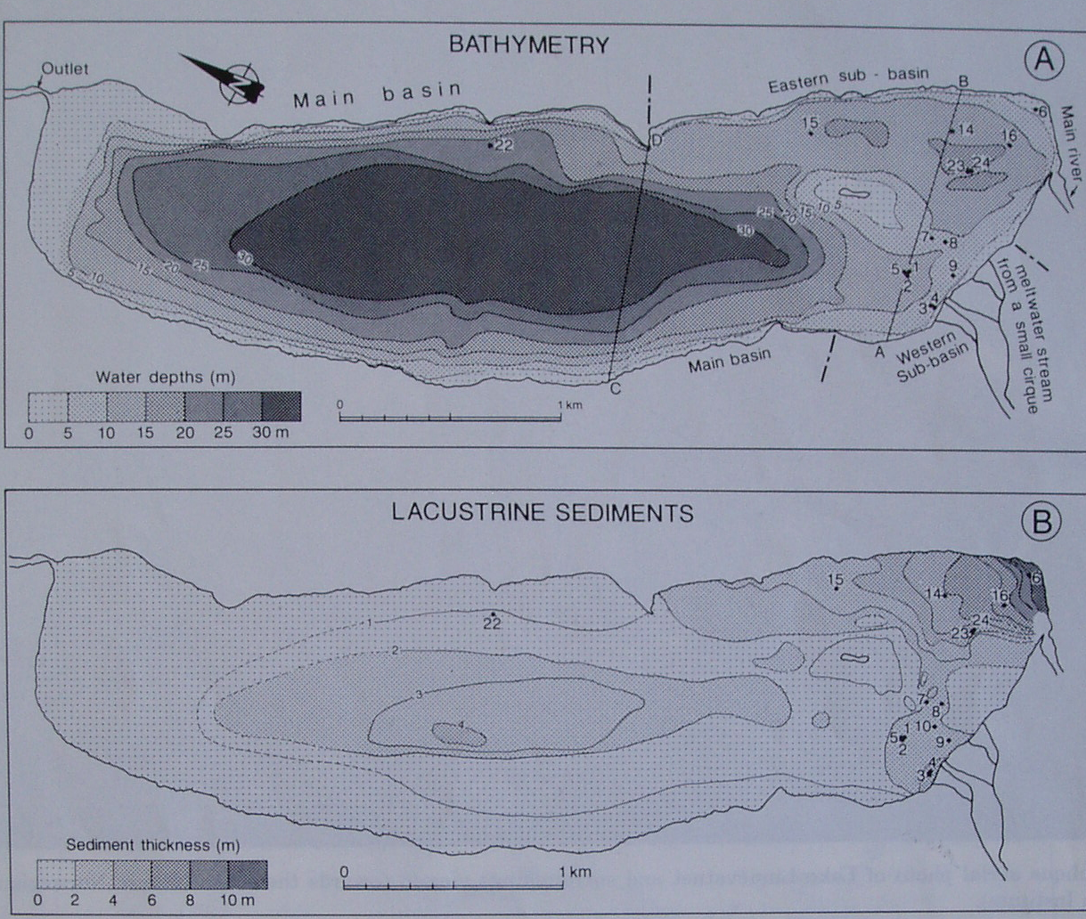
Figure 1. A) Bathymetry of Linné, with darker color representing deeper water. B) Isopach map of lacustrine sediments, with darker pattern representing higher sediment thickness. (Mangerud and Svendsen, 1990.)

3.2 Glacial Mass Balance
The mass balance of Linné has been determined for budget years 2004 and 2005, but a longer record for the glacier does not locally exist. The mass balance of glacier Midre Lovenbreen and Austre Broggerbreen near Ny-Alesund (150 km north of Linné Valley) has been recorded since 1968, and these records are used to relate glacier changes to stratigraphy changes in Lake Linne’. Midre-Lovenbreen is similar to Linnébreen in size, elevation ,facing direction, and proximity to the west coast. (Kohler, pers. comm.)
3.3. Weather Records
Weather records in the Linné valley are limited to the past 3 years, however, meteorological data from the Longyearbyen airport is nearly complete back to 1912, (Figure 3.3.1). Work has been done to show that temperatures in Longyearbyen compare to existing Linnédalen weather data with an R² value of 99.2%, indicating that Longyearbyen temperatures can be used for Linnédalen temperatures (Lane, 2005.) This data offers a way to calibrate the lamination stratigraphy of Linné in relation to weather records. Figure 3.3.1 shows average annual temperature and total annual precipitation from 1912 through 2005. Important things to note are the steady rise in temperature from 1912 to about 1940, which may be related to post-Little Ice Age warming, the peaks in temperature between 1970 and 1985, which will be discussed later, and the recent rise in temperature. Another thing to note is where approximately precipitation tracks temperature between 1960 and 1980, unlike other time periods. (Figure 3.3.1.)
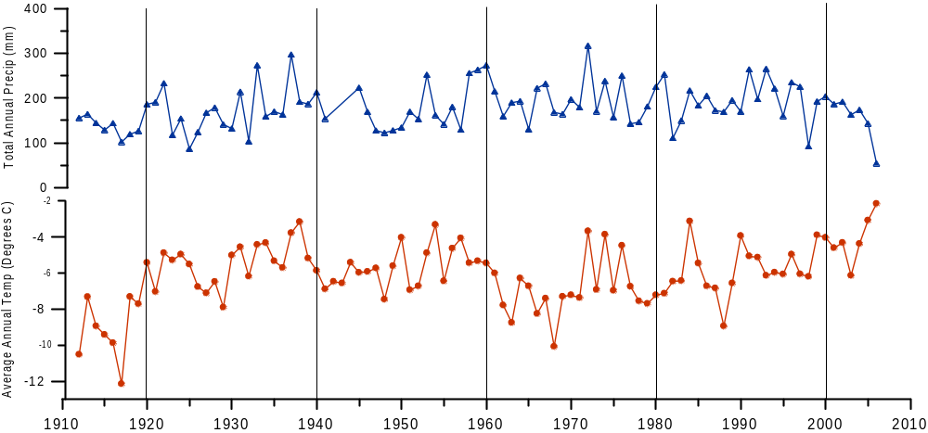
Longyearbyen Weather Data
Figure 3.3.1. Weather data for Longyearbyen Lufthaven 1912 through 2005. Top blue show total annual precipitation, and bottom red is average annual temperature. (data courtesy of Ole Humlum),

3.4 REU Modern Process Studies
The Svalbard Research Experience for Undergraduates, funded by the National Science Foundation, are aimed at providing a better understanding of the environmental factors that influence sediment deposition in the lake. A few of the resulting projects are of particular importance to this project. Projects with sediment traps results indicate annual sedimentation cycles (varves) occur in the lake with fine grained material (clay) deposited in the fall and winter, and larger-grained material (silts) deposited with the spring freshet (subsequent to May) in the spring and into the summer (Motley, 2006; McKay, 2005.) 4. METHODS

4.1 Field Methods

A total of 20 cores (4 long and 16 short), were recovered from Lake Linné during the summers of 2004 and spring of 2005 (Fig. 4.1.1 and Table 1.) These cores were recovered from 5 different locations within the Linné lake basin: site C the most proximal east basin site has a water depth of 15.5 m; site D the intermediate east basin has a water depth of 15.1 m; site E the bathymetric high with a water depth of 5.3 m; site F the west sub-basin with a water depth of 10.5 m, and site G the deep main basin with a water depth of 35.5 m (Fig. 4.1.1). This large number of cores were recovered in order to evaluate and characterize the sedimentation rates and lamination stratigraphy throughout the basin and to identify the best site for a comprehensive evaluation of the lamination stratigraphy. Short cores were recovered using a Universal Short Corer with the purpose of preserving the water-sediment interface, and long cores were recovered with a Nesje Piston Corer in order to capture a 2 to 3 meter long sediment record (Nesje, 1992.)

Table 1. Cores recovered from Lake Linnè with year recovered, location, water depth, and core length.
CORE ID | LOCATION | WATER DEPTH (m) | RECOVERED SED. Length (cm)
C1-2004 | Proximal east basin | 15.5 | 24
C2-2004 | Proximal east basin | 15.5 | 36.4
C3-2004 | Proximal east basin | 15.5 | 41.0
C1-2005 | Proximal east basin | 15.5 | 73
C2-2005 | Proximal east basin | 15.5 | 60.5
CL1-2005 | Proximal east basin | 15.5 | 240
CL2-2005 | Proximal east basin | 15.5 | 242
D1-2004 | Intermediate east | 15.1 | 51.6
D3-2004 | Intermediate east | 15.1 | 44
D4-2004 | Intermediate east | 15.1 | 41.6
D1-2005 | Intermediate east | 15.1 | 37
DL-2005 | Intermediate east | 15.1 | 240
E1-2004 | Bathymetric high | 5.3 | 24
E2-2004 | Bathymetric high | 5.3 | 35.0
F1-04 | West sub-basin | 10.5 | 27.2
F2-04 | West sub-basin | 10.5 | 28.8
G4-04 | Deep main basin | 35.5 | 24
G7-04 | Deep main basin | 35.5 | 21
G1-05 | Deep main basin | 35.5 | 38.7
GL-05 | Deep main basin | 35.5 | 237

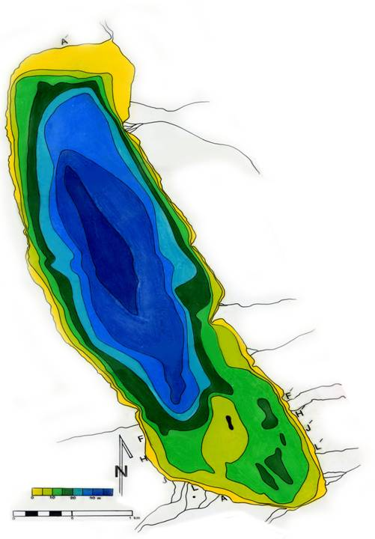
G
C
D
F
E
Figure 4.1.1. Bathymetric map of Lake Linné and core sites. Main inflow stream is identified by the large blue arrow. Sites C and D are located in the east basin, most proximal to the inflow stream. Site E is located on the bathymetric high that separates the east and west basins. Site F is located in the west basin, and site G is in the deep main basin, most distal from the main inflow stream. (modified from Snyder, et. al., and Werner, 1988.)

Core Site Selection:
Five core locations in Lake Linné were selected in order to find the most optimal site, to evaluate proximal to distal and basin variability within the lake and to allow inter-basin correlations between the recovered cores (Figure 4.1.1). Core site G, located in the deep main basin with a water depth of 35.5 meters, was cored in order to capture the longest record for the length in a basin based on isopach data (Svendsen, 1996.) Core site F is located in the west basin with a water depth of 10.5 meters, receives runoff from a nearby cirque, and was cored only in the first year of coring in order to find the most representative and well laminated coring site, as well as to better understand east and west basin differences. Core site E sits on the bathymetric high where water is 5.3 meters deep, and was cored in order to better understand sedimentation in that location. Core site D, at 15.1 meters water depth, is located in the more distal east basin, also referred to as the intermediate core site when compared to C (most proximal to the main inflow stream) and G (deep main basin.) Site D was cored to serve as the intermediate between cores from sites C (about 0.5 km from site D) and G when comparing lamination stratigraphy. Core site C at 15.5 meters water depth, is located in basin most proximal to the main inflow stream (about 0.4 km away), and is in the same general area as much of the previous work done on Linnévatnet. This core site proved the most optimal in terms of thick clear lamination stratigraphy and became the focus site of this study. Each site is associated with sediment trap moorings, which allows comparison of annual sedimentation rates and textures.
Core Recovery:
Short cores were recovered during August 2004 over the side of a Zodiac during open water conditions. Additional short and long cores were taken from the ice surface in early May, 2005. Long cores were recovered using a Nesje piston corer (Nesje, 1992). Short cores were recovered using an Aquatic Research Universal Short Corer. With gravity and a sliding hammer the core tubes were tapped into the sediment. Care was taken to preserve the water surface interface. Recovered core bottoms were capped before they came out of the water to minimize sediment loss out of the bottom of the core tube. The tops were capped once the core head had been removed; all water above the sediment was left in the core tube to minimize agitation. Once on land, the water was carefully drained off through a small hole sawed through the core tube about 1 cm above the sediment-water interface. The cores were kept vertical and the water was able to be drained-off slowly with out disturbing the sediment. The cores were then left uncapped to allow remaining surface water to evaporate for a few days before they were hand carried back to Isfjord Radio. At the base station, cores were left uncovered until all standing water had drained or evaporated before they were finally packed for transport.
Transportation:
In preparation for transportation back to Longyearbyen and MHC, all excess water was removed from the cores with the help of gently blowing warm air (boot dryers) and wicking paper towels. For the short cores, a layer of plastic was then placed on the sediment surface to protect the interface. Two or three layers of absorbency pads were used as packing materials in order to absorb additional water that might be liberated during transport. Florist foam was used to take-up the remaining space in the core tube before a cap was put on and secured with electrical and duct tape. Cores were transported horizontally in cases, packed tightly to minimize jostling, and transported home as checked luggage. Long cores were packed with green florist foam and cloth scraps and sealed with duct tape before being shipped to the lab. All cores arrived in excellent condition and were stored in a walk-in cooler.
4.2 Laboratory Methods
Core Splitting:
In the lab, short cores were split in half using a plastic cutting tool and a taught wire. The cutting tool was used to minimize disturbance of the cores that a saw could have caused. After the plastic on one side had been split, it was taped closed until the second side had been split. Once both sides of the core tube had been cut and tape removed, a taught piano wire was used to slice through the sediment from bottom to top. Long core tube walls were cut with a hand-held circular saw. The two halves were cut with the taught piano wire and allowed to fall open. Each core was labeled with up arrows and core identification, and one half of each core was designated the working half to be used for laboratory analysis, while the other half was designated the archive half and stored for reference.
Photo Documentation:
Immediately following the core splitting, each core was digitally photographed to document original textural and color changes. The surface of the original working half was cleaned with razor blade (parallel to layering) to better expose color changes, whereas, the archive half was left untouched to reveal textural changes. High resolution digital photographs were taken with a camera mounted on a camera stand, in close-up mode. Overlapping (by about 2 cm) pictures were taken incrementally down core with a depth and color scale visible.
Magnetic Susceptibility:
Magnetic susceptibility (MS) measures the ability of a material to be magnetized which is related to properties of density, organic matter content, grain size, and composition (Dearing, 1999). In lake sediments, mineral composition, among other things, can be a main factor in MS variations (Dearing, 1999). Large down core changes in MS can be indicative of important stratigraphic changes in sediment composition. MS in Linné was measured using a Bartington MS2 meter, MS2E1 hand-held detector, and Multisus computer software. Cores were allowed to warm to room temperature and the detector was placed in the center of the core and moved down incrementally, recording the MS value for every 5 mm. The software corrected for drift by measuring the difference in air readings at the beginning and end of every five readings.
Loss On Ignition:
The content of organic matter and carbonate content in a sediment sample can be determined by weight loss in samples after they are burned at specific temperatures (Shuman, 2003.) One cubic centimeter samples were taken with a syringe every other centimeter down the edge of each core and placed in pre-weighed oven-dried crucibles. Samples were weighed to the nearest thousandth of a gram and placed in a muffle furnace at 90°C for at least 12 hours. After cooling in a desiccation chamber these samples were reweighed for dry weight, returned to the furnace at 550°C for 6 hours, allowed to cool in a desiccation chamber, and weighed again to determine organic carbon lost to combustion. Samples were then burned at 900°C for six hours to combust all carbonate material, cooled in a desiccation chamber and weighed one last time to determine weight percent carbonate content.
Grain Size Analysis:
Grain Size Analysis was run on 1 cubic-centimeter-sized samples taken at various intervals down the length of the core. These samples were prepared by adding a solution of deionized water with sodium metaphosphate (Calgone bubble bath was used for this project but is not recommended if straight sodium metaphospate is available. For this project 1 gram of bubble bath was used per 100 mL of deionized water.) The samples with sodium metaphospate solution were gently shaken to break up the sediment, then placed in a sonic dismembrator for 15 minutes to further break apart sediment clumps. All samples were then centrifuged for 2 hours to separate the water which was decanted before the samples were run. The desired consistency of the sample before running it is of creamy peanutbutter. The samples were run on a Coulter LS 200 partical size analyzer capable of measuring particles between 0.4 and 2000 μm in diameter. Each sample was run 3 times at 60 seconds per run with an obscuration of about 9%.
Thin Sections:
Most of the lamination stratigraphy in the Linné cores is so thin that it is best seen in thin section. For this process, cores had to be sub-sampled using aluminum box trays (2 cm x 18 cm x 0.7 cm). Approximately 10-20 holes (5 mm in diameter) were punched into the bottom of each tray for subsequent epoxy impregnation. The box samples were then gently pressed into the sediment along the center-line of each core. Most of the cores have varying amounts of doming as a result of drag along the core tube wall during the coring process. Samples were taken in the center of the cores in order to minimize this deformation. After the box was pressed into the sediment, a cheese-cutter-like tool 3cm wide was drawn underneath the tray allowing the wire to cut the sediment. When overlap was required, a slab was either taken from the center of the archive half of the core, or the sections were taken down the middle.
The freeze-drying technique (Lotter & Lemcke, 1999) was used to make thin sections of each core for its entire length. The sub samples in the aluminum trays (2 cm x 18 cm x 0.7) were used for this process. The tray of slab samples were first shock frozen in liquid nitrogen by placing the slab in a shallow tray and moving it incrementally deeper, to minimize cracking. After each slab was submerged in approximately 15 cm of liquid nitrogen for 1 to 5 minutes, they were moved to the freeze dryer. They remained in the freeze dryer under a vacuum for about 42 hours to ensure complete sublimation of the interstitial water. Dried slabs were placed in aluminum trays on top of thin (1 mm thick) plastic strips for epoxy impregnation. Spurr Low Viscosity resin was used with ratios of Vinylcyclohexene dioxide (VDC), Diglycidyl ether of polypropleneglycol (DER), Nonenyl succinic anhydre (NSA), Dimethylaminoethanol (DMAE) prescribed by Pierre Francus (UMass procedure). This resin was carefully poured into the trays, but not directly on top of the slab allowing it to soak up through the bottom replacing the air escaping through the top. Resin was added slowly until it just reached the tops of the slabs and more resin was added to maintain that level as it was absorbed by the sediment. The trays full of resin were left under low-pressure vacuum (100mg / 4” Hg) for about 24 hours to remove air pockets. Once the slabs appeared completely saturated they were submerged in resin and cured in an oven for 24 hours at 50-60°C (UMass procedure.)
Cured slabs were cut with a trim saw to 6 cm x 2cm at 30° angles for overlap. The samples were placed on slides, ground to approximately 100 microns thick, and polished to 600 grit. Each thin section was labeled with an up arrow, the site number, and core number taken from that site, followed by a letter assigned to the sub sampled slabs alphabetically from the top, and since each slab was cut into three pieces for mounting to the slide, the last number in the label referred to the slide’s place from the top of the section. For example C2-A1 is the top-most thin section from the second core taken from cite C (figure 4.2.1).
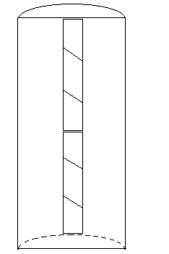
18cm
2cm
Core C
C2-A
C2-A1
C2-A2
C2-A3
C2-B1
C2-B2
C2-B3
C2-B
Figure 4.2.1. Labeling system of sub-samples. Core location, core number, sub sample set, sub sample number.

Image Processing:
In order to work with the thin sections digitally, high resolution scans of each slide were completed. An Agfa Duoscan flatbed scanner (2000x1000 dpi) was used to scan thin section in batches of four. Histogram color settings were set on automatic allowing the computer to adjust for each thin section, thus reduced the size of each image and improving the brightness of each image. Subsequent to scanning, images were adjusted to gray scale using Adobe Photoshop Elements 2.0 for future image processing.
Image processing can provide quantitative assessments of the lamination stratigraphy. NIH’s program Image Processing and Analysis in Java (ImageJ) was used for gray scale analysis. A line-analysis was processed down the center of the top 2004-C2 thin sections (avoiding cracks or other irregularities) producing a gray scale number by depth. These numbers were plotted and used to quantify varve counts.

5. RESULTS
A total of 20 cores (4 long and 16 short), were recovered from Lake Linné during the summers of 2004 and spring of 2005 from 5 different locations within the Linnévatnet (table 1.) Of the 20 cores, 6 are discussed in detail these are: G1-05, GL-05, D1-05, DL-05, CL1-05, and C2-05. Cores from sites E and F are described generally, although, they were not studied as part of this project. Most cores recovered from the lake contained domed deformation, an artifact of sediment cohesion and drag on the core tube during the coring process.
5.1 Core F1-04 and F2-04 (Western sub-basin, 10.5 m water depth)
Visual Stratigraphy:
Two short cores were recovered in the summer of 2004 from core site F, the west sub-basin (Fig. 4.1.1.). The west basin is 10.5 meters deep and receives sediment from a small inflow stream in the south west corner of the lake. The stream runs exclusively from the side valley cirque and carries sediment with a unique yellow-tan color. The two cores recovered show almost identical stratigraphy with well defined and thin laminations in the top 5 cm that become less well defined down core. The top 5 cm contain couplets of dark brown clay layers and yellow-tan silt layers about 1 mm to 5 mm thick. At 4.8 cm down core thick (3 cm) brown, poorly defined layers begin to appear between sets of finer dark brown and yellow-tan couplets. Ten centimeters down core, these thicker poorly defined layers dominate the core and couplets become less well-defined and in some cases thicker. In Core F2-05, a phyllite drop stone from west side of basin about 5 mm in diameter at 8.5 cm down core and clearly disturbed sediment above and below it. In general cores recovered from site F are poorly-laminated and irregular below the top 5 cm. These cores record a sediment signature dominated by the local cirque area, unlike the core sites in the eastern part of the lake which are mostly influenced by the main inflow stream.
5.2 Core E1-04 and E2-04 (Bathymetric high, 5.3 m water depth)
Visual Stratigraphy:
Two cores were recovered from core site E in a water depth of 5.3 meters. Core E1-04 measured 24 cm in length and core E2-04 was 35 cm long. Both cores were primarily composed of homogeneous sediment with minimal indication of layers. Thin sections were made of E1-04 revealing a brown homogenous top six cm, with an exception of small drop stones at 2 cm, 8 cm, 11 cm, and 12.5 cm, and two light layers 2 mm thick occurring at 3.5 and 4 cm down core. Overall core site E preserves almost no lamination stratigraphy and contains many small drop stones (~5 mm in diameter.)
5.3 Cores G4-04, G7-04, and G1-05 (Deep main basin, 35.5 m water depth)
Four cores were recovered from core site G (figure 3), cores G4-04 (the fourth core recovered from site G in 2004) and G7-04 were used for preliminary analysis, G1-05 was studied more extensively, and GL-05 (the long core from the site is discussed below.
Visual Stratigraphy:
The visual stratigraphy of core G1-05 was thinly (< 5 mm) layered clay rich-pastey sediment. Light brown layers occur at 10 to 13 cm, and more frequently between 15 cm and 27 cm down core. Thin but particularly distinct light brown layers appear at 28 cm and 33 cm down core. Other than these light brown layers, the stratigraphy remains consistently sub-millimeter in thickness and clay dominated (Figure 5.3.1).
Magnetic Susceptibility:
The magnetic susceptibility of core G1-05 remained consistently between 5 and 10 x10⁻⁵ SI units except for a peak of 40 x10⁻⁵ SI units in the top 2 cm of the core. Curiously this peak disappeared in subsequent measurements and therefore its significance is in question (see Interpretations) (Figure 5.3.1).
Bulk Density:
The bulk density of core G1-05 ranged between 0.8 and 1.2 grams per cubic centimeter. Despite small oscillations in density, there is a general but subtle trend toward higher density down core with the top at 0.84 g/cc to 1.03 g/cc at 36 cm down core (Figure 5.3.1).
Loss on Ignition Organic Carbon:
The profile of organic carbon percent down core varies between 7.3% and 9.0% and averages 8.1%. The core top contains 8.3% organic carbon while the whole core shows a trend towards less carbon down core with 7.6% at 36 cm. There are changes throughout the core with the highest peak at 9.0% from 5 to 10 cm, a low of 7.5% at 12 cm to 15 cm, another peak of 8.8% around 16 cm, and the lowest point of 7.3% at 28 cm depth (Figure 5.3.1).
Loss on Ignition Carbonate:
The average carbonate content of G1-05 is 3.66% with a low of 2.21% and a high of 5.38%, although most of the core appears to vary only between 2.2% and 2.9% with one rise of 5.38% at 28 cm depth. This peak appears at the same depth as the lowest level of organic carbon (7.3% at 28 cm). The organic carbon and carbonate content have an inverse relationship. The R-squared value of organic carbon to carbonate in G1-05 is 0.28 (Fig. 5.3.1).

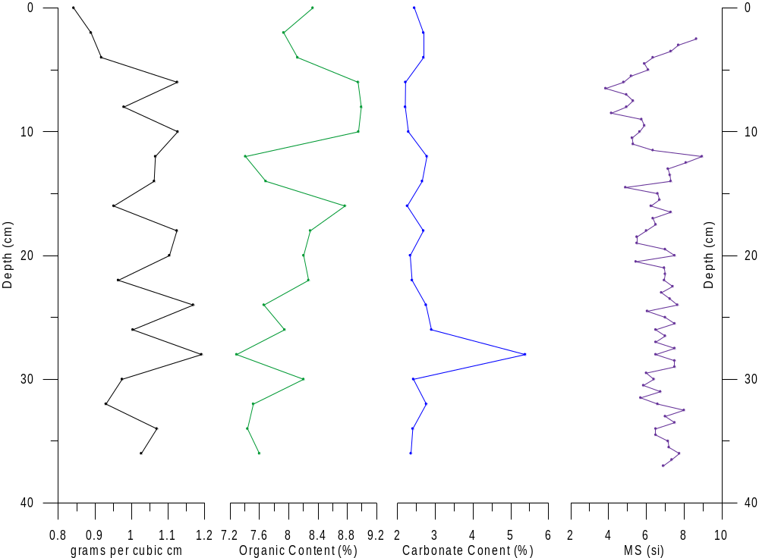
G1-05

Figure 5.3.1. Results for core G1-05. From left to right: bulk density (grams per cc), organic carbon, carbonate, magnetic susceptibility. All plotted against depth from core top.
(plot didn’t show)

5.4 Core GL-05 (Deep main basin, 35.5 m water depth)

Visual Stratigraphy:
Core GL-05 was 237 cm long with very fine laminations which become increasingly difficult to see with depth. The top 85 cm contain clear laminations and consist of predominately pastey clay textures. The thickest and clearest laminations are in the top 20 cm, below 20 cm laminations are thinner and less defined. Light tan-orange laminations stand out and appear in the top 85 cm but not below that. A few thick orange layers appear at 66 and 77 cm with slightly higher grain size than the rest of the core. Green-brown laminations begin to appear 70 cm down and become increasingly frequent down core. Below 130 cm these green-brown laminations appear with black flecks which oxidize a lighter color. Below 200 cm very small rocks, the size of large sand grains, appear frequently.
Magnetic Susceptibility:
The magnetic susceptibility profile of GL1 shows variation only between 5 and 18 x10⁻⁵ SI units (see figure 5.4.1). A gradual trend from lower to higher values is apparent down core. A few zones of change occur: in the top 50 cm the long-term trend hovers around 8 x10⁻⁵ SI units, and at 50 to 90 cm the values rise to around 9 x10⁻⁵ SI units, between 100 and 150 cm the values includes a gradual rise from 9 x10⁻⁵ SI units to about 12 x10⁻⁵ SI units, between 150 cm and 180 cm the MS trend reverses and decreases from about 12 x10⁻⁵ SI units to 10 x10⁻⁵ SI units, from here to the base of the core it rises abruptly to 18 x10⁻⁵ SI units by 235 cm. These are all very small changes but larger than the changes that appeared in only the short core.
Bulk Density:
The bulk density profile (grams per cubic centimeter) varies only slightly between 0.75 and 1.0 g/cc. It remains fairly consistent with only small oscillations. There is a trend from higher bulk density of about 0.95 g/cc at the top of the core to lower bulk density about 0.8 g/cc at the bottom of the core. This change is small but apparent (Figure 5.4.1).
Loss in Ignition Organic Carbon:
Organic carbon content in core GL-05 varies between 9.2% and 5.2% with a trend of higher organic carbon content at the top and lower values at the bottom of the core. The top 50 cm shows a negative trend in carbon content from about 9% to 6%. Between 50 cm and 125 cm the carbon content stays fairly consistent at about 8% before dropping to 6% at 125 cm. Between 150 cm and 200 cm carbon content stays around 6.5% and then drops to 5.5% at the bottom of the core from 200 cm to 237 cm (Figure 5.4.1).
Loss on Ignition Carbonate:
Carbonate content varies between 0.8% and 4.2% with no clear down-core trends. In the top 15 cm the carbonate content increases from 1.5% to 2.5% before dropping back to 1.5% between 20 cm and 40 cm. At 50 cm the content rises to 2.5 and remains at about 2% until 100 cm down. Between 100 cm and 125 cm the carbonate content drops 1%. Between 125 cm and 180 cm the content rises t0 2.5% then peaks to 4.2% before dropping gradually back to 1% between 190 cm and 237cm (Figure 5.4.1).

G1U-05

Figure 5.4.1. Results for core GL-05. From left to right: bulk density (grams per cc), organic carbon, carbonate, magnetic susceptibility. All plotted against depth from core top.

5.5 Core D1-05 (Intermediate east sub-basin, 15.1 m water depth)

Visual Stratigraphy:
The visual stratigraphy of core D1 contains alternating couplets of dark cohesive clay and lighter silt layers. Couplets in the top 5 cm have very similar silt to clay ratios. Thick silt bands occur at 6 cm, 8 cm, and 9 cm. Below 11 cm the stratigraphy becomes thinner and clay dominates between 10 cm and 26 cm. Separations appear in silty layers at 12 cm, 19cm , and 23 cm. There are some disturbed laminae between 27 cm and 28 cm. Overall laminations are thicker and more prominent than those found in core site G although they become thinner down core.
Magnetic Susceptibility:
The magnetic susceptibility of core D1-05 changes very little down core, between 4 and 8 x10⁻⁵ SI units. A peak of 31 x10⁻⁵ SI units in the top 2 cm occurred when MS was first tested after cores had been freshly opened, but disappeared in subsequent tests. The magnetic susceptibility curve hovers right around 6 x10⁻⁵ SI units down most of the core. At about 25 cm down some of the variations present themselves as a few low points of about 4 x10⁻⁵ SI units at about 32 cm, and a few high values of about 8 x10⁻⁵ SI units at about 30 and 36 cm down core (figure 5.5.1).
Bulk Density:
The bulk density of D1-05 changes only 0.4 grams per cubic centimeter down core. These very small changes present themselves as an increase in density in the top 22 cm and a decrease from 24 cm to the bottom (36 cm). The top 6 cm weighed about 1.2 g/cc, from 8 cm to 12 cm, the bulk density went up to 1.4 g/cc. Between 14 and 22 cm it rose to 1.6 g/cc before dropping back to 1.2 g/cc by the bottom at 36 cm. These are very small changes despite the interesting curve. (Figure 5.5.1).
Loss on Ignition Organic Carbon:
The organic carbon profile ranges between 5.8% and 9.4% and contains two small but interesting curves. In the top 10 cm the organic carbon increases from 6.4% to a small but distinct rise of 7.4% and 7.0% (at 2 and 4 cm) before dropping back to 6.1%. From 10 cm to 34 cm the organic carbon percent increases almost continually from 5.8% to 9.4% (Figure 5.5.1).
Loss on Ignition Carbonate:
The carbonate profile of D1-05 reflects the organic carbon profile of the same core: with an inverse relationship R-squared of 0.72. The carbonate curve shows a decrease in the top 10 cm (from 7.1% to 4.5% and back to 7.4%) where there is an increase in organic carbon. From 10 cm depth the carbonate content slowly decreases down core from 6.3% to 1.9% while organic carbon content increases.

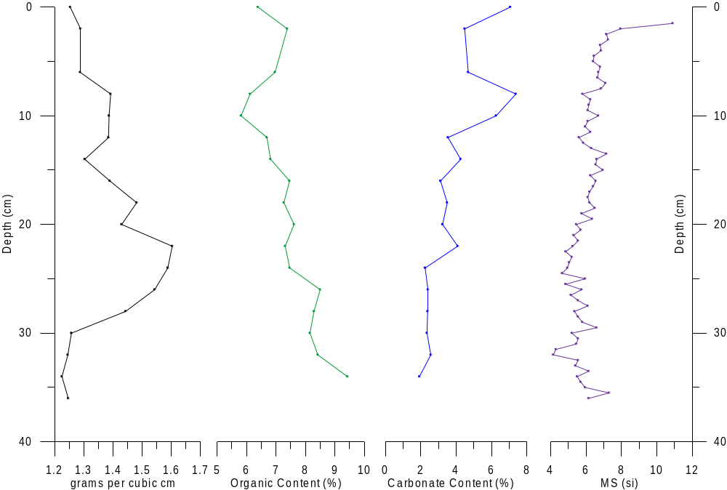
D1-05

Figure 5.5.1. Results for core D1-05. From left to right: bulk density (grams per cc), organic carbon, carbonate, magnetic susceptibility. All plotted against depth from core top.

5.6 Core DL-05 (Intermediate east sub-basin, 15.1 m water depth)

Visual Stratigraphy:
DL-05 is 240 cm long and well laminated with thin, well defined stratigraphy. Below 110 cm laminations are still present but no longer well defined. The top 20 cm is a lighter, silt-dominated zone with a few thicker than average silt layers at 4 cm, 7 cm, 11 cm, 17 cm, and 20 cm depth. Between 20 cm and 47 cm the laminations remain even but appear as darker zones, probably due to higher levels of clay. Between 47 cm and 51 cm is an especially dark zone. From 52 cm to 59, there are a number of thick silt layers at 53.5 cm, 55 cm, 57 cm, and 59 cm. 59 cm to 100 cm shows nothing remarkable, just many finely laminated layers with a few clear silt-clay-silt rail-road tracks at 64 cm, 73 cm, 82 cm, and 88 cm. Between 101 cm and 110 cm is a darker zone dominated by clay layers. The zone between 110 cm and 135 cm is poorly laminated and dominated by clay with only a few noticeable silt laminations at 127 cm and 135 cm. From 135 cm to the bottom of the core stratigraphy is poorly defined to the eye. Thin sections may be able to reveal a bit more detail. Below 230 cm the clay changes to a slightly lighter color. DL-05 is very finely laminated, becoming nearly indistinct to the unaided eye below 135 cm down core.
Magnetic Susceptibility:
The MS profile for DL-05 ranges between 4.5 x10⁻⁵ SI units and 11.5 x10⁻⁵ SI units with many small oscillations and a few long trends. The top 50 cm changes from an average of about 10 x10⁻⁵ SI units to 6 x10⁻⁵ SI units before reversing the trend in the next 50 cm. Between 100 cm and 150 cm the MS oscillates around 9 x10⁻⁵ SI units, then rises to about 9.5 x10⁻⁵ SI units to a depth of 175 cm. Between 175 cm and 200 cm the MS rises from about 8 x10⁻⁵ SI units to 10 x10⁻⁵ SI units. Below 200 cm oscillates greatly between 6 x10⁻⁵ SI units and 11.5 cm.
Core C2-05 (Proximal east sub-basin, 15.5 m water depth)

Visual Stratigraphy:
Core C2-05 is 60.5 cm long and very well laminated with relatively thick and well defined laminations. There are clear dark clay and lighter silt couplets ranging from 0.5 mm and 7 mm in thickness. Particularly thick layers appear between 7.5 cm and 9.5 cm and again between 12 cm and 14 cm. Below about 31 cm laminations become thinner and zone from 32 cm to 51 cm is particularly clay-rich. Between 45 cm and 50 cm is a small deformation. The rest of the core is finely laminated with no clear changes.
Magnetic Susceptibility:
Magnetic susceptibility in C2-05 ranges from about 2.5 x10⁻⁵ SI units to 5.5 x10⁻⁵ SI units. The top 2 cm showed and initial spike of 70 x10⁻⁵ SI units, but that disappeared during later MS tests. The top 10 cm show an slow increase from about 3 to 5 x10⁻⁵ SI units, and from 15 cm to 40 cm this trend is reversed. Below 40 cm the magnetic susceptibility oscillates from about 2.5 to 5.5 x10⁻⁵ SI units with no clear trend (Figure 5.6.1).
Bulk Density:
The bulk density profile ranges from about 1.1 grams per cubic centimeter to 1.6 g/cc. There is a general trend towards slightly less dense sediments down core, but there are many oscillations and most of the samples fell between 1.35 g/cc and 1.55 g/cc. There are a couple of very low points at 10 cm, 30 cm , 44 cm, and 52 cm. And higher points at about 5 cm, 15 cm, 25 cm, 40 cm, and 55 cm, but even these points deviate from the average only slightly (Figure 5.6.1).
Loss on Ignition Organic Carbon:
Organic carbon content of C2-05 stays between 5% and 9% down core with a few large oscillations and longer trends. The top 10 cm contains a rise in organic carbon content from about 5.5% to about 7.5%. From 10 cm to 16 cm the content drops again and reaches a low of 5.1% at 16 cm. Between 20 c and 50 cm the organic carbon content oscillates between 7.5% and 8% until it spikes to 9% right above 50 cm. The bottom 10 cm stays between 7% and 7.5% (Figure 5.6.1).
Loss on Ignition Carbonate:
Carbonate content appears similar to the inverse of organic carbon content of C2-05, but the R-squared value is only 0.42. With a range from 2.5% to 8.5%, the carbonate content stays at about 6% in the top 4 cm, decreases to about 3.7% from 4 cm to 10 cm, spikes to 8.4% at 14 cm, then drops to 2.7 by 24 cm. The carbonate content hovers at about 3% from 24 cm to 48 cm, and then begins to rise in the bottom 10 cm to 6.9% (Figure 5.6.1).

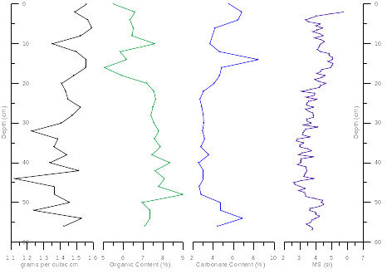
C2-05
Figure 5.6.1. Results for core CL1-05. From left to right: bulk density (grams per cc), organic carbon, carbonate, magnetic susceptibility. All plotted against depth from core top.

Cesium Age Control A cesium activity profile was determined for core C2-05 and shows a peak at 18.5 cm. This peak is identified as the event associated with the years 1963 to 1964 (Ku, pers. comm.). Based on this the top 18.5 cm of C2-05 have a sedimentation rate of 4.5 mm per year (Figure 5.6.2).
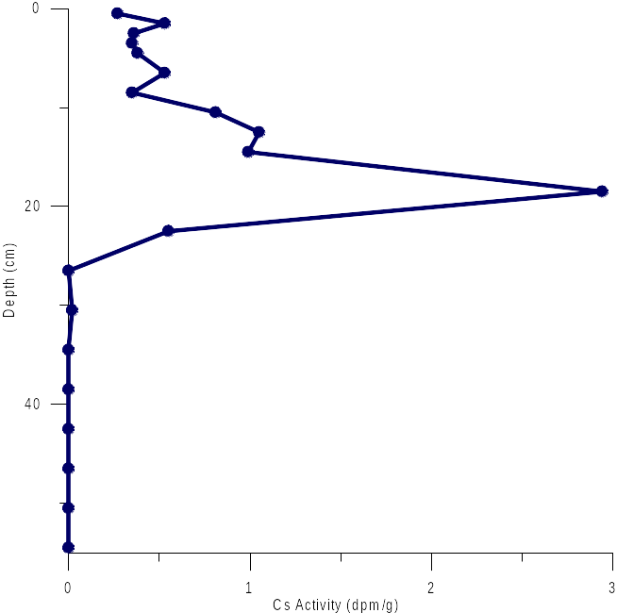
Cesium Activity

Results for Core C2-05

Figure 5.6.2. Cesium activity result for core C2-05 from Richard Ku, University of Southern California, with peak at 18.5, related to 1963-64. Indicating a sedimentation rate of 4.5 mm/yr.

Image Processing:
NIH Image-J image processing was used for gray-scale analysis on the top 20 cm of core C2-05. The program was used primarily to document relative down core changes to aid in lamination counting. Gray values ranged from about 20 to 150. Some of the higher gray values were a result of uneven thin sections (the ends of the thin sections analyzed were ground thinner than the center, therefore allow more light to permeate and give higher gray values.) The smaller changes in the gray-scale curve are real and reflect the color changes of the thin sections resulting from grain size changes. Anything below 40 gray-value was interpreted as clay textures, while everything over 40 gray-value was interpreted as silt textures. These gray-scale analyses suggest about 42 couplets of light and dark (or silt and clay) in the top 18.5 cm of the core.
Lamination Counts:
Lamination counts based on image gray-scale analysis of thin sections, as well as visual counts of the thin sections under microscope result in 42 designated couplets of silt and clay laminations. When related to the cesium age control, these counts indicate annual couplets going back to 1963.

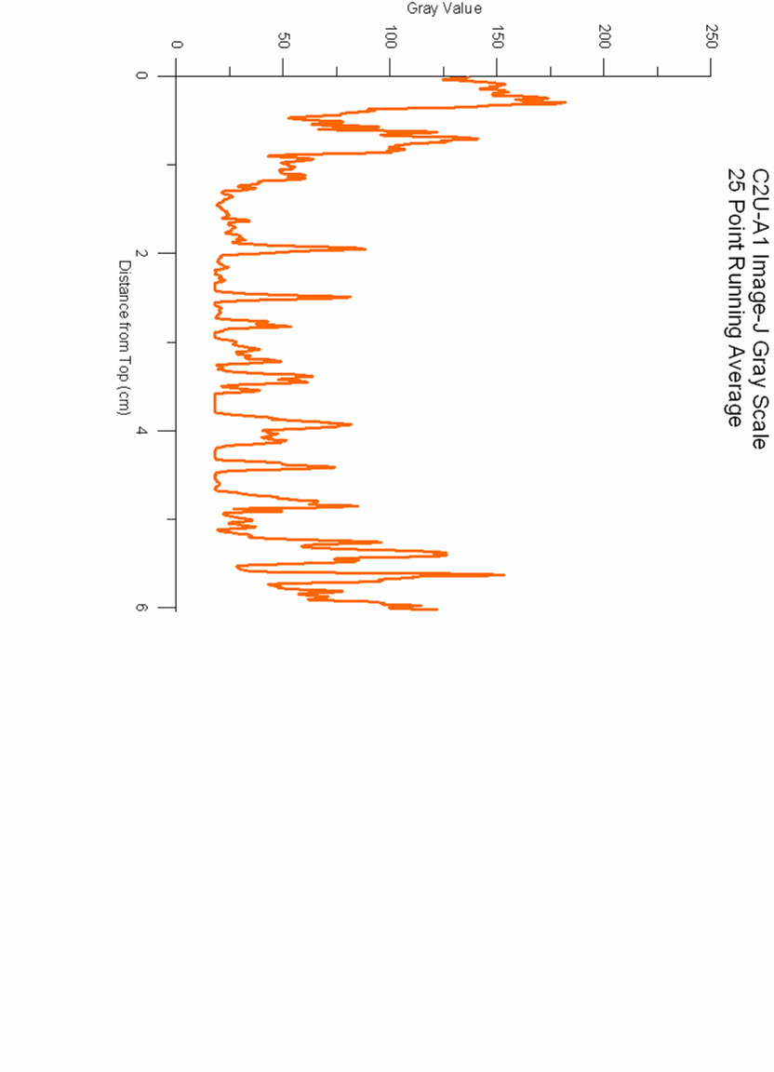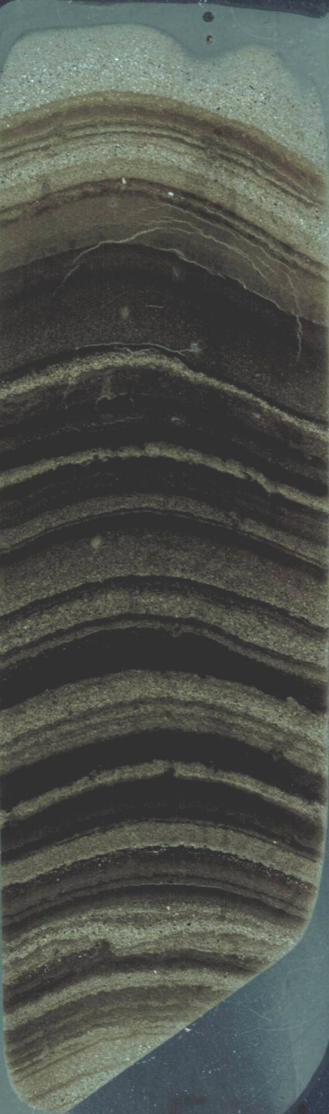
04
03
02
01
00
99
98
97
96
95
94
93
92
91
C2-A1
4
6
2
Figure 5.6.3. 1 out of 4. Top 6 cm of C2-05. Thin section on left, simplified lamination couplets: light blue (silt) and dark blue (clay), with assigned year for each couplet in orange. On Right is Image-J gray scale results.

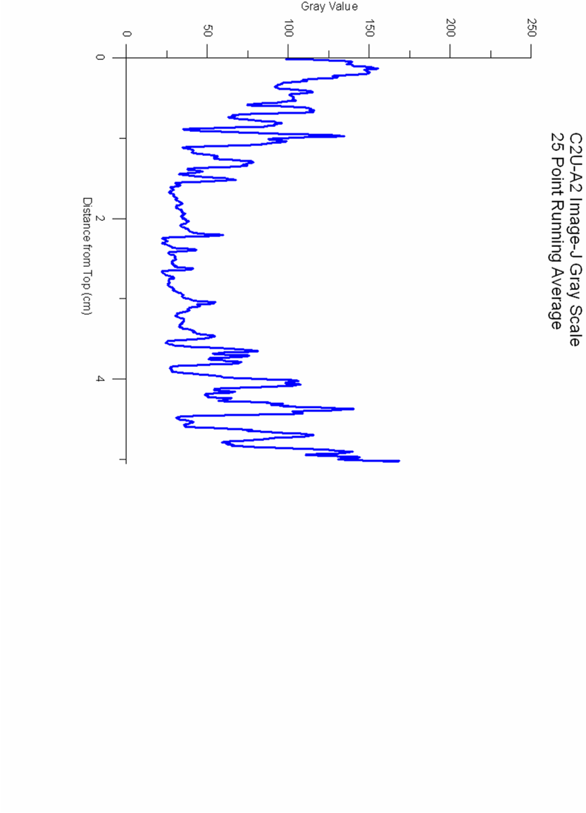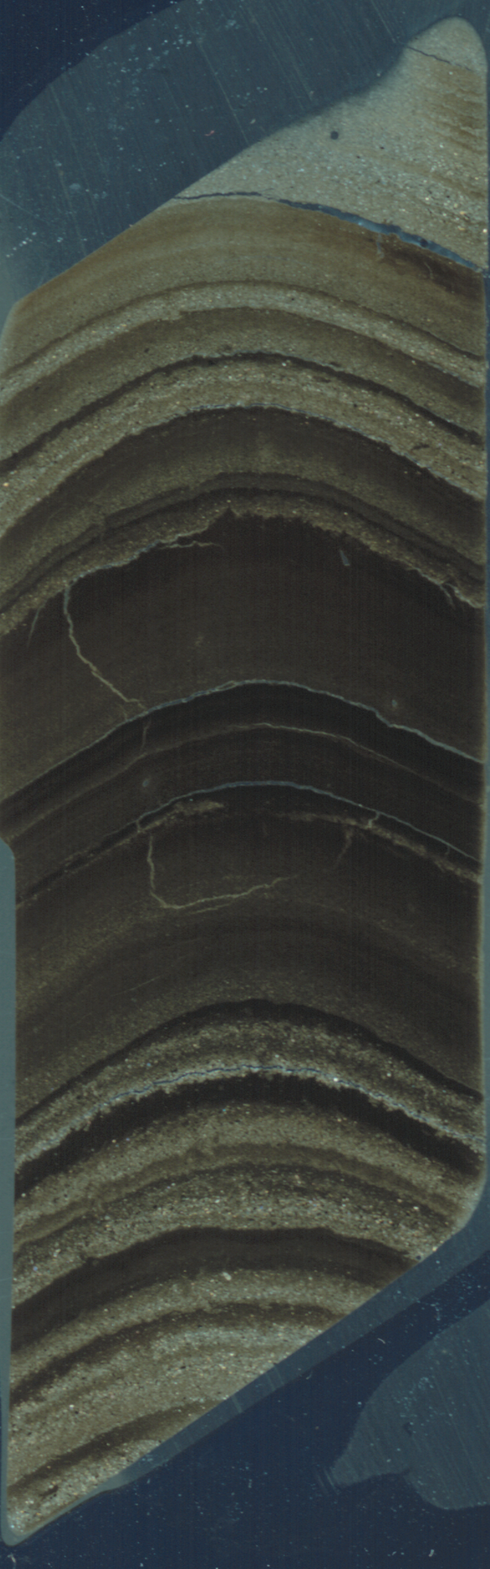

90
85
84
83
76
77
78
79
80
81
82
86
88
89
91
87
C2-A2
10
8
Figure 5.6.4. 2 out of 4. 6 to 11 cm of C2-05. Thin section on left, simplified lamination couplets: light blue (silt) and dark blue (clay), with assigned year for each couplet in orange. On Right is Image-J gray scale results.

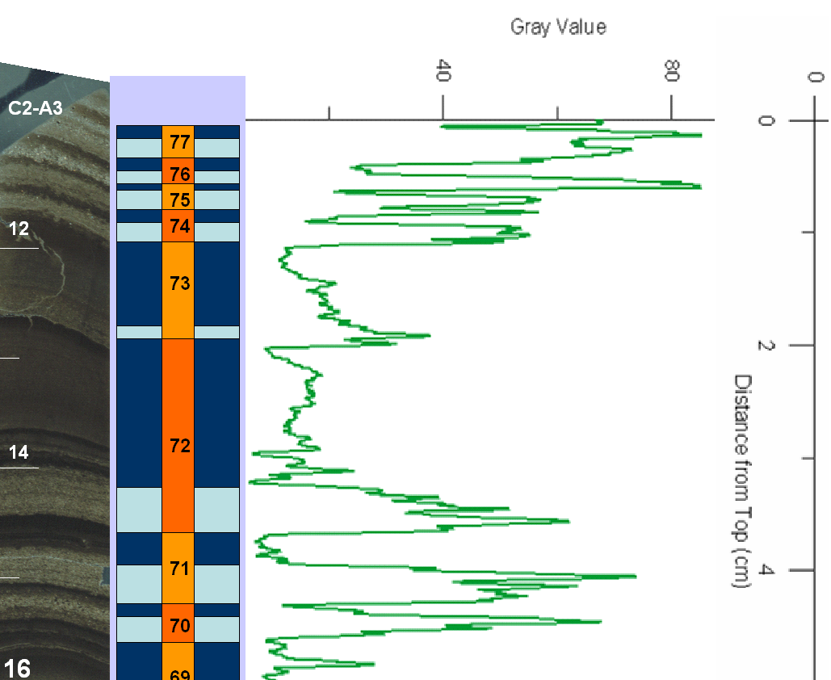
Gray Value

Figure 5.6.5. 3 out of 4. 11 to 16 cm of C2-05. Thin section on left, simplified lamination couplets: light blue (silt) and dark blue (clay), with assigned year for each couplet in orange. On Right is Image-J gray scale analysis. (This section is missing the bottom 2 cm and varves 1969 through 1966 due to technical errors.)

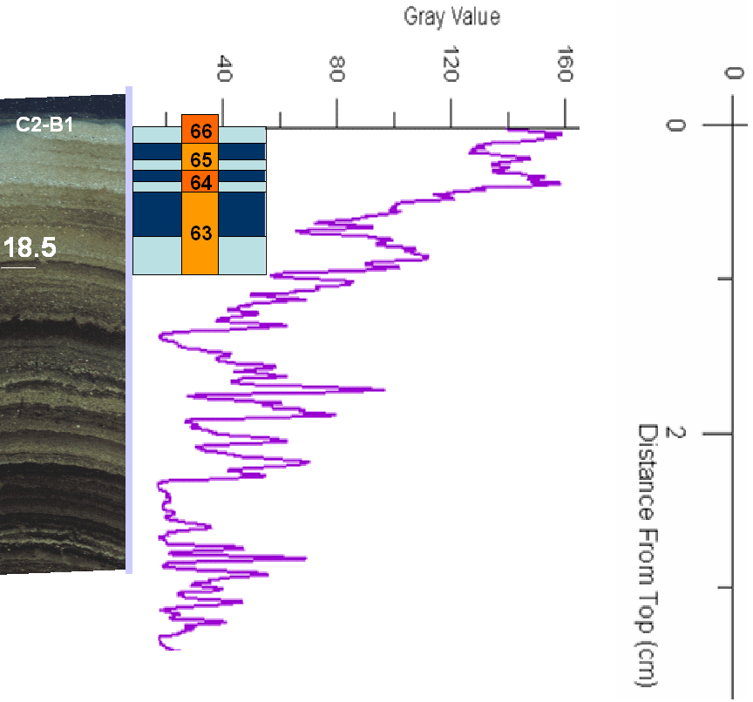
Gray Value

Figure 5.6.6. 4 out of 4. 17 to 18.5 cm of C2-05. Thin section on left, simplified lamination couplets: light blue (silt) and dark blue (clay), with assigned year for each couplet in orange. On Right is Image-J gray scale analysis.

5.7 Core CL1-05 (Proximal east sub-basin, 15.5 m water depth)

Visual Stratigraphy:
Core CL1-05 was the first long core recovered from core site C, most proximal (0.4 km) to the main inflow stream. CL1-05 is 240 cm long and contains thick and distinct lamination stratigraphy in the top and visible stratigraphy throughout the core. The top 32 cm contain clear, even laminations with silt and clay couplets. A thick light-colored silt band appears at 11 cm, and a few sand layers appear between 10 cm and 15 cm. In the silt layers individual grains are still visible, and in some cases the sand layers pulled apart when the core was split. Between 39 cm and 81 cm is a dark, clay-rich zone. Laminations are about 1 to 2 mm thick and contain more clay than silt. From 81 cm to 91 cm is a lighter, silt-dominated zone. Between 91 cm and 151 cm laminations are very fine, with relatively even silt and clay lamination thickness. Only a few thick laminations are visible while finer laminations would probably appear in thin section. From 151 cm to 202 cm is a zone dominated by clay with very infrequent sandy layers. Below 202 cm very few laminations are visible with an exception of thin silt layers that appear about every 1 cm. More detail will probably appear in thin section. In the bottom 5 cm no stratigraphy is visible, just grey clay.
Magnetic Susceptibility:
The MS profile for CL2-05 resembles that of DL-05, ranging between 4 x10⁻⁵ SI units and 11 x10⁻⁵ SI units and filled with oscillations. The top 50 cm of CL2-05 shows a steady decrease from 10 x10⁻⁵ SI units to 6 x10⁻⁵ SI units except for the top couple of readings which appear at 5 x10⁻⁵ SI units and 7 x10⁻⁵ SI units. Between 50 cm and 100 cm the magnetic susceptibility oscillates around 7 x10⁻⁵ SI units. Between 100 cm and 150 cm the general trend of the MS profile rises again from values of 7 x10⁻⁵ SI units to 10 x10⁻⁵ SI units. 150 cm to 242 cm has some larger oscillations around 9 x10⁻⁵ SI units with a few high readings between 220 cm and 225 cm. (Figure 5.7.1).
Bulk Density:
The bulk density of CL1-05 ranges from 1.0 g/cc to 1.5 g/cc down core. There are a few noticeable trends in the very small variations. While the top 25 cm oscillate around 1.4 g/cc, the density between 50 cm and 100 cm drops to about 1.2 g/cc. From 100 cm to 175 cm the bulk density hovers at about 1.5 g/cc and then from 175 cm to the bottom, the bulk density oscillates from 1.1 g/cc to 1.5 g/cc (Figure 5.7.1).
Loss on Ignition Organic Carbon:
The organic carbon content profile of CL1-05 ranges only from 5.5% to 9%. The top 25 cm of the core have about 5.5% organic carbon, and below that, from about 25 cm to 100 cm, the content rises to about 9% below which it falls back to 6%. Below 100 cm the organic carbon content oscillates between 5.5 and 7.5 pretty consistently with no clear trends increasing or decreasing (Figure 5.7.1).
Loss on Ignition Carbonate:
Carbonate content ranges only from 2.5% to 8% down core. The top 25 cm oscillates around 5% before dropping to 2% from about 30 cm to 80 cm. From 80 cm to 100 cm the carbonate content rises to 8%. Below that carbonate content oscillates between 2.5% and 8% and seems to have slightly higher percentages down core (Figure 5.7.1).

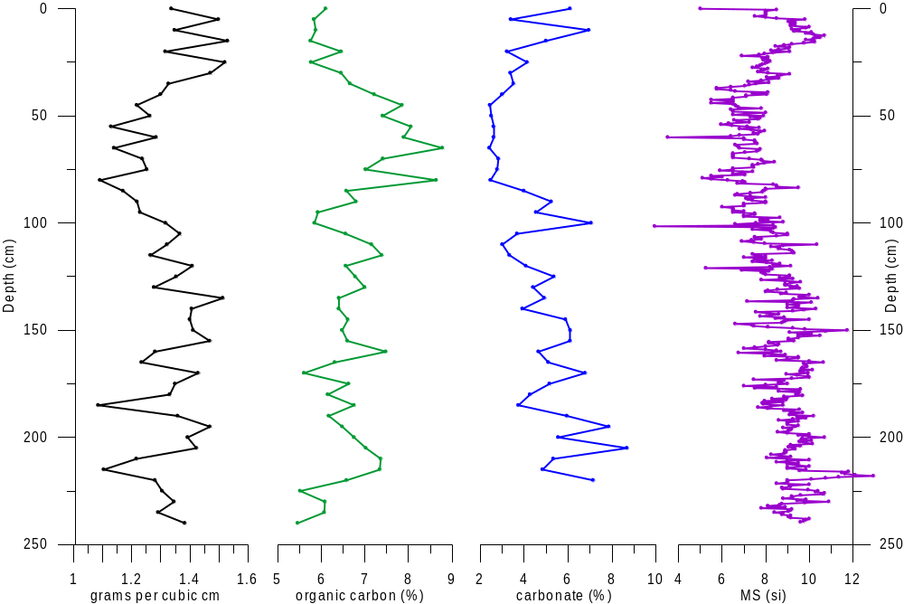
CL-05

Figure 5.7.1. Results for core CL1-05. From left to right: bulk density (grams per cc), organic carbon, carbonate, magnetic susceptibility. All plotted against depth from core top.

Grain Size:
Grain Size is reported as the mean of the distribution frequency given by the Coulter LS 200 for each sample. Down core grain size averages range from 6.7 μm to 23.8 μm with many variations through out the core. The top 25 cm of core CL1-05 contains the largest grain sizes, with the peak of 23.8 μm at 13 cm down core. Between 22 and 90 cm depth, average grain size drops with some variations until it reaches a core low of 6.7 μm average size. From 95 cm to 237 cm average grain sizes fall at about 13 μm with a high of 18.6 μm at 150 cm and a low of 9.0 μm at 205. Below 100 cm grain sizes fluctuate more gradually than they do in the top 100 cm. General grain size trends show a larger grained zone in the top 30 cm followed by a finer-grain size zone from about 30 to 90 cm. Between 90 cm and 100 cm there is a zone in which grain size fluctuates significantly. This zone contains the smallest average grain size of the core. From 100 cm to 130 cm seems to be a gradual transition zone, below which is a larger grained zone from 133 to 180 cm. From 180 cm to the bottom of the core is a generally finer grained zone, similar to that between 30 and 90 cm (Figure 5.7.2).
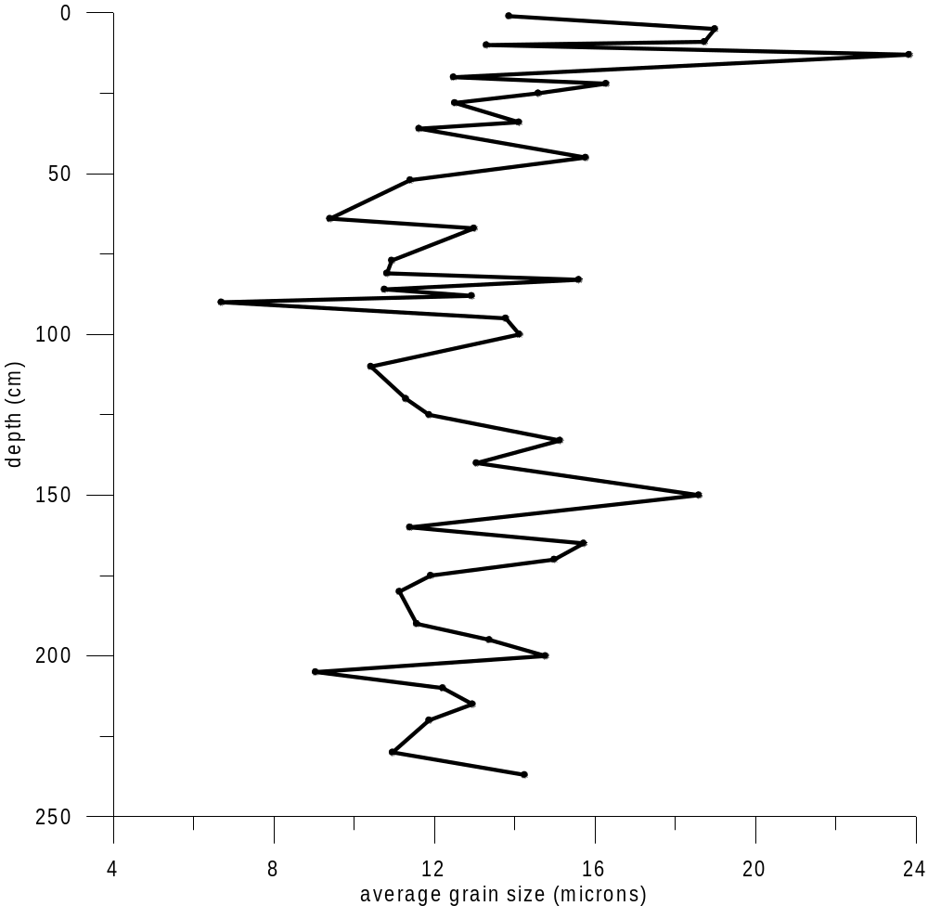
CL1-05 Ave Grain Size
Figure 5.7.2. Mean grain size values as defined by the Coulter LS 200 for the length of CL1-05. This shows down core changes in grain size described in section 5.7.

6. INTERPRETATIONS
Cores from locations E and F were not as well laminated as those from sites C, D, and G. They also contained sediment signatures unique to the west side of the lake, unlike cores on the east side which received the most direct inflow from the glacier. For these reasons, cores from sites E and F were not studied in as much detail as cores from sites C, D, and G, and therefore will not be discussed further. The comparison of physical and compositional properties of cores G1-05, D1-05, C2-05, and CL1-05 allow for the correlation of cores of different basins and recovery times. Analysis of the cores also allows for comparison to temperature and glacier mass balance records.

6.1 Correlation of Cores

Long and Short Cores:
The long core from site C (Core CL1-05) and the corresponding short core (C2-05) correlate well. The long core did not preserve the water sediment interface making it important to define the amount of long core top missing. The visual stratigraphy of the two cores can be matched to reveal that only the top 1 cm of the long core is missing (Figure 6.1.1).
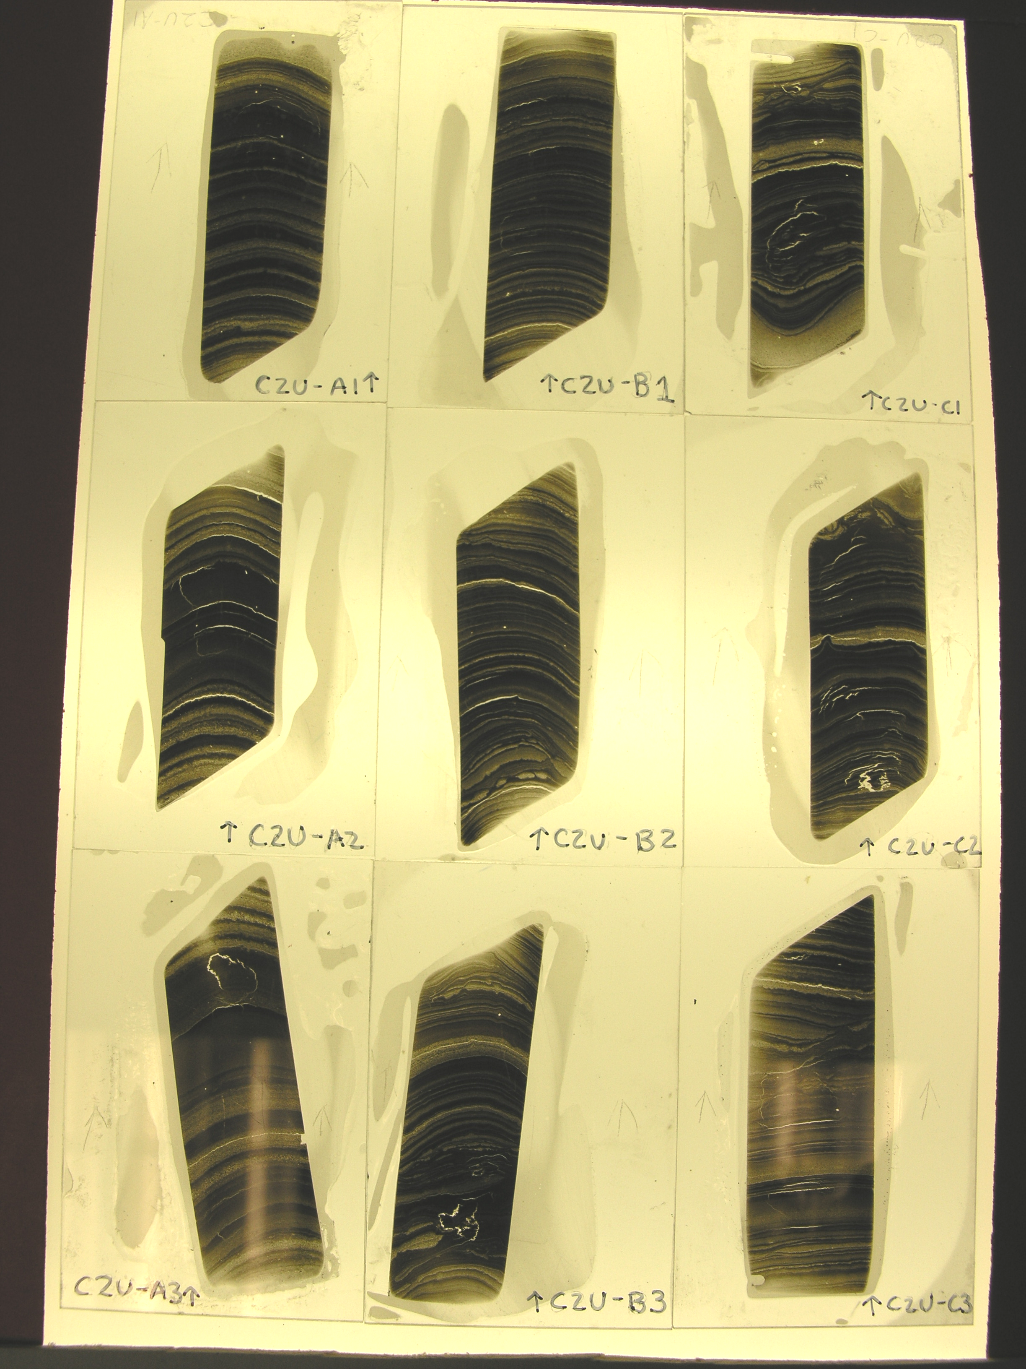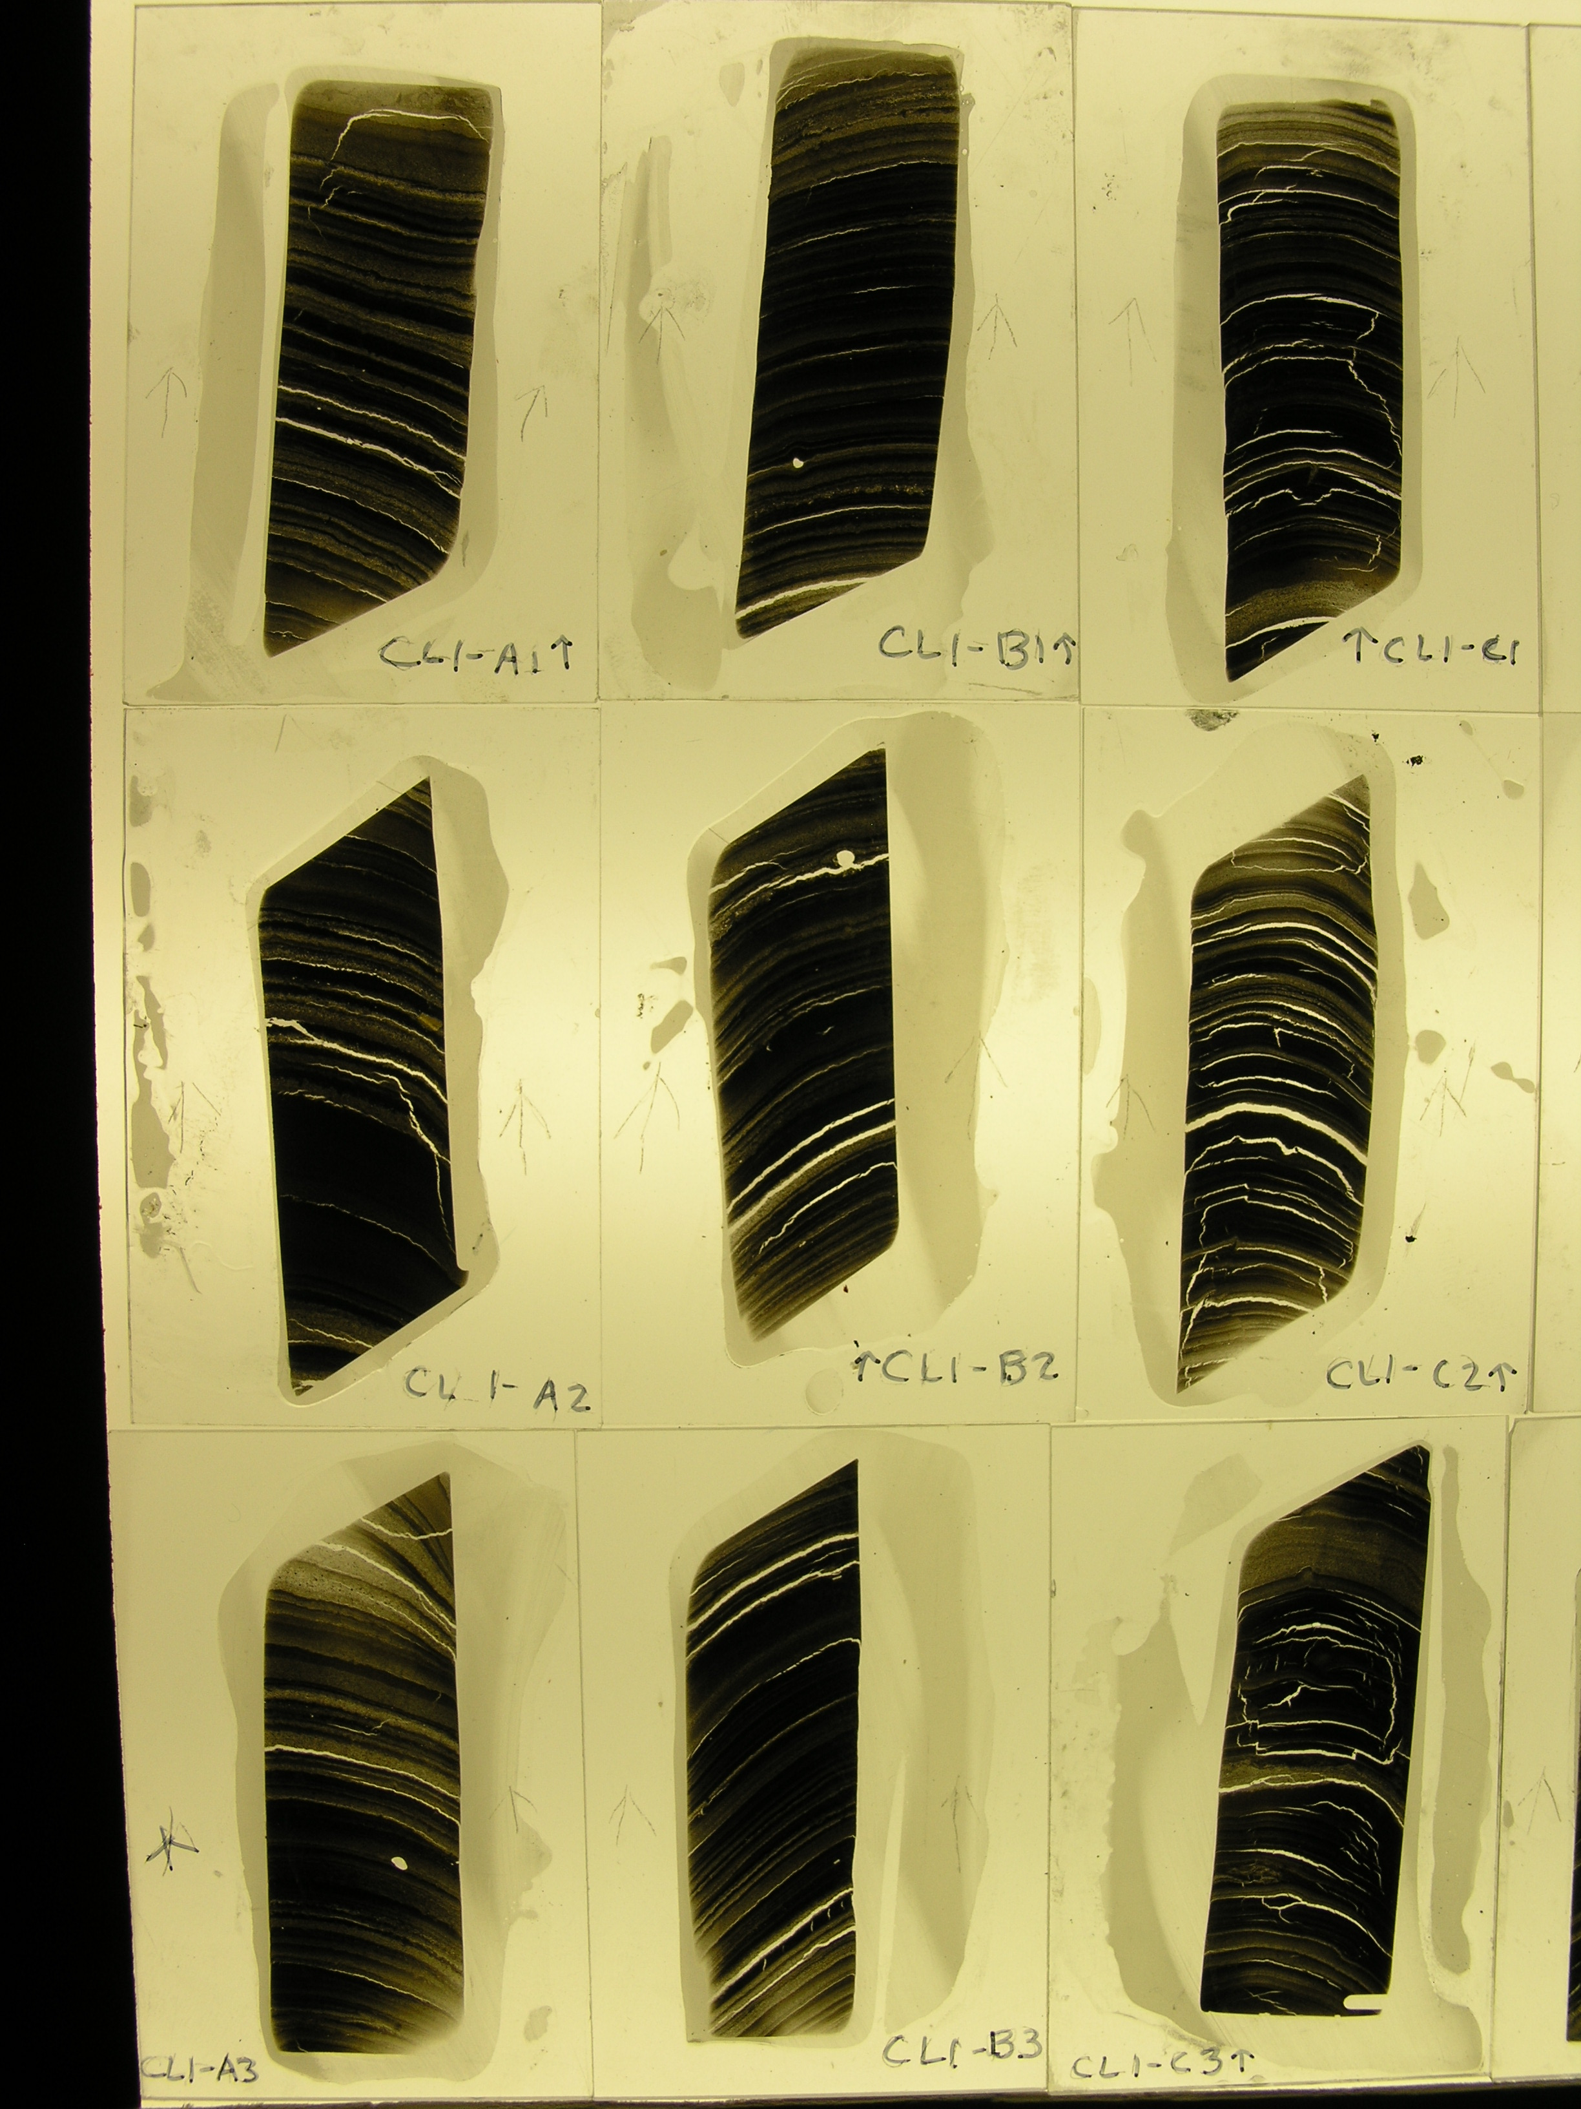
Missing top 1 cm
Short Core
Long Core
Figure 6.1.1. Comparison of thin section scans of the tops of short core C2U-05 and long core CL1-05 demonstrating that the corresponding visual stratigraphy shows only the top 1 cm of the long core missing.

Inter-basin Correlation:
The visual stratigraphy in the top thin sections of short cores from sites C and D were compared for inter-basin correlation and variability. Laminae from the more proximal site are generally thicker than those in the intermediate site D, and is consistent with inferred sedmentation rates based on the isopach map, by Mangerud and Svendsen, 1990 (see previous work.) Despite the variations in thickness, stratigraphy from the two sections can be correlated. The top 5.5 cm of the intermediate core correspond to the top 7.5 cm of the proximal core (figure 6.1.2).
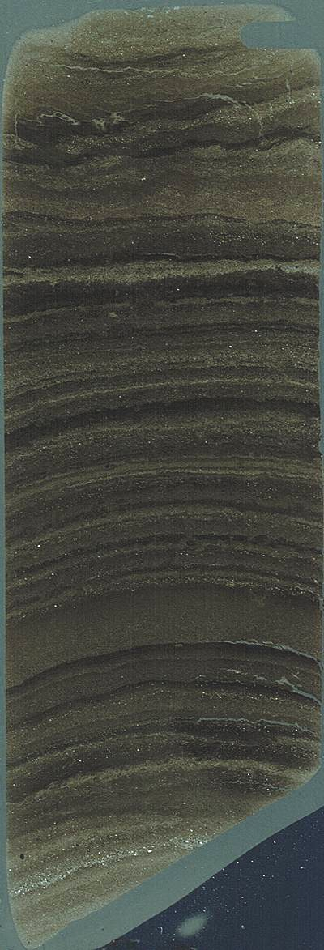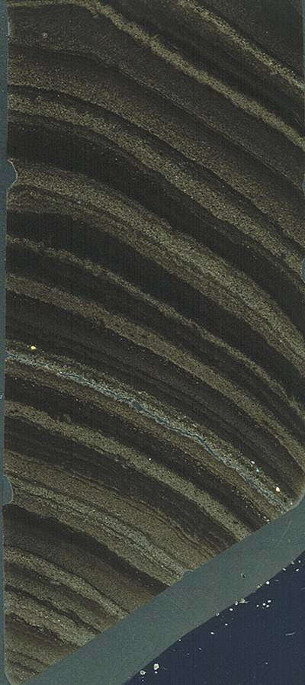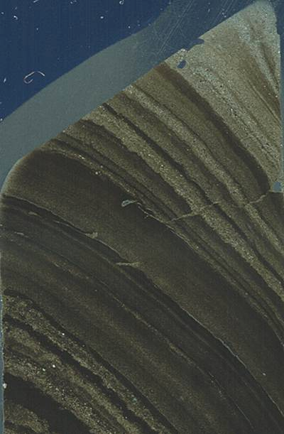
1cm
4cm
3cm
2cm
5cm
6 cm
4cm
3cm
2cm
7 cm
5cm
Intermediate
Proximal
Figure 6.1.2. Comparison of cores from the most proximal site, C and the intermediate site, D. Correlation shows that events occur basin-wide.

This correlation shows that events occur lake-wide and are not unique to sub-basins. Comparisons were not done to cores from site G, as the stratigraphy is about an order of magnitude thinner.
2005 and 1985 Correlation:
The organic carbon content of the long core recovered from site C in 2005 (CL-05) was compared to that of Core 24, recovered in 1985 from approximately the same location (see Previous Work). The amount of sediment lost from the top of core 24 when the core tube overtopped (or the distance to the sediment-water interface) was not recorded, and since 1985, there has been more sedimentation, thus making it impossible to correlate from the tops of the cores. Despite this difference, a correlation was established for the two cores based on peaks and troughs in the organic carbon content down core (figure 6.1.3).
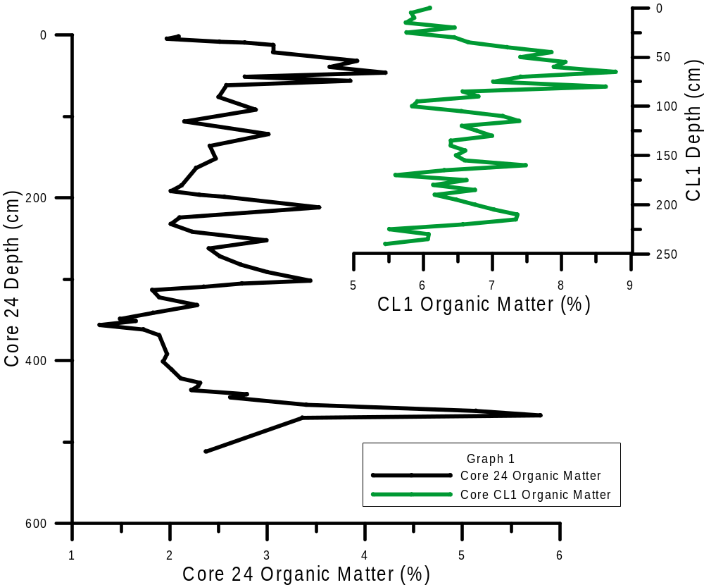
LIA
‘85
‘05
Old Core
New Core

Figure 6.1.3. Organic carbon correlation between the older core from 1985 and the newer core from 2005.

Previous work indicates that the peak in organic carbon, indicative of increased coal, near the tops of both cores is associated with the Little Ice Age (Werner, 1988). With this correlation, that same LIA peak can be inferred on the core from 2005.

6.2 Lamination Counts –Varves
Cesium 137 age control of C2-05 indicates that 18.5 cm depth contains sediment that was deposited in 1963-64. Manual counts and gray-scale analysis identified 42 clay-silt couplets in those top 18.5 cm of C2-05 (Figures, 5.6.3, 5.6.4, 5.6.5., 5.6.6.). Based on the couplet counts and age control it appears that the couplets occur annually and are interpreted as varves. This is supported by sediment trap data from Lake Linné (see previous work.)

6.3 Glacier Mass Balance and Temperature Records
Temperature records from Longyearbyen from 1965 to 2005 show many variations, and when compared to glacier mass balance records from Ny-Alesund of the same time period, correspond to similar variations. For example: Particularly hot summers in Longyearbyen are recorded in 1974, 79, 85, 92, and 98, and troughs (lower mass balance) appear in the glacier records of Ny-Alesund. Conversely, peaks of higher mass balance records appear in 1982 and 87, which occur simultaneously with cold summers in the Longyearbyen record. These two records correspond to weather events simultaneously and theoretically, such events should appear as changes in lamination thickness in the sediment record.

6.4 Correlation of Lamination Changes to Weather and Mass Balance
Varve Thickness was measured for the top 20 cm of C2U based on couplet counts. The silt thickness and clay thickness of each varve was measured to the nearest millimeter. These thicknesses, total varve, clay, and silt, were compared to Longyearbyen temperature and precipitation records from 1967 through 2004, and Ny-Alysund glacier Midre Lovenbreen mass balance records from 1968 through 2005. This assessment evaluated total varve thickness, clay lamination thickness, and silt lamination thickness in relation to glacier mass balance, average temperature and total precipitation for periods: May and June; April, May, and June; June, July, and August; and September, October, November. Of these 30 plots, none of them showed a strong positive correlation, but some suggest a relationship. One of these suggestive correlations was with total varve thickness and JJA temperature, where some of the thick laminae peaks and warmer temperature peaks occurred at about the same time in years, (figure 6.4.1). Another suggestive relationship is that between total annual precipitation and total varve thickness (Figure 6.4.2). When temperature and precipitation anomalies are considered at face value there is some suggestion of a correlation, but it does not seem to be direct and therefore done not graph cleanly. This is apparent in the year 1972 weather records and varve count year 1972: The average annual temperature from 1965 to 1985 is -6.6°C, but in 1972 the average annual temperature was -3.7°C, which may not seem significant, but was the warmest year between 1960 and 1980. This coincides with an anomalously wet year when precipitation blew past its total annual average amount of 191.6 mm per year (1965 – 2005) to reach 317.0 mm, the wettest year on record (1912 – 2005). According to varve counts (Figure XX) the year 1972 is associated with one of the thickest varves documented. The complication arises when 1973 has average values of -6.9°C and 170 mm of precipitation, and 1974 is another anomalously warm and wet year (-3.9°C and 238 mm of precipitation), which do not correspond to varve counts. The varves show two consecutive thick layers corresponding to the years 1972 and 1973. Delayed responses or incorrect varve counts seem unlikely based on previous work and strenuous effort to figure out another way to count the two varves. What seems more likely, and is supported by the two suggestive relationships between varve thickness and precipitation and temperature, is that there is a combination of influences affecting annual sedimentation. While weather events do appear to affect annual sedimentation, they cannot directly account for changes in the sediment record.
Varve, clay lamination, and silt lamination thickness were all compared to glacier mass balance of Ny-Alesund’s glacier Midre Lovenbreen mass balance records from 1968 through 2005 (eg. Figure 6.4.3). This comparison did not show any strongly positive correlations (Figure 6.4.3.)
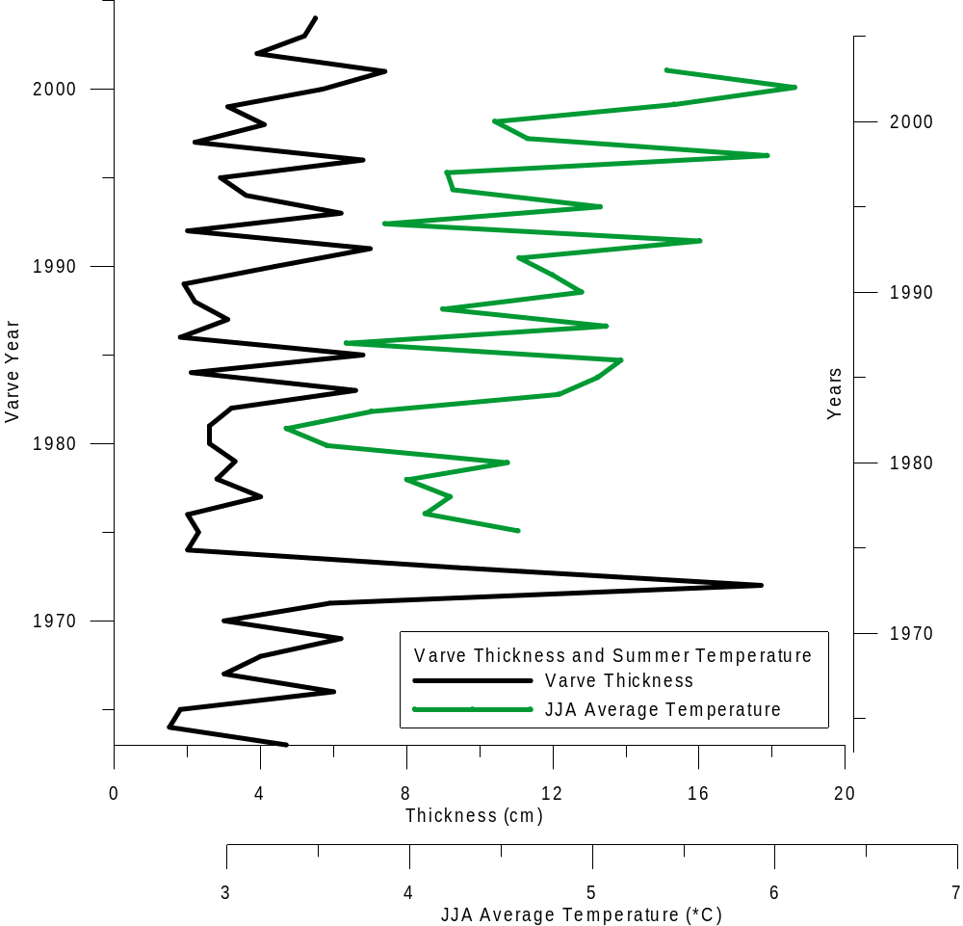
Total Varve Thickness and JJA Ave Temp
Figure 6.4.1. Total varve thickness (black) and June, July, August average temperature (green) comparison.

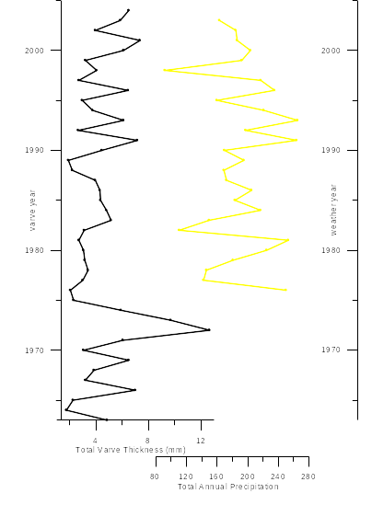
Varve Thickness and Annual Precip
Figure 6.4.2. A correlation between total varve thickness and total annual precipitation is drawn with red lines connecting the corresponding peaks and troughs in thickness and precipitation. Although this relationship appears to be a positive correlation in some places, it does not sustain the length of the graph and therefore other influences (such as temperature, glacier conditions, cloud cover, rate of spring melt, etc.) must be considered, not in replace of but in conjunction with precipitation.
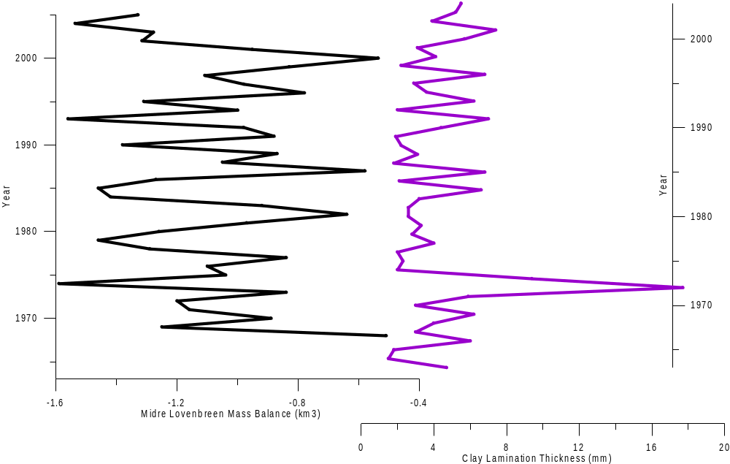
Glacier Mass Balance and Clay Lamination Thickness
Figure 6.4.3. Midre Lovenbreen mass balance vs. C2-05 clay lamination thickness with depth.

6.5 Linné chronology
Based on previous work by Snyder, et. al. and Werner (see previous work) a radiocarbon chronology is available from Core 24, of approximately the same basin as Core CL1-05 that can be applied to CL1-05 based on organic matter and carbonate profiles (Figure 6.5.1). The zone from 31 cm to 85 cm of Core CL-05 is associated with a rise in organic matter that corresponds to the same rise found in Core 24 and associated with the Little Ice Age. This hypothesis that the high organic matter zone (31 cm to 85 cm) is related to the Little Ice Age is supported by the corresponding zone of smaller grain sizes (see Results) and visual stratigraphy which shows a zone of thin clay-rich laminae. This Little Ice Age is also supported by the chronology based on radiocarbon dates applied to Core 24 (Figure 6.5.2) where the calibrated radiocarbon date of 600 calendar years before present (~1400 AD) corresponds to the beginning of the so-called LIA zone (Figure 6.5.2). The Medieval Climatic Optimum can also be approximately identified based on the calibrated radiocarbon ages of 800 and 1200 calendar years before present (Figure 6.5.2.) Also based on the transferred radiocarbon ages, approximate sedimentation rates can be defined as 1.21 mm/year from 250 to 175 cm, 3.73 mm/year from 175 to 95 cm, 1.03 mm/year from 95 to 20 cm.(Figure 6.5.3.) (The sedimentation rate of 4.5 mm/year in the top 20 cm is based on Cesium 137 dates.) The interpretations of this transferred chronology as it applies to the Little Ice Age zone are that sedimentation rates were lower. This combined with other interpretations indicate that not only were sedimentation rates lower, but finer grained sediments were deposited, a lower percent of carbonate was deposited, and a higher percent of organic matter was deposited during the LIA as opposed to other times. Causes for these differences could be related to colder temperatures incurring less melt, longer winters, delayed spring freshette, less glacial runoff, and therefore less sediment being deposited in the lake. Lower carbonate percents could be related to the solubility of carbonate matter increasing with colder temperatures associated with the Little Ice Age. Based on results and interpretations the Little Ice Age appears to have been a major event in Linnédalen’s past.

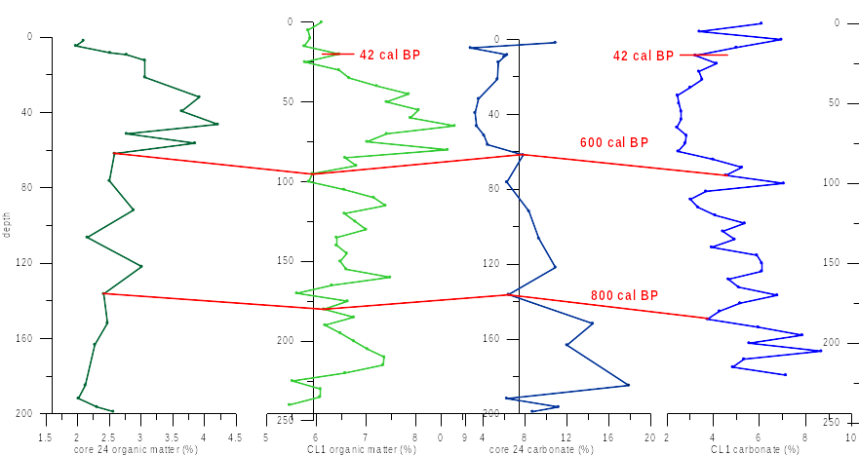
CL1-05 core chronology based on radio carbon
ages of Core 24 and cesium 137 ages
Figure 6.5.1. Transferred chronology from core 24 (far left and second from right) to CL1-05 (second from left and far right) based on organic matter content (left) and carbonate content (right).

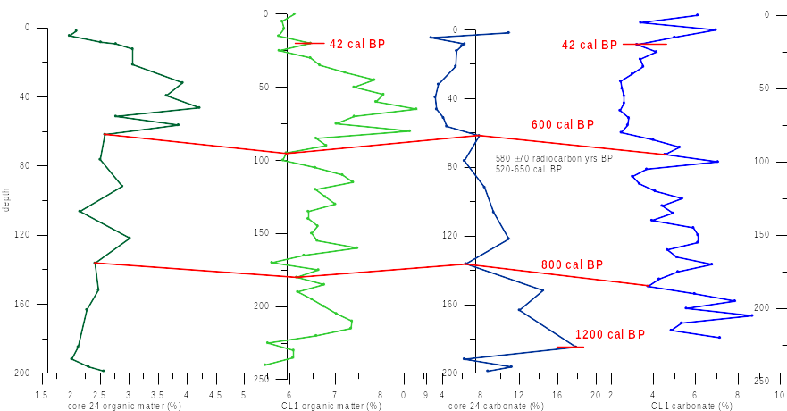
LIA
MCO
CL1-05 Chronology based on Core 24 and Cs 137 ages
24 Organic
CL1-05 Organic
24 Carbonate
CL1-05 Carbonate
Figure 6.5.2. Approximate Little Ice Age (Blue LIA) and Mediaeval Climatic Optimum (Orange MCO) zones identified with the transferred chronology and supported by previous work, visual stratigraphy, and grain size analysis. Calendar years before present shown in red.
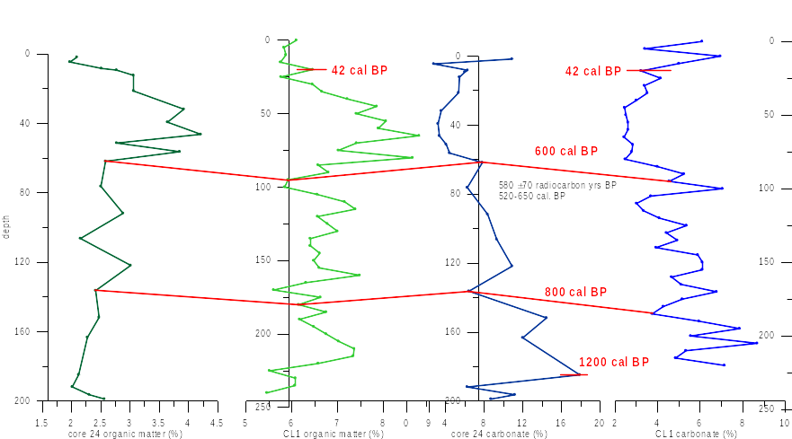
1.03 mm/yr
3.73 mm/yr
1.21 mm/yr
4.5 mm/yr
24 Organic
CL1-05 Organic
24 Carbonate
CL1-05 Organic
Figure 6.5.3. Sedimentation rates based on transferred chronology from Core 24 to core CL1-05 based on radiocarbon ages. Calendar years before present shown in red. Sedimentation rates shown in bold black for associated depths.

7. CONCLUSIONS
Cores recovered from Lake Linné contain clear lamination stratigraphy that can be defined as varves based on cesium 137 dates and sediment trap results. There are three zones in the top 100 cm of the core CL1-05 defined by visual stratigraphy, grain size analysis, loss on ignition carbonate and organic matter content. The top zone from 0 to 31 cm down core consists of thick, silt-dominated laminae, larger average grain size, low organic matter, and high carbonate content. Cesium 137 dating defines 18.5 cm down core at the year 1963/1964, indicating that the top 31 cm are representative of today’s climate. The second zone, from 31 to 85 cm down core, is defined by dark, thin, clay-dominated laminae, high organic matter content, and low carbonate values. The bottom of this zone is associated with 600 calendar years before present, supporting the hypothesis that this zone represents the Little Ice Age. The third zone from 85 to 100 cm down core is similar in characteristics to that of the second zone, but is more orange in color as opposed to the black of the second zone, suggestive of a transition zone. Below 100 cm of core CL1-05 there are no other zones as distinctive, but transferred radiocarbon dates suggest that the Medieval Climatic Optimum occurred at about 130 to 180 cm down core. Based on transferred radiocarbon ages and cesium 137 ages, sedimentation rates are 4.5 mm/year in the top 20 cm, 1.03 mm/year from 20 to 95 cm, 3.73 mm/year from 95 to 175 cm, and 1.21 mm/year from 175 to 250 cm. These sedimentation rates when compared to other results indicate increased sedimentation rates with warmer temperatures, and lower rates of deposition with colder temperatures. This is consistent with zones associated with current conditions, the Little Ice Age, and the Medieval Climatic Optimum.
There is no singular positive correlation between varve thickness and a weather condition, but general associations indicate that increased precipitation and increased temperature result in thicker laminae. This is not a linear correlation. The primary environmental influence on laminae thickness may change over time increasing the difficulty of positively correlating a singular parameter. There is also likely a combination of influences on laminae thickness. Based on this study, both increased precipitation and increased temperature bring increased laminae thickness.

REFERENCES
Ashley, G. M.,1972: Rhythmic sedimentation in glacial lake Hichcock, Massachusetts-Connecticut: Univ. Mass., Amherst, Geology Pub. 10, 148 p.

Boyum, A.; Kjensmo, J. 1978. Physiography of Lake Linnévatn, Western Spitsbergen. Verh. Internat. Verein. Limnol, 20:609-614.

Francus, P.; Asikainen, C.A. 2001. Sub-sampling unconsolidated sediments: a solution for the preparation of undisturbed thin-sections from clay-right sediments. Journal of Paleolimnology, v. 26: 323-326.

Intergovernmental Panel on Climate Change (IPCC), 2001: Climate Change 2000 – Third Assessment Report, Cambridge University Press.

Lamoureux, S.F. 1994: Embedding unfrozen lake sediments for thin section preparation. Journal of Paleolimnology, v. 10:141-146.

Lane, D.P. 2005. Reconstruction of a temperature time series for Linnédalen, Svalbard. Undergraduate Thesis, Atmostpheric Science, College of Agriculture and Life Sciences, Cornell University.

Lotter, A.F.; Lemcke, G. 1999: Methods for preparing and counting biochemical varves. Boreas, v. 28: 243-252.

Mangerud, J., and Svendsen, J.I., 1990: Deglaciation chronology inferred from marine
sediments in a proglacial lake basin, western Spitsbergen, Svalbard: Boreas, v. 19:
249-272.

McKay, N.P., 2005, Characterization of climatic influences on modern sedimentation
in an Arctic lake, Svalbard, Norway. Geological Society of America Absatracts with
Programs, v. 37, no. 1, p. 29.

Motley, B. 2006. Sedimentation in Linnévatnet, Svalbard during 2004-2005: A modern process study using sediment traps. 36th Annual International Arctic Workshop, Poster Presentation.

Nesje, A.; Dahl, S. 2000. Glaciers and Environmental Change. New York: Oxford University Press.

Nesje, A. 1992: A Piston corer for lacustrine and marine sediments, Arctic and Alpine Research, v. 24, 257-259.

Overpeck, J., et. al., 1997: Artic Environmental Change of the Last Four Centuries. Science, 278, 1251-1256.

Pike, J.; Kemp A. 1996. Preparation and analysis techniques for studies of laminated sediements. Palaeoclimatology and Palaeoceanography from Laminated Sediments, Geological Society Special Publication No. 116.

Renberg, I. 1981. Improved methods for sampling, photographying and varve-counting of varved lake sediments. Boreas, v. 10: 255-258.

Ruddiman, W. F. 2001. Earth’s Climate: Past and Future. New York: W.H. Freeman and Company.

Snyder, J.A.; Miller, G.H.; Werner, A.; Jull, A.J.T.; Stafford Jr., T.W. 1994: AMS-radiocarbon dating of organic-poor lake sediment, and example from Linnévatnet, Spitsbergen, Svalbard. The Holocene, v. 4.4, 413-421.

Snyder, J.A.; Werner, A.; Miller, G.H. 2000: Holocene cirque glacier activity in western Spitsbergen, Svalbard: sediment records from proglacial Linnévatnet. The Holocene 10.5, 555-563

Svendsen, J.I.; Mangerud, J. 1997. Holocene glacial and climatic variations on Spitsbergen, Svalbard. The Holocene, v. 7.1, 45-57.

Svendsen, J.I.; Mangerud, J.; Miller, G.H. 1989. Denudation rates in the Arctic estimated from lake sediments on Spitsbergen, Svalbard. Palaeogeography, Palaeoclimatology, Plaeoecology, v. 76: 153-168.

Werner, A. 1988. Holocene glaciation and climate change, Spitsbergen, Svalbard. Unpublished PhD Thesis, University of Colorado.

