USING SEDIMENT GEOCHEMISTRY, PARTICLE SIZE DISTRIBUTION AND REMOTE SENSING TO STUDY PROVENANCE IN THE KRONERBREEN/KONGSVEGEN GLACIERS, WEST SPITSBERGEN, SVALBARD

by

Hector Alejandro Zamora

SUBMITTED TO THE DEPARTMENT OF GEOLOGICAL SCIENCES IN PARTIAL FULLFULLMENT OF THE REQUIREMENTS FOR THE DEGREE OF

BACHELOR OF SCIENCE WITH HONORS
AT THE
UNIVERSITY OF TEXAS AT EL PASO

JASPER G. KONTER, FACULTY ADVISOR

JULIE BRIGHAM-GRETTE, UNIVERSITY OF MASSACHUSSETS
AND
ROSS POWELL, NORTHERN ILLINOIS UNIVERSITY,
PROJECT ADVISORS

MAY, 2010

I. Abstract
Sediment provenance at the Kronerbreen/Kongsvegen glaciers in Spitsbergen can be used to understand the effects that climate change can have on the sedimentation in fjords, and streams at northern latitudes. These sediments are directly related to glacial processes and reflect the conditions under which they formed. Such conditions are sensitive to global climate change, which is amplified in northern latitudes, creating a unique environment for climate change research.
Quantitative provenance studies have never been carried out in the Kongsfjorden before, and can provide data for a better understanding of glacial processes and dynamics, and changes in erosional conditions. Particularly, sedimentation rates and sediment grain size distribution can help unravel the glacial history of the area. This study will focus on analyzing the grain size distribution of the material being deposited by the mentioned glaciers and finding the source rock of these sediments. Fine sediment was transported by streams and upflows identified in the field, and fed by the glaciers melting ice. On the other hand, coarser material ranging from cobble to boulder size was deposited by ice, moraines, and alluvial processes.
Sediment and rock samples were collected during the months of July and August 2009, along the terminus of the glacier, and in the surrounding areas, respectively. Grain size analysis was performed on the samples using a Malvern Mastersizer with the resulting in different groups showing a change in particle size and sorting depending on the location along the glacier. This analysis is important as mineral composition and transportation is influenced by grain size.
Electron microprobe studies were carried out on sediment grains to obtain a rough compositional profile of the sediments, and a first-order mineralogical make-up. The microprobe results provided us with information about composition of some of the minerals present, based on the content of Fe, Ca, K and Al derived from the erosion of the local lithologies. Chemical composition can distinguish sediments derived from different sources, and may ultimately be compared with representative rock samples taken from the moraines.
Due to the limited accessibility to some areas, many geological units in the Kongsfjorden area have not been mapped or studied, limiting the possible comparisons with contributing material to the fjord’s seafloor. Remote sensing techniques were used to map lithologies in previously unmapped regions using ENVI®, and ASTER satellite imagery. A GER 3700 radiospectrometer was used to collect spectral properties of the rock samples. These properties were compared to the outcrops in the satellite imagery giving us an idea of the bedrock composition of the area.
The results of our research can be compared with future studies in order to obtain information, regarding responses in the glacier dynamics and processes, related to climate change.

II. Acknowledgements
I would like to thank the UTEP Geology Department for the help and support I have received through these years. It was a privilege and a marvelous experience for me to be a student of this department, which has given me the tools to open new doors in my life, and to keep pursuing my goals.
I’m especially thankful to Julie Brigham-Grette and Ross Powell who selected me and gave me the opportunity to work on this exciting project. It was an experience that changed my life, and reaffirmed my love for the earth sciences. I would like to thank my field mates Laura Poppick, Hannah Marshburn, Laura Kehrl, Phaedra Tinder, Theodore Barnhart and Mike Rhinard for the great times and adventures I shared with them since we met. It was a privilege for me to have the opportunity to work with such a brilliant group of people.
The Pathways Research Experience for Undergrads program provided me with the equipment and tools necessary for my project. I would like to thank Tina Carrick and Aaron Velasco for the opportunity to take part of this wonderful program as well as for the support and motivation given to me during the hardest times. To my mentors Jasper Konter and Richard Langford that guided me through this process, and illuminated me with their wisdom and dedication for their work which I highly respect.
Finally, I would like to thank my friends Christina Hernandez and Tony Alvarado for their unconditional friendship and support and for the marvelous experiences we have shared in the field during these years. Funding for this project was provided by the National Science Foundation Research Experience for Undergraduates (REU) program under grant 0649006.
Table of Contents
I. Abstract
II. Acknowledgements
III. List of Figures
- Introduction
  - Physiography
  - Oceanography and climatic setting
  - Geologic setting
  - Glacial history of Kongsforden
  - Sediment sources to Kongsfjorden
  - Sediment provenance studies
2. Field Methods
2.1. Sediment and rock sample collection
2.2. Sample location identification and storage
3. Laboratory Methods
3.1. Remote sensing
3.1.1 ASTER
3.1.2 Data processing
3.2. Laser diffraction particle analysis
3.3. Electron microprobe analysis

4. Results
4.1. Remote Sensing
4.2. Laser diffraction particle analysis
4.3. Electron probe microanalysis
5. Discussion
5.1 Remote Sensing
5.2 Laser diffraction particle analysis
5.3 Electron probe microanalysis
6. Summary
7. Works Cited
8. Appendices
I. Location of collected samples (lat/long)
II. Weights collected with different sieves
- Dry weights of samples
- Results obtained for laser diffraction particle analysis

III. List of figures

Figure Page

1. Location of Kongsfjorden and Ny Alesund in Svalbard 10
2. The Kongsfjorden, surrounding areas and glaciers 11
3. The East and West Spitsbergen Currents 13
4. Norsk Polarinstitutt geologic map of the area 15
5. Main sources of sediment into the Kongsfjorden (aerial view) 18
6. Kongsfjorden bathymetry 19
7. Ekman coring during field work days 23
8. Location of samples collected along the fjord 24
9. Samples used for microprobe analysis 31
10. Results for ASTER Band2 / Aster Band1 ratio 34
11. Results for Carbonate Index 35
12. Results obtained using bands 9, 8, and 7 37
13. Results for laser diffraction grain size analysis 39-40
14. Interpretation of microprobe results 41

1. Introduction

This study is part of a bigger Research Experience for Undergraduates taking place in Kongsfjorden, Svalbard. The whole research objective is to understand how the sedimentation in the high latitude glaciers is affected by climate variations and ice dynamics. The provenance or origin of sediments was studied using samples collected from the Kongsfjorden depositional basin that is fed by two tidewater, polythermal glaciers Krobebreen and Kongsvegen. These sediments are directly related to glacial processes and reflect the conditions under which they formed. Such conditions are sensitive to global climate change, which is amplified in northern latitudes. Provenance studies can provide data for a better understanding of glacial processes and dynamics, and changes in erosional conditions. Particularly, sedimentation rates and sediment grain size distribution can help unravel the glacial history of the area. This study will focus on analyzing the grain size distribution of the material being deposited by the two glaciers and finding the source rock of these sediments.

1.1. Regional Setting

Our study area was located in the Kongsfjorden, located near Ny Alesund, Svalbard, Norway, one of the world’s northernmost settlements situated at 78° 55´ N, 11° 56´ E. Ny Alesund is located on the west coast of Spitsbergen, the largest island of the Svalbard archipelago (Figure 1). Kongsfjorden extends about 20 km into the Spitsbergen Island, and it varies in width from 4-10 km long (Figure 2). The fjord is usually divided into an inner, a central, and an outer fjord basin Water depth increases from less than 100 m in the inner section to deeper waters in the central and outer parts of the fjord (Howe et al. 2003), and the total estimated volume is about 29.4 km³ (Ito & Kudoh, 1997). Kongsfjorden is a depositional basin surrounded by tidewater glaciers, including Kronebreen, Kongsbreen and Kongsvegen on the eastern side of the fjord, and Conwaybreen and Blomstrandbreen in the northern side of the fjord (Figure 2). Tidewater glaciers can be described as ice masses with marine margins grounded below sea level, and in Svalbard they cover about 1000 km or 20% of the coastline (Dowdeswell, 1989). According to Liestol (1989), an area of 1013 km² is covered by the glaciers draining into Kongsfjorden. Most of the glaciers in the area have been classified by Lefauconnier & Hagen (1991) and Hagen et al (1993) as polythermal having a temperature above the freezing point throughout most of the year, except during summer melting season, and a basal layer of temperate ice where melting occurs. Of those glaciers, 80-90% of them are considered as surge type glaciers. In a surge–type

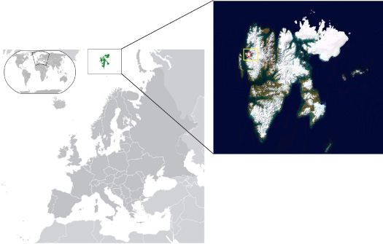
Figure1. Left: Svalbard Location.
Right: Kongsfjorden, and Ny Alesund Location (LandSat, 2001)
the Kongsfjorden

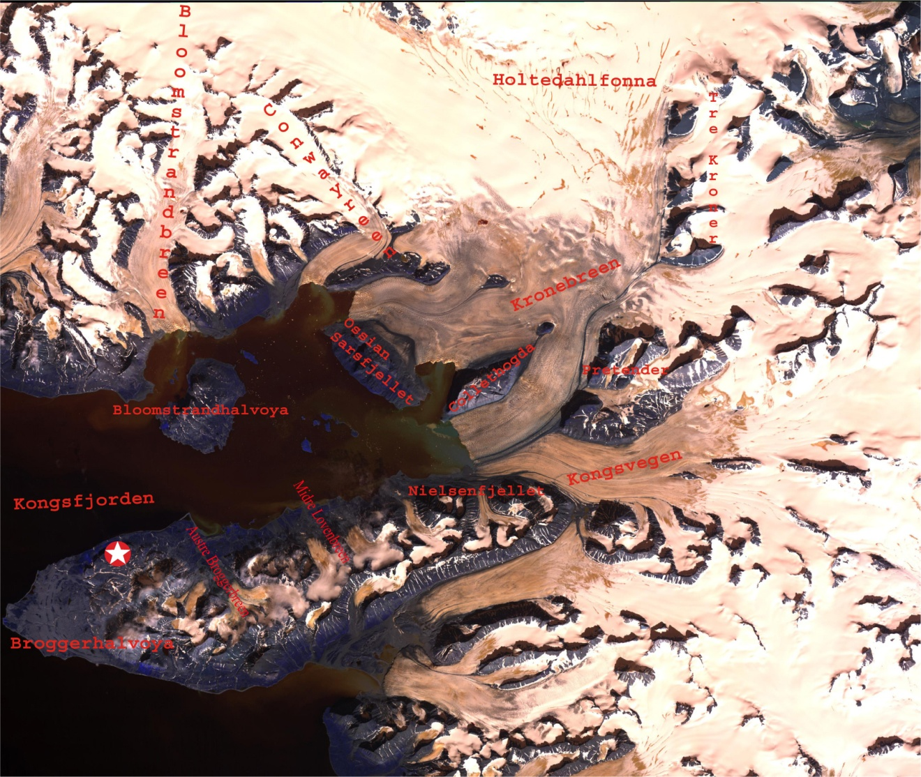
glacier in quiescent phase, accumulation of ice is drastically larger than the ice flux. This causes a gradual increase in the surface gradient and basal shear stress, and when a critical (unknown) value of shear stress has been reached sliding increases rapidly and results in a surge (Svendsen, 2002). On the southern side of the fjord, two small cirque glaciers are found, Austre Broggerbreen (5 km ²) and Midre Lovenbreen (6 km ²) (Figure 2). Our study focuses in the Kronerbreen and Kongsvegen glaciers that enter the fjord from the east. Kronerbreen is a fast-flowing active glacier divided by a topographic high (Collethogda; Figure 2) into two separated calving fronts reaching estimated velocities of 700-800 m/a (Melvold, 1992), and a calculated calving rate of 0.25 km³/a (Leffauconnier et al, 1994). Kongsvegen, a surge-type glacier, has an ice flow velocity of less than 4 m per year along the entire basin where transportation of accumulated precipitation into the ablation area is minimal causing the glacier to build up into what seems to be a new surge event (Melvold & Hagen 1998). Like other glaciers in the area, glaciers in the Kongsfjorden area are retreating at rates of between zero and 300 m per year with an average of 200 m per year as calculated by Lefauconnier et al (1994).
Figure2. Kongsfjorden, Ny Alesund, and adjacent areas using an ASTER image

1.2. Oceanography and climatic setting
Svalbard is located between 76°N and 81°N (Figure 3). About 60% of the 63,000 km² total area is glacially covered (Hjelle, 1993) and is dominated by a maritime Arctic climate. The western side of Svalbard is influenced by the West Spitsbergen Current (WSC) (Figure 3), which is the northernmost extension of the Norwegian Atlantic Current, and provides a milder climate and ice free conditions due to the movement of warm and more saline Atlantic waters along western Spitsbergen (Aagard et al. 1987,
Gascard et al.1995). Temperature of the Atlantic waters in the WSC has increased in the recent years while the Arctic ice extent has been diminished (Vinje, 2001). Svenden et al. (2002) have linked these changes to changes in the atmospheric circulation towards north-western Europe, which are directly related to an increased North Atlantic Oscillation (NAO) index, which refers about the air pressure variation between the Icelandic low and the Bermudas/Azores high. The eastern side of the archipelago is affected by the East Spitsbergen Current (Figure 3). This current brings cold water and ice from the pole, therefore bringing colder temperatures to the eastern side of the archipelago. The climate of Svalbard can be described as being potentially influenced by different factors such as the atmospheric general circulation, variation in light conditions during the year, extent of arctic sea ice and ocean currents (Svendsen et al., 2002). The annual average temperature is about -4°C, and summer temperatures can reach an average of 4°C with the highest measured temperature in Svalbard being 21.3 °C, and the lowest -46.3°C (NPI Webpage). Annual precipitation varies from east to west as well. When mild maritime air is transported by advection over colder surfaces, low clouds develop and have the potential to cover the area for several days limiting visibility and bringing with them light showers. Precipitation ranges from about 300-400 mm with a maximum precipitation rate of 1000 mm in the west side of the archipelago, and this consists mostly of light snow and rain, typically, falling during the summer and fall months. Precipitation in the east side of the archipelago is very low when compared to the west side of the island with only 10mm per year (Harland, 1997). Katabatic winds transporting cold air from the inland glaciers into the fjord were observed to have a direct effect on the weather of the area by drastically changing the conditions in the area from relatively warm into colder temperatures in a short period of time.
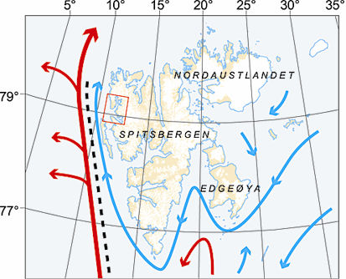

Figure3. Svalbard main currents, Red: WSC, Blue: ESC. NPI Property
1.3. Svalbard Geology
The area surrounding Kongsfjorden is situated between a Tertiary fold-thrust belt that extends across western Spitsbergen, and the Northwestern Basement Province, which lies to the north-east (Bergh et al., 2000)(Figure 4). Svalbard has drifted by the motion of tectonic plates and geological processes from the South Pole, where it was located during the Precambrian, in a northerly direction, and it reached its present location in the Tertiary. Throughout its history the archipelago has been subject to different orogenies and climatic conditions that have been recorded in the fossil and rock diversity of the area. The oldest till deposits found are 600 Ma old and these were deposited when Svalbard was found in the South Pole (Ingolfsson, 2005). Proterozoic-Silurian rocks form the so- called basement rocks of the area. Such rocks are composed mainly of medium-grade metamorphic marble, mica-schist, phyllites and quartzites product of different orogenies that the Svalbard crust was subjected to, including the Caledonian Orogeny, which occurred when Europe and Greenland converged (Hjelle, 1998). These rocks are found in the northern side of the Kongsfjorden, and over Broggerhalvoya (Figure 3). Svalbard continued to move towards the north, and between 350-400 Ma during the Devonian, the archipelago was located just north of the equator (Ingolfsson, 2005). Earlier formed mountains started to erode under dry, desert like conditions as can be inferred from the red bed sandstones and conglomerates found in the north-central Spitsbergen. Devonian conglomerates and sandstones are characterized by their red, brown or orange color. These rocks are currently exposed on the island of Blomstrandhalvoya, the Broggerhalvoya peninsula and the area surrounding the upper eastern flank of the Kongsfjorden (Figure 4). During the Carboniferous and the Cretaceous, Svalbard drifted from the equator to 45°N (Thomas, 2005; Ingólfsson, 2005).
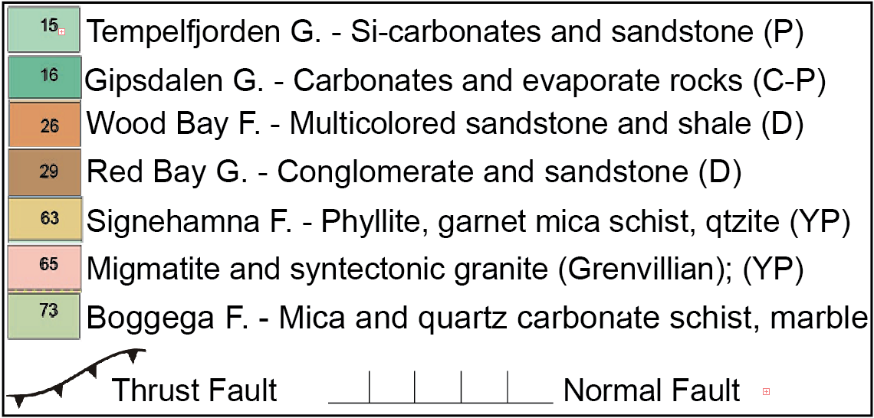
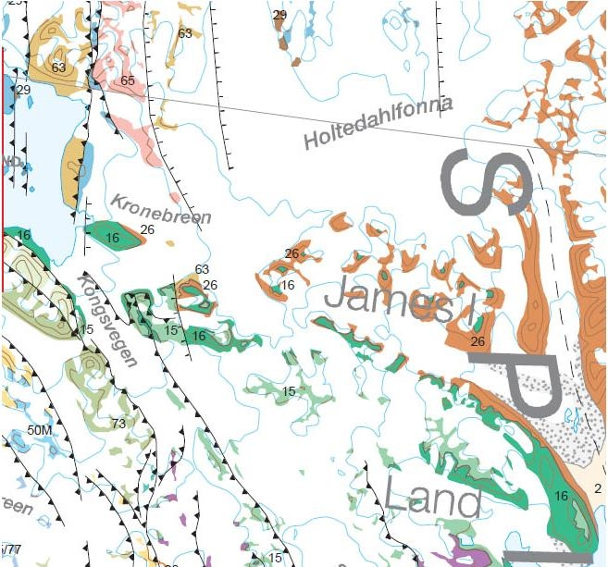

Figure4. Kongsfjorden Geologic Map, courtesy and property of NPI

Limestone and chert of this age cover the eastern lower reaches of the Kongsfjorden (Harland, 1997) (Figure 4). During the Tertiary, Norway drifted apart from Greenland, forming the Norwegian Sea, then, Svalbard collided with Greenland causing folding and faulting seen today in most of northwestern Spitsbergen (Hjelle, 1998). Svalbard acquired its present location near the end of the Tertiary, and glaciation in the area started around this time (Ingulfsson, 2005). In summary, based on the geologic description of the area, we can say that three groups of rocks predominate in the area: quartz rich sedimentary rocks, carbonates, and low/medium grade metamorphic rocks such as schist and phyllite.

1.4. Glacial history of Kongsfjorden
The glacial history of the area has been studied extensively by a number of research groups (Svendsen, 2002; Forman, 1987). Glacial activity and ice movement have strongly influenced and shaped the landforms around Kongsfjorden which is characterized by jagged peaks, fjord systems, and raised beaches. Glaciation in the area has been recorded by tillites dating from the Proterozoic, when the area was located in the South Pole. Current glaciation in the area started around the Tertiary and it was during the Late Weichselian, 13,000 yrs BP, when the last glacial maximum in western Spitsbergen occurred with all the glaciers terminating at sea (Thomas, 2005). Forman (1987) suggests a two-step deglaciation process on Svalbard at the end of the Weichselian as it can be inferred from radiocarbon-dated whalebones collected from raised beaches in the northern side of Broggerhalvoya. Broggerhalvoya (Figure 2) records a rapid emergence due to isostatic rebound after 10,000 yr B.P. All the glaciers had begun to retreat during the early Holocene (9500 yrs BP) and the region was ice-free until 4500 yrs BP, when maximum Holocene ice extent was reached during the Little Ice Age (Svendsen et al, 2002). Since about 1900 retreat has been almost continual for the local glaciers. Although different periods of glaciation and retreat have been influenced the glaciers’ extension, certain glaciers might be independent of glacial advances or retreats, and their maximum extent might be product of surge dynamics as is the case of Kongsvegen. Kongsvegen’s last surge occurred in 1948, but the glacier seems to be in the process of building a new surge event.

1.5. Sedimentation and depositional processes

Kronebreen and Kongsvegen are described as having a glaciomarine depositional environment where glacially transported sediment settles in proximal and distal basins (Howe, 2003). Based on field work investigation and aerial photos, three main systems of sediment transportation and deposition were identified and were considered as the main suppliers of sediment into the fjord (Figure 5). These include an ice-marginal stream and an upwelling, product of melt-water, and ice-rafting. An ice-marginal stream was located in the southern side of Kongsvegen. An ice-marginal delta has been building up since first observed in 1990 possibly due to the retreat of Kongsvegen back onto land. Product of submarine meltwater discharge, sediment deposition, and medial moraine dumping at the former Kongsvegen tidewater terminus, the delta (Figure 5) could have originally formed as a grounding line fan that developed over time by accumulating sediment and eventually aggrading above sea level (Trusel et al., 2009). Kongsvegen flows mainly over “basement” formations eroding Proterozoic mica-schist, phyllyte,
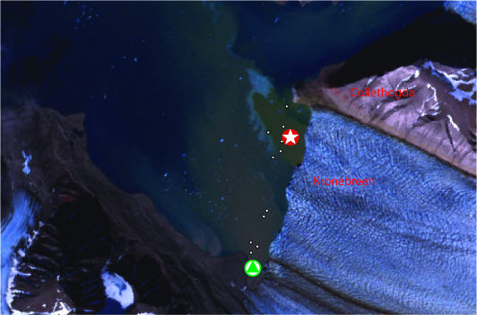
Figure5. Sediment sources 1: Triangle: ice-marginal stream location, Star: upwelling location, using an ASTER image

quartzite, metamorphosed carbonates, and Carboniferous limestone. The second depositional system is found in the north side and consists of a submarine turbulent jet with the capability of carrying high concentrations of sediment. This upwelling system is the primary meltwater source delivering sediment to Kongsfjorden from Kronebreen producing a distinct stratified water column and is easy to identify due to the red coloration present in the water that flows into the surface. This red to brown color is product of the erosion of Devonian sandstones, siltstones and conglomerates formations present in the upper eastern side of Kronebreen over which the glacier flows. Every year, over 2 million tons of sand, mud, and gravel are estimated to be carried by meltwater and deposited into the inner basin, providing us information about the intense glacial erosion present in the area (Hjelle, 1998). As could be expected, areas adjacent to the glaciers are experience the highest sedimentation rates and decrease as we move away from the glacier front where sediment input is lower (Howe et al. 2003). This can be observed as well in the bathymetry study realized by Kehrl (Figure 6). Lastly, icebergs can carry material of different sizes ranging from clay to boulders into the fjords. Ice rafting and entrain of sediment during grounding and scouring are some of the processes that can potentially be present by iceberg deposition of sediment. As mentioned in previous studies (Glasser, 2001), iceberg sediments can be used to sample beds that otherwise would be inaccessible and above which modern tidewater glaciers flow. The iceberg debris found in the Kongsfjord consists mainly of clast-poor or clast-rich diamicton and have been interpreted by Glasser and Hambrey as basal sediment on the basis of the sediment texture (diamicton), clast shape (subangular/subrounded), and clast features (striations) with the most common lithologies being sandstone, cherty limestone, siltsone, schist, quartzite, microgranite, gneiss and marble.
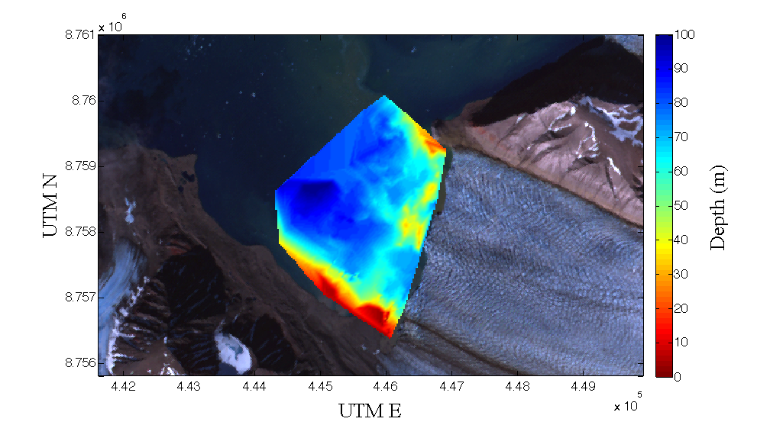

Figure6. Inner Kongsfjorden 2009 Bathymetry courtesy of Laura Kehrl
1.6 Sediment provenance studies
Provenance analysis of sediments can be used to reconstruct the climatic-physiographic conditions to which sediments were exposed to when they formed, to reconstruct the parent-rock assemblage and to quantify the relative contribution of sediment into drainage basins systems (Weltje, 2004). In the Kongsfjorden, quantitative provenance studies can provide data for a better understanding of glacial processes and dynamics, and changes in erosional conditions. Particularly, sedimentation rates and sediment particle size distribution can help unravel the glacial history in the area. In the Arctic, where changes due to global climate change are expected to be specially amplified, the understanding of modern sedimentary processes becomes essential to evaluate the potential ramifications of environmental disruption (Viscosi-Shirley et al, 2003). Previous provenance studies have been used in the Arctic before to track sediment transport, ice-rafted debris dispersal, or the movement of particle-reactive contaminants (Viscosi-Shirley et al, 2003), to monitor changes in production locations and drift patterns of turbid ice sea (Pfirman et al, 1990; Dethleff et al, 2000), and to interpret paleoclimates. Different methods have been used to determine provenance and some of them include heavy mineral counts (Hussain, et al., 2004; Yu et al., 1997), pebble counts (Frisch et al., 1997), isotope ratios (Frumkin and Stein, 2004; Schwartz and Gromet, 2004) and magnetic susceptibility (Hoogakker, 2004; Vlag, 2004; Thomas, 2004). Modern techniques to study provenance include geochemical and particle size analysis. X-Ray Diffraction (XRD) and Inductively Coupled Plasma Mass Spectrometer (ICP-MS) are two techniques used to measure the major, trace, and rare-earth elements in a sample. Although these techniques are highly reliable, sample preparation might take several weeks, and requires the crushing, powdering and dilution of the rock or material to be measured (Weltje, 2004). Sediment provenance studies are complex and many parameters have to be taken into account when this kind of study is being carried. The contribution of similar material from different lithologies, mixing of sediment from different sources prior to deposition, and the sorting of particles after the breaking down of rock by mechanical and chemical processes are likely to affect the final product. Specially, sorting of particles might lead to a preferential enrichment of specific materials in certain grain-size fractions making grain-size analysis an important factor to realize as sediment composition tends to be a function of grain size (Weltje, 2004). While unstable minerals including feldspars and mafic minerals (e.g. pyroxene, biotite) are likely to be depleted by weathering processes, stable minerals such as quartz, zircon, and clay minerals are enriched. Our provenance study included remote sensing technique, particle size analysis, and geochemistry methods in order to measure the major and trace element compositions. Sediments derived from different sources can be identified based on their chemical composition, and may ultimately be compared with representative rock samples taken from the moraines. Our results will help us to interpret the contribution of different lithologies and transportation/deposition processes, and can be used as a basis for comparison for changes in geochemical composition in future studies in the area.

2. Field Methods
2.1 Sediment sample collection
Field work took place during the 2009 summer season, starting July 18th and ending on August 15th. Two sediment source streams were identified during field exploration. One of these sediment sources consisted on an ice-marginal stream on the southern side of Kongsvegen glacier (Figure 5) depositing mainly eroded low-medium grade metamorphosed material. The second source consists of a meltwater submarine upwelling located in the north side of Kronebreen (Figure 5). Our sampling tool consisted on an Ekman box-corer (Figure 7.) attached to a wire and a winch system. The purpose of using the Ekman box-corer was to grab a sample of the top layer of modern sediment being deposited into the fjord. Sampling procedure consisted in deploying the corer into the fjord at the appropriate place. Extra weight was added on the box-corer to stabilize it in the turbid currents flowing at the bottom of the fjord and to be able to reach the seafloor faster. The box was attached to a 200 M steel wire with 1 meter marks on the whole length of the wire, and the wire was coiled into a winch system that was used to deploy and bring back the box-corer. When the box corer reached the seafloor, a 10-cm steel messenger was sent through the wire line. The messenger would then hit the upper part of the box core where the closing mechanism was located in order to close the formerly open jaws at the bottom of the box, and obtain the upper sediment layer. Finally, the instrument was carefully brought to the surface and the sediment was carefully collected. Samples were obtained from along a transactional section parallel to the glaciers termini as this would help us to determine how the sediments from different sources mix in the drainage basin.
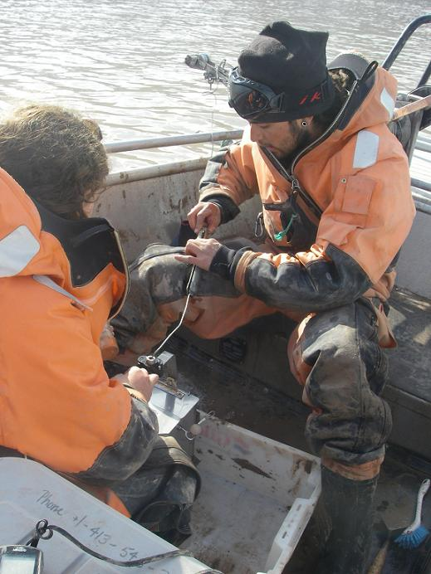
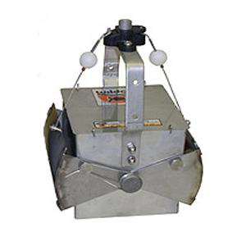

7. Ekman box coring during field work

Although extensive efforts to collect samples at equidistant intervals along the face of the glacier, and at a close but still safe distance from the calving front were made, it was almost impossible due to the strong currents and wind conditions in the work area. Samples were collected in a range of 200 to 700 meters from the calving front. Samples collected consisted mostly of clay and silt sized particles, although a sandy fraction was present in some of the samples. Figure 8 shows the exact location of every sample collected from the bottom of the fjord. Rock samples were collected from three different locations in the area: Nielsenfjiellet, Collethogda, and Ossian Sarsfjellet (Figure 2). These samples were picked up from morainal deposits as these could be carried from the same place where sediment is being eroded by the glacier. Every rock sample was labeled and stored in three different containers according to their location.
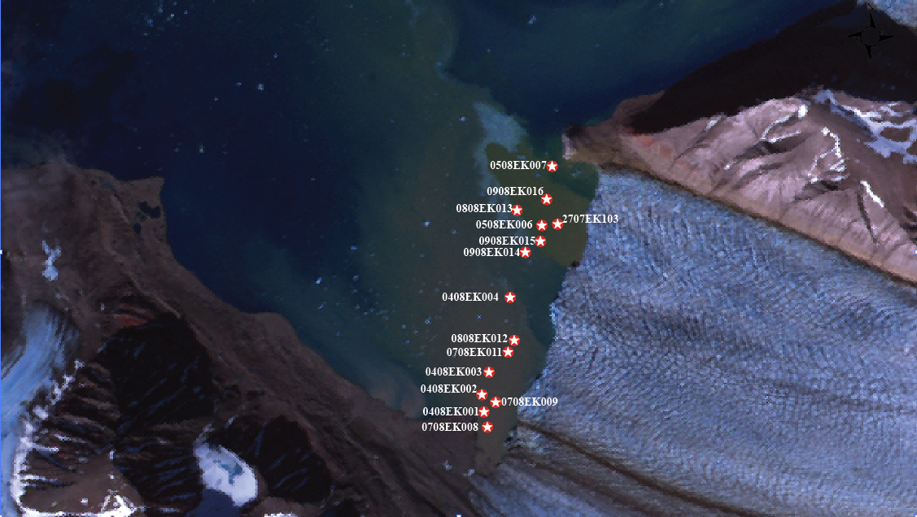
8. Ekman samples locations over ASTER image

2.2. Sample Identification and Storage
Although, a reasonably high number of attempts were tried in order to collect a stratified sample of the modern sediment, the amount of material obtained with the use of the Ekman box corer was usually not enough to make use of a core liner. The sample obtained was appropriately placed in a Ziploc bag and marked with a label that included the date when it was collected, and a GPS reading was taken for every sample collected. After the daily collection run, all the samples were taken to the lab facilities in Ny Alesund. Samples were weighed, set to dry at room temperature for two to three days, weighed again, and repacked inside three Ziploc bags each with its own label to prevent them from leaking. A database containing the sample name, GPS location, and brief description was made. Table 1 lists the samples that were collected in the area and their GPS locations. Samples were sent to The University of Texas at El Paso where they are currently stored.

3. Lab Methods
3.1. Remote Sensing
Although extensive geologic work has been done in the area by the Norwegian Polar Institute, a geologic map for certain areas near the Kongsfjorden has not been published. Remote sensing has recently become alternative approach to explore the geology of inaccessible areas. It is possible to use remote sensing in order to investigate the distribution of rock types in areas where no geologic data exists, and which might contribute material into the depositional basin. The application of remote sensing technology for geologic mapping has been around for some years proving to be successful in other parts of the world (e.g. Hook et al., 1994). Based on the work of previous research in similar areas of difficult access (e.g. Hurtado, 2002), we applied various interpretative tools to a region where the geology is well-known and to access the reliability of extrapolating the geology into adjacent, less well-known areas (Hurtado, 2002). Multispectral (several spectral bands) and hyperspectral (many spectral bands) remote sensing sensors are capable of collecting data in many different wavelength regions that are outside the visible spectrum for the human eye, and the chemical composition of different minerals can be easier to distinguish from the data obtained by such sensors using reflected sunlight (Perry & Vincent, 2009).

3.1.1 ASTER
Two ASTER high spatial resolution images where used in our study to cover the area of interest. The Advanced Spaceborne Thermal Emission and Reflection Radiometer (ASTER) is onboard the Earth Observing System (EOS) TERRA platform where it records solar radiation in 14 spectral bands. ASTER measures reflected radiation in three bands between 0.52 and 0.86 micrometers (VNIR) and in six bands from 1.6 to 2.43 micrometers (SWIR), with 15- and 30-m resolution respectively. In addition, emitted radiation acquired at 90-m resolution is measured at 90-m resolution in five bands in the 8.125-11.65 micrometers wavelength region (TIR). The swath width is 60 km, but ASTER’s pointing capability extends the total cross-track viewing capability to 232 km (Fujisada, 1995). Remote identification can be performed using the different reflectance/absorbance and emissivity spectra displayed by different geologic materials (Hunt, 1980). While absorption features of transition metals, especially iron and some rare-earth elements (REE) can be obtained using the three VNIR bands (Hunt, Salisbury, & Lenhoff, 1972; Rowan, Kingston, & Crowley, 1986), characteristic molecular absorption features are displayed by carbonate hydrate and hydroxide minerals in the six SWIR bands (Hunt, 1977), but other important minerals such as quartz and feldspar will display fundamental molecular absorption in the TIR region only (Hunt & Salisbury, 1976; Lyon, 1964).

3.1.2. Data processing
During this study data analysis was carried out using the ENVI image analysis software. Our objective was to map the sandstone and limestone that are found in the east side of the Kongsfjorden as observed during field work and by collected samples. Spectral properties of actual rock samples were collected using a GER 3700 Radiospectometer with a range from 0.35-2.5 microns and 704 channels. Two different spectral libraries were built and resampled in order to match the same properties as the ASTER images (0.55-2.4 microns, 9 bands). Although many different techniques were applied to the images, brightness codes and band ratios (indices) were the most successful. The brightness code methods consists of selecting a triplet of spectral bands and assigning each of them to the red, blue, and green (RGB) colors, the primary colors distinguished by humans. ASTER has 14 spectral bands, thus, a different number of possible triplet combinations can be made. Band combinations are created by combining bands of spectral data to enhance the particular land form or land cover of interest. A significant advantage of multispectral imagery is the ability to detect important differences between surface materials by combining spectral bands. Within a single band, different materials may appear virtually the same, but by selecting particular band combination, various materials may be contrasted against their background by using color. The use of logic and information about the material to be remotely sensed is expected when combining different bands for better results. After choosing a triplet of bands, a decorrelation stretch transformation was performed in the image in order to remove the high correlation usually found when multispectral images are displayed as false color images in RGB colors (RSI, 2000; Hurtado, 2002). The other technique, called band rationing, is a simple and very useful technique that works by emphasizing or exaggerate anomalies derived from high reflectance and absorptions features present in the target mineral (San, no date). Ratios are performed using the Bandmath option in the ENVI software package. The results are displayed in black and white color and the minerals of interest will usually be displayed in brighter colors. A good example would be the commonly used ratio for mapping vegetation where high reflectance features are found in the near-infrared (0.78-0.86 microns) region and low reflectance in 0.6-0.7 microns interval of the spectrum, respectively (Bannani et al., 1995 and Tucker, 1979). ASTER VNIR (15m), SWIR (30m) and TIR (90m) have different spatial resolutions. Before any data processing was done they were normallized to 15m to make mixing between the bands possible. Emitted heat is measured in the TIR region and reflected sunlight is measured in the VNIR and SWIR regions, so bands should not be mixed when mapping different chemical composition (Perry and Vincent, 2009). Following, an atmospheric correction was performed to remove or minimize the effect of the atmosphere on the pictures. Different band combinations and band ratios were performed on the image using bands that would help to discriminate the lithologies of interest (limestone and sandstone) from the others. Our results are discussed in the remote sensing results section.

3.2. Laser diffraction particle size analysis
Fifteen Ekman sediment samples from the bottom of Kongsfjorden were used for this analysis. Our particle size analysis was carried out using a Malver Mastersizer 2000 Laser Diffraction Particle Sizer capable of performing quantitative measurements of particle sizes from submicron to 2 mm in diameters, and quantities as small as a fraction of a gram. Samples were prepared following the method described by Zobeck (2004). The samples were dried and sieved through a stack of sieves with sizes 18, 14, 10, 7, 5, 1/4, and 3/8 (Table 2), respectively. Dispersion of the sample is required prior to analysis, and it was performed using 100 to 450 mg of sample of each soil that were dispersed in a 20-mL plastic bottle filled with 10mL of hexametaphosphate (soap) solution (50 g L -1). After shaking for several nights in a reciprocating shaker, the prepared samples were placed in the Malvern Mastersizer. The sample was diluted as it circulated in the sample vessel until an obscuration level of 20% + 5% polarization intensity differential of scattered light (10% to + 3% total obscuration) was obtained as described by the method used by Buurman et al. (1997). It is necessary to set the circulation pump at an appropriate speed so than no bubbles develop into the liquid and can produce an erroneous result. It took approximately 10 minutes to average three 1-min readings for each test and to flush the system for a new analysis. Three separate replications of the same soil were averaged for every third soil tested.

3.3 Electron probe microanalysis
A qualitative element analysis was performed on six representative Ekman samples (Figure 9) of different sections along Kronebreen/Kongsvegen to obtain a preliminary chemical composition of the solid material being transported into the drainage basin. For this analysis non-destructive electron probe microanalysis was carried out. The electron microprobe is designed for detecting and measuring characteristic x-rays by focusing a beam of high energy electrons (5-30 KeV) to non-destructively ionize a solid specimen surface and induce an emission of x-rays (0.1-15 KeV) and the chemical composition is determined by comparing the intensity of the obtained unknown x-rays with the known standard measurements. This study was carried using a Cameca SX50 instrument equipped with SX RAY N50 operating software on a Solaris 2. The selected representative samples were carbon coated and probed for a qualitative estimate of major elements including Fe, Ca, K and Al using a beam current of 100 nA, an accelerating voltage of 15kV, and counts of 20 m s per pixel.

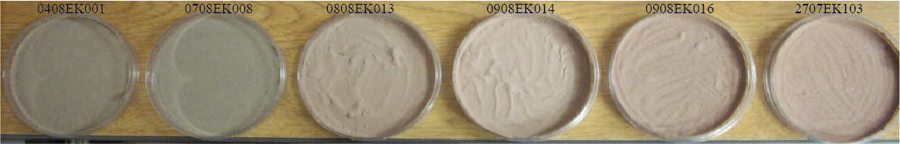
9. Microprobe Samples

4. Results
4.1. Remote Sensing
The main objective of our remote sensing analysis was to determine the spatial distribution of the limestone and sandstone lithologies in the area. These lithologies are important contributors of material into the depositional basin and key for our provenance study as well. For our remote sensing analysis, band combinations and band rationing (discussed above) were the most successful methods we used to reach our objective. Aside of those, a third method was tried. The third method consisted in comparing the individual spectra contained in the spectral libraries, obtained from the collected samples in the area, with the spectral properties of the ASTER image by using the Spectral Angle Mapper (SAM) algorithm. With the SAM algorithm, the similarity between two spectra is determined by calculating the spectral angle between them, treating the spectra as vectors in n-D space where n is the number of bands, and where a small angle will represent a more precise match (Kruse et al., 1993). The SAM algorithm was found to be time consuming and the results obtained with this method were not convincing, therefore, we have decided not to further discuss them in this paper. The results we will discussnext are those for the images we obtained using band ratios and using different band combinations. Two images will be shown for the first method, and one for the second.

4. 1. 2. Band Ratios
Sandstones in the area were deposited during dry periods when Svalbard was located at the same latitude as the current Sahara Desert region. When sandstones are deposited in desert environments their color tends to be red/brown due to the oxidation of iron-bearing minerals contained within the rock, as can be seen in the Old Red Sandstones in the area. The content of iron oxide in the Devonian red bed sandstones near Kongsfjorden was the basis to discriminate this material from other lithologies in the area. Commonly observed features in the visible-near infrared region are due to presence of iron occurring naturally in surface materials (Hunt, 1977). A series of ratios have been used by different authors to map iron related materials using satellite images. For our purposes we decided to use
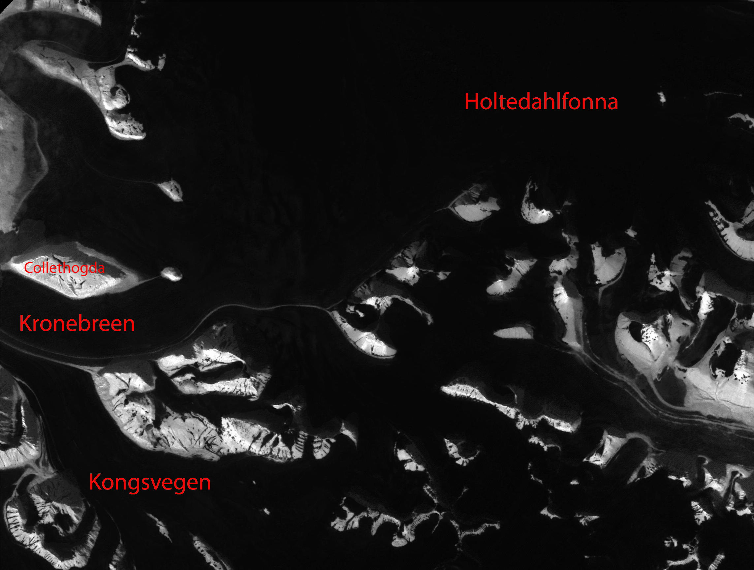

ASTER Band2/ASTER Band1 ratio, as described by Rowan (2003), to highlight occurrences of iron material in the area. Figure10 shows the image obtained using ratio
10. ASTER Band2/ ASTER Band1 ratio , image processed using ENVI. Lighter colors represent carbonates.

the ratio of ASTER Band2 over ASTER Band1. Although the obtained image is in black and white we can observe two different color tones. In this case we have interpreted the brighter white areas to be the carbonate rich rocks, and the dull areas are likely to be mostly composed of sandstones as we can infer when we compare the image with the geologic map of the area (Figure 4). Another ratio was used to find the possible location of carbonates in the area. Carbonates and calcite show low emissivity features in ASTER Band 14 and high emissivity features in ASTER bands 10 to 13. The Carbonate Index, CI=D13/D14, uses these band anomalies to differentiate carbonate from other rocks in a specific area and
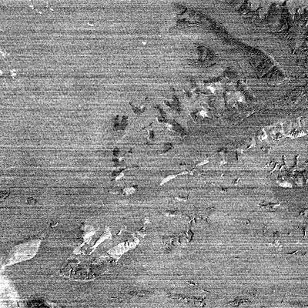

11. Carbonate Index CI=13/14, processed using ENVI. Lighter colors represent carbonates

was defined by Ninomiya (2001). TIR images have a lower resolution than VNIR and SWIR images, and the results we obtained were similar to those obtained with the previous ratio (Figure 11) but at a larger scale. Figure11 shows at least two well discriminated lithologies in the area. We have interpreted the brighter areas, in the middle to lower portions of the image, to be carbonates and the middle to upper dark areas to be the Devonian sandstones and conglomerates. Some brighter spots can be seen within the darker areas indicating carbonate rich beds or other local effects. Other similar images were obtained using the different ratios for rocks containing iron and carbonates, but will be omitted from this paper.

4.1.3. Band combinations
The results obtained using different band combinations were very similar to those results provided by using band ratios method. We used the ASTER Brightness Codes, described by Perry (2009), as a guide to find different combinations that would allow us to highlight a certain mineral or lithology in a specific band. A series of different band combinations were performed where our prime target was to identify the possible location of carbonates and iron-bearing sandstones. Among the different combinations performed, the combination ASTER Band9 (blue), ASTER Band8 (green), and ASTER Band7 (red) provided us with the best results. Figure 12 shows the image obtained after processing the bands and performing a decorrelation stretch transformation. This image helps us to distinguish at least three different rocks groups in the area that can be compared with the geologic map provided by the Norsk Polarinstittut (NPI), and the previous images we obtained using the band ratios method. Based on the information found in the geologic map of the area, descriptions of the rock units obtained during field work, rock samples, and previous work done by other authors in the area, we have interpreted that the northeastern part of the image is dominated by red bed sandstone and conglomerates represented by a greenish color (Wood Bay Formation). Then, according to our image, the carbonates (Gipsdalen Group) in the area are exposed in the middle to southern parts of the area, right south the Wood Bay Formation. The image was useful to distinguish
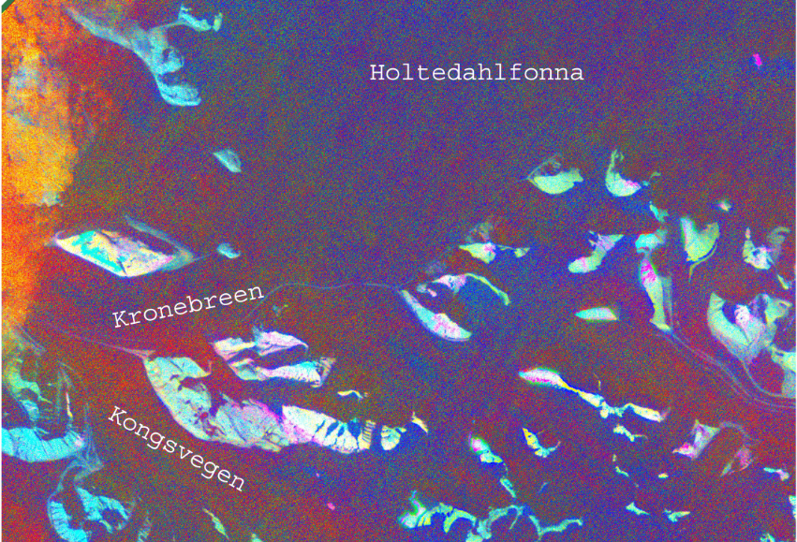
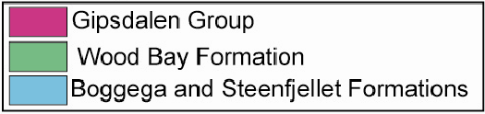
12. B:9,G:8, R:7 1, processed using ENVI

another unit in the area that would be composed of low/medium grade metamorphic rocks composed mainly schists, phyllites and marbles (Boggega, Steenfjellet Formations).

4.2. Laser diffraction particle analysis
The results for the laser diffraction particle analysis are shown in Table 4. The sediment samples, prepared and analyzed using the methods as described by Zobeck, are primarily dominated by clays, silts and sand sized clasts. Three different graphs were made for three different groups (Figure 13a, 13b, 13c). Group 1 contains the samples recovered near the ice-marginal stream, Group 3 contains the samples recovered near the upwelling, and Group 2 contains the samples recovered between the ice-marginal stream and the upwelling. Clay-sized particles were characterized as having an angular/subangular shape as could be observed in the electron microprobe back-scattered images. Gravel and sand suspensions carried by the outflow of the glaciers are usually within approximately 200-300 meters from the glacier (Elverhoi et al., 1983). Finer particles are expected to be found away from the glacier as sediment transport slows down, and suspended particles slowly begin to settle. Sample 0508EK006 from Group 3 contained the finest sediment in the area, and it was located about 400 meters from the upwelling in the Kronebreen side with an average phi size of 7.65. 90% or more of the total composition of this sample is made up of silt and clay particles. Two subgroups with different mean phi particles sizes are found in Group 1, 5.14-6.08 phi and 2.23-3.38 phi. The samples with mean size 5.14-6.08 (0408EK001, 0708EK008) contain a 76-83% of silt and 11-17% clay, while the other two samples (0408EK002, 0708EK009) have a lower percentage of clay and a higher percentage of coarser materials especially gravel. Group 2 contains a lower percentage of silt (33-49%), but is enriched in fine sand sized particles (up to 28%). Gravel makes up to 18-30% total composition of samples in Group 2. Except for sample 0508EK006, all the other samples in Group 3 show higher concentrations sands with up to 40-50% total sand composition, but the group was for the most part depleted of gravels. As observed during this investigation, sedimentation in Kongsfjorden depositional basin is complex due different depositional systems present in the area (ice-marginal stream, upwelling, ice rafting). Especially, particles deposited by ice rafting might affect the mean particle size as they settle in areas where different depositional dynamics have taken place. These results will be further discussed below.
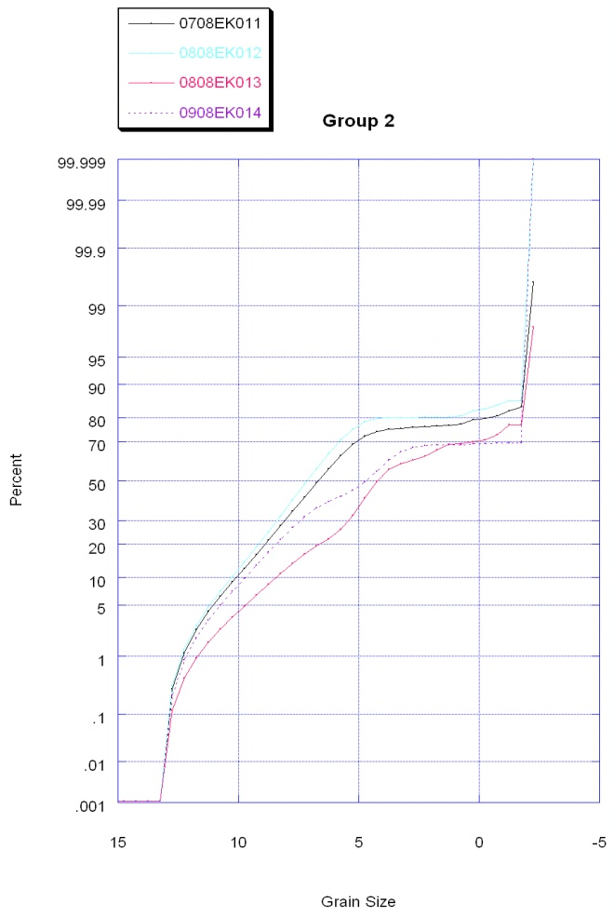
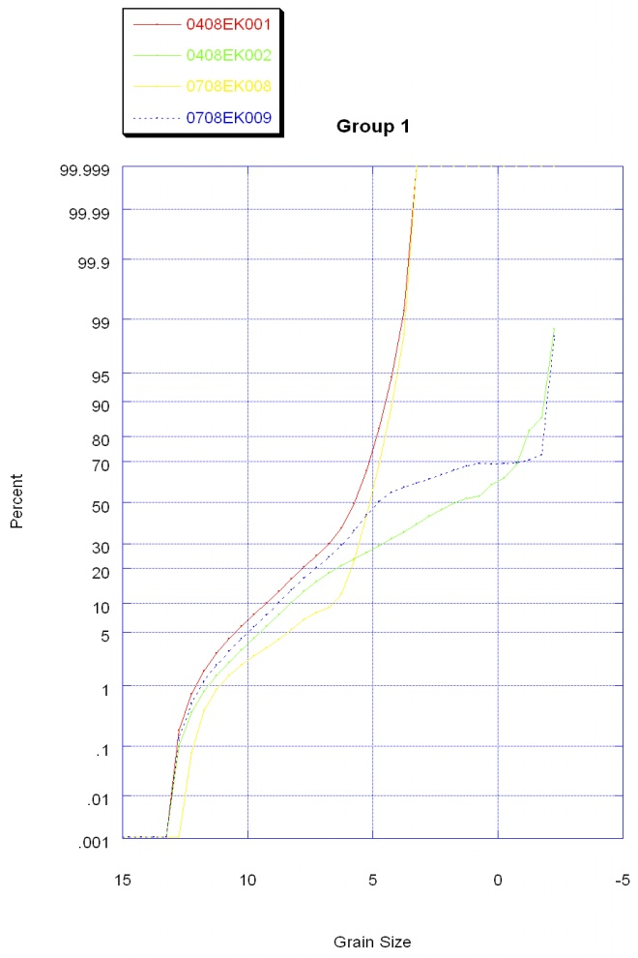
Left, Figure13a; Right Figure 13b; Bottom; Figure 13c, results for laser diffraction particle analysis, graphs obtained using Caleidograph
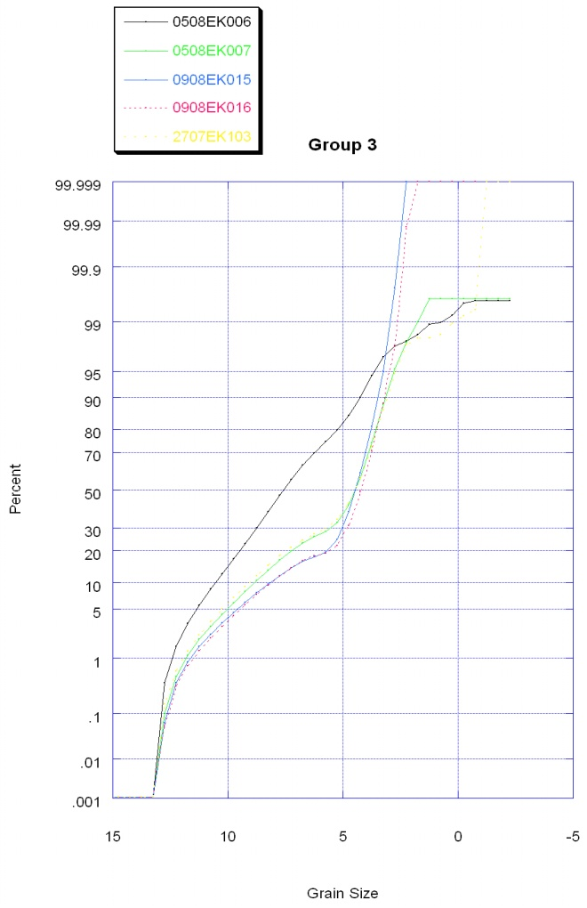

4.3. Electron probe microanalysis
The purpose of using the electron probe was to obtain a preliminary composition of the samples collected in the Kongsfjorden. We have interpreted the fifteen 20 second counts performed on each of the samples as the minerals described in Figure 14. Based on Fe, Ca, K, and Al count, we made educated guesses of the possible minerals these signatures might represent. The minerals shown appear to be the most common minerals found in the depositional basin, but the concentration of each of the minerals change depending on the sample location. Hematite and calcite were pretty abundant throughout the samples, and the chloritoid/glaucophane was only found in the samples deposited in the north side of the glacier by the upwelling.
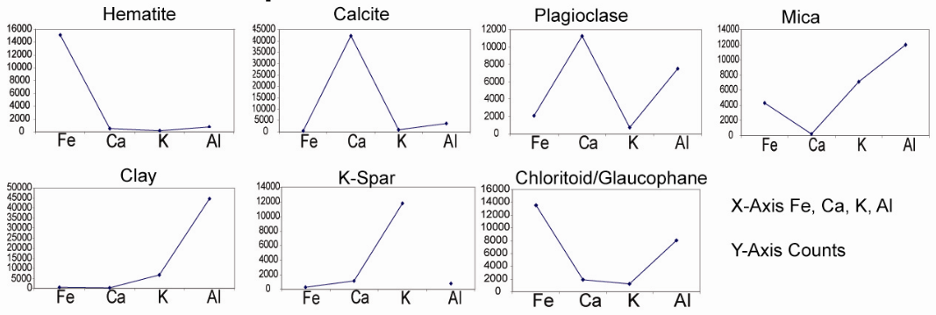
14. Electron probe results, graphs obtained using Microsoft Excel

5. Discussion
5.1 Remote Sensing
NPI’s most recent geologic map of the Kongsfjorden area (Figure 4) helped us to compare the results we obtained using remote sensing techniques with the work done in the area by the NPI geologists. The images obtained by manipulating the ASTER images using different analytical methods (Figures 10, 11, 12), show mainly two different lithologies in the area east of Kronebreen and Kongsvegen. When these results were superimposed on the NPI’s geologic map, the Devonian Wood Bay Formation was identified in the central/northern sections of the area while the Gipsdalen Formation was located in the central/southern side. The identification of these rocks was important to our investigation as they contribute with different materials into the depositional basin. It is important to note that NPI’s geologic map was obtained after the images were processed, and has not been published yet by the NPI. This map, generously provided to us, ended up being an important component of our investigation as it provided valuable information we could compare our results with. Remote sensing analyses can be affected by other external factors in a certain area that usually include cloud cover in the region, vegetation, and even deficiencies in the sensors that provide the data images. Furthermore, some of the ratios that have been previously used in an area are not guaranteed to work efficiently everywhere. In addition, the existence of pixels classified as one formation within a different formation demonstrate that remote sensing analysis complements existing data sets such as geologic maps, literature of the area to be mapped, ground truth analyses, and any other available data. The benefit of using remote sensing data is that otherwise inaccessible areas can still be investigated.
5.2 Laser diffraction particle analyses
Important information for our provenance study was obtained with the laser diffraction particle analyses. The variety of particle sizes found on the collected samples provided us with evidence about the different origins of the samples being deposited into the Kongsfjorden depositional basin. The differences observed in the sediments deposited by Kronebreen and those found in Kongsvegen reflect the conditions under which sediments formed and how far they have traveled from their original source. The information obtained using the laser diffraction particle analyses was not easy to decipher; sedimentation in the depositional basin is complex as different processes contribute with deposition of sediment into it. From the grain size analysis we can deduce the following regarding sedimentation in a high latitude setting. Coarser, heavier samples will be found close to the face of the glacier while the better sorted, finer and lighter samples will be found further from the glacier (sampled at about 400 meters in this study). The different grain textures show as well the distances traveled by the sediments. The samples observed in the back scattered microprobe images show a subangular texture in some of the grains but a subrounded texture in others inferring a variability in the distance traveled by sediments. Therefore, it is likely that many samples represent a mixture of sediments coming from a nearby source and sediments coming from far away sources. Likewise, silica rich minerals are likely to be concentrated in particles coarser that 2 microns while aluminum rich silicates (clays) will tend to be found in particles finer than 2 microns. Finally, we need to consider that grain size is affected by the velocity of the fluid by which it is being transported to interpret our sediment grain size distributions. Therefore, heavier and coarser particles can result from short transport distances, or higher flow velocity. In long sediment cores, coarser grains could mean higher flow velocity which might be due to a faster melting of ice; therefore, sediment analysis may reveal changes in the rate of retreat of a glacier. However, our samples were mostly taken from the top seafloor layer, and are more likely be controlled by lateral differences in sedimentation processes, as opposed to glacial retreat (and ultimately, climate change).

5.3 Electron probe microanalysis
The different types of elemental signatures, interpreted as different minerals found in the samples, show the diversity of rocks that surround the area. Particularly, clays, feldspars and micas are expected minerals in these sediments. Although we suggest possible signatures to represent micas (phyllosilicate minerals) and clays, quantitative data is required to truly identify the different minerals. For example, just some of the clay minerals present in the area could be smectite [(Na,Ca)_{0.33}(Al,Mg)₂(Si₄O₁₀)(OH)₂·nH₂O], kaolinite [Al₂Si₂O₅(OH)₄], and illite [(K,H₃O)(Al,Mg,Fe)₂(Si,Al)₄O₁₀[(OH)₂,(H₂O)], which are usually present and derived from the weathering of granites, low grade metamorphic rocks, and feldspars. These clay minerals already span a range in compositions in the elements we monitored. Other minerals, with a higher concentration of iron (hematite, magnetite) were found in the northern side of the glaciers as Kronebreen mainly flows over Devonian red bed sandstones and conglomerates, while the southern side Kongsvegen flows mainly over carbonate rich rocks (calcite, dolomite, limestone, marble). Feldspars [KAlSi₃O₈ - NaAlSi₃O₈ - CaAl₂Si₂O₈] are likely to be derived from the igneous and metamorphic rocks surrounding the area. A non-unique signature, possibly representing chloritoid or glaucophane minerals were only found in the northern side of the glacer, and were subject to the furthest transportation by the glaciers.

6. Summary
In conclusion, remote sensing analyses were helpful to identify the different main rock types over which the glaciers flow. The techniques we used gave us very similar results that helped us to interpret the lithologies from the obtained images. Then, according to our results, the northern side of the glacier is image is dominated by red bed siliclastics from the Wood Bay Formation while the southern side, near Kongsvegen, is mostly dominated by carbonates from the Gipsdalen Group. In terms of albedo, it is important to remember that red bed siliclastics are likely to absorb a higher amount of radiation (lower albedo) than carbonates. A higher radiation absorption in the northern side of the glacier due to the presence of the red beds would represent a higher amount of snowmelt, possibly a faster retreat on the Kronebreen glacier and subsequently a higher sedimentation in the northern side of the glacier.
Our samples represent a mixture of sediments coming from a nearby source and sediments coming from far away sources. Coarser, heavier samples were found close to the face of the glacier while the better sorted, finer and lighter samples were found further from the glacier. Silica rich minerals are likely to be concentrated in particles coarser that 2 microns while aluminum rich silicates (clays) will tend to be found in particles finer than 2 microns. Grain size and texture are affected by the velocity of the fluid by which it is being transported, the topography of the terrain under the glacier, distance traveled, and the relative hardness of the rocks these sediments used to make up. Heavier and coarser particles can result from short transport distances, or higher flow velocity. Our samples were taken from the top seafloor layer, and are more likely to be controlled by lateral differences in sedimentation processes rather than glacial retreat. In long sediment cores, coarser grains could mean higher flow velocity which might be due to a faster melting of ice; therefore, sediment analysis may reveal changes in the rate of retreat of a glacier.
Minerals with a higher concentration of iron (hematite, magnetite) were found in the northern side of the glaciers as Kronebreen mainly flows over Devonian red bed sandstones and conglomerates, while the southern side Kongsvegen flows mainly over carbonate rich rocks (calcite, dolomite, limestone, marble). Although other accessory minerals were found, carbonates and iron-bearing minerals were most commonly observed in the samples; these results indicate a higher sedimentation from the nearby red-bed sandstones (and conglomerates), and carbonates (limestone, dolostone, marble), and a lower contribution of sediment from other sources such as igneous rocks.

7. Works cited
Aagaard, K., Foldvik, A. & Hillman, S. R. 1987: The West Spitsbergen Current: disposition and water mass transformation. J. Geophys. Res. 92, 3778-3784.

Bannari, A., Morin, D., Bonn, F. & Huete, A. R. 1995: A review of vegetation indices. Remote Sensing Reviews, 13, pp. 95-120.

Bergh, S. G., Maher, H. D. & Braathen, A. 2000: Tertiary divergent thrust directions from partitioned transpression, Broggerhalvoya, Spitsbergen. Nor. Geol. Tidsskr. 80, 63-82.

Buurman, P., Th. Pape, & C. C. Muggler. 1997: Laser grain-size determination I soil genetic studies 1. Practical problems. Soil Sci. 162(3): 211-218.

Dethleff, V. Rachold, M. Tintelnot and M. Antonow, Sea-ice transport of riverine particles from the Laptev Sea to Fram Strait based on clay mineral studies. International Journal of Earth Sciences 89 (2000), pp. 496–502.

Dowdeswell, J. A., and Dowdeswell, E. K. 1989: Debris in icebergs and rates of glacimarine sedimentation: Observations from Spitsbergen and simple model. Journal of Geology, v. 97, p. 221–231.

Elverhoi, A., Lonne, O., & Seland, R. 1983: Glaciomarine sedimentation in modern fjord environment, Spitsbergen. Norsk Polarinstitutt Skrifter, 172: 33-60.

Forman, S. L., Mann, D. H., & Miller, G. H. 1987: Late Weichselian and Holocene relative sea-level history of Broggerhalvoya, Spitsbergen. Quaternary Research 27, 41-50.

Frisch, W., Bruegel, A., Dunkl, I. and Kuhlemann, J., 1997: Record of exhumation and
mountain building in foreland molasse sediments of the Eastern Alps. Geological
Society of America Abstracts with Programs, v. 29, p. 421.

Frumkin, A. and Stein, M., 2004: The Sahara-East Mediterranean dust and climate
connection revealed by strontium and uranium isotopes in a Jerusalem
speleothem. Earth and Planetary Science Letters, v. 217, p. 451-464.

Fujisada, H. (1995). Design and performance of ASTER instrument. Proceedings of SPIE, 2583, 16-25

Gascard, J. C., Richez, C. & Rouault, C. 1995: New insights on large-scale oceanography in Fram Strait: the Spitsbergen Current. Coast Estuar. Stud. 49, 131-182.

Glasser, N. F., Hambrey, M. J. 2001: Tidewater glacier beds: insights from iceberg debris in Kongsfjorden, Svalbard. Journal of Glaciology, Vol. 47, No. 157.

Hagen, J. O., Liestøl, O., Roland, E. & Jørgensen, T. 1993: Glacier atlas of Svalbard and Jan Mayen. Norsk Polarinstitutt Medd. 129. 141 pp.

Harland, W. B. The geology of Svalbard. Geological Society, London, Memoirs; 1997; v. 17; p. 8.

Hjelle, A. 1993: Geology of Svalbard. Norsk Polarinstitutt Polarhandbok no. 7. 6-12, 105 pp.

Hoogakker, B.A.A., 2004: Variations in terrigenous dilution in western Mediterranean
Sea pelagic sediments in response to climate change during the last glacial cycle.
Marine Geology, v. 211, p. 21-43.

Hook, S. J., Karlstrom, K.E., Miller, C.F., and McCaffrey, K. J. W., 1994: Mapping the Piute Mountains, California, with thermal Infrared multispectral scanner (TIMS) images. Journal of Geophysical Research, v. 99, no. B8, p. 15605-15622.

Howe, J. A., Moreton, S. G., Morri, C., Morris, P. 2003: Multibeam bathymetry and the depositional environments of Kongsfjorden and Krossfjorden, western Spitsbergen, Svalbard. Polar Research 22(2), 301-316.

Hunt, G. R. 1977: Spectral signatures of particulate minerals in the visible and near infrared. Geophysics, 42(3), 501-513.

Hunt, G. R., 1980, Electromagnetic radiation: The communication link in remote sensing, in Siegal, B.S., and Gillespie, A.R.,eds,. Remote Sensing in Geology. New York, John Wiley, p. 5-45

Hunt, G. R., Salisbury, J. W., & Lenhoff, C. R. 1972: Visible and near-infrared spectra of minerals and rocks: V. Halides, phosphates, arsenates, vanadates, and borates. Modern Geology, 3, 121-132.

Hunt, G. R., & Salisbury, J. W. 1976: Mid-infrared spectral behavior of sedimentary rocks. Technical Report AFRCL-TR-750356, US Air Force Cambridge Research Laboratory, Cambridge, MA.

Hurtado, J. M. (Jr), and Hodges K.V. 2002. Tectonic Evolution of the Thakkhola Graben and Dhaulagiri Himalaya, Central Nepal. Doctoral Thesis. Massachusetts Institute of Technology, 2002.

Hussain, M., Bablola, L. and Hariri, M.M., 2004: Heavy minerals in the Wajid Sandstone from Abha-Khamis Mushayt area, southwestern Saudi Arabia; implications on provenance and regional tectonic setting. GeoArabia Manama, v. 9, p. 77-102.
Ingólfsson, Ólafur, 2005, Outline of the geography and geology of Svalbard,
http://www.mtholyoke.edu/proj/svalbard/participantarticles.shtml, 12 p.

Ito, H. and S. Kudoh. 1997: Characteristics of water in Kongsfjorden, Svalbard. Pro. NIPR Symp. Polar Meterolog. Glaciol. 11, 253.

Kruse, F. A., and A. B. Lefkoff, A., 1993b: Knowledge-based geologic mapping with imaging spectrometers: Remote Sensing Reviews, Special Issue on NASA Innovative Research Program (IRP) results, v. 8, p. 3-28.

Lefauconnier, B. & Hagen, J. O. 1991: Surging and calving glaciers in eastern Svalbard. Norsk Polarinstitutt Medd. 116. 130 pp.

Lefauconnier, B., Hagen, J. O., Pinglot, J. F. & Pourchet, M. 1994: Mass-balance
estimates on the glacier complex Kongsvegen and Sveabreen, Spitsbergen,
Svalbard, using radioactive layers. Journal of Glaciology, 40, 368-376.

Liestøl, O. 1988: The glaciers in the Kongsfjorden area, Spitsbergen. Norsk Geografisk
Tidsskrift, 48, 231-238.

Lyon, R. J. P. 1964: Evaluation of infrared spectrophotometry for compositional analysis of lunar and planetary soils, II. NASA Contract. Rep. NASA CR-100.

Melvold, K. 1992: Studie av brebevegelse pa Kongsvegen or Kronebreen, Svalbard. Oslo, Universitetet i Oslo. (Rapportserie i Naturgeografi 1).

Melvold, K. & Hagen, J. O. 1998: Evolution of a surge-type glacier in its quiescent
phase; Kongsvegen, Spitsbergen, 1964-95. Journal of Glaciology, 44, 394-404.

Perry, J.L. & Vincent, R. K. 2009: ASTER brightness and ratio codes form Minerals: Application to lithologic mapping in the West-Central Powder River Basin, Wyoming. Society of Economic Geologists, V.16, 143-168.

Pfirman, S., Lange, M.A., Wollenburg, I., Schlosser, P., 1990. Sea ice characteristics and the role of sediment inclusions in deep-sea deposition: Arctic–Antarctic comparisons. In: Bleil, U., Thiede, J. (Eds.), Geological History of the Polar Oceans: Arctic versus Antarctic, Kluwer, Netherlands, pp. 187–211.

Rowan, L. C. & Mars, J. C. 2003: Lithologic mapping in the Mountain Pass, California area using Advanced Spaceborne Thermal Emission and Reflection Radiometer (ASTER) data. Remote Sensing of Envirnonment, 84, 350-366.

Rowan, L. C., Kingston, M. J., & Crowley, J. K. 1986: Spectral reflectance of carbonatite and related alkalic igneous rocks from four North American localities. Economic Geology, 81, 857-871.
Salisbury, J. W., Walter, L. S., Vergo, N., and D’Aria, D. M., 1991: Infrared (2.1-25 micrometers) Spectra of Minerals, Johns Hopkins University Press, 294 p.

Schwartz, J.J. and Gromet, L.P., 2004: Provenance of a late Proterozoic-Early Cambrian basin, Sierras de Cordoba, Argentina. Precambrian Research, v. 129, p. 1-21.

Svendsen, H., Beszczynska-Møller, A., Hagen, J. O., Lefauconnier, B., Tverberg, V.,
Gerland, S., Ørbaek, J. B., Bischof, K., Papucci, C., Zajaczkowski, M., Roberto,
A., Bruland, O., Wiencke, C., Winther, J.-G. & Dallmann, W. 2002: The physical
environment of Kongsfjorden-Krossfjorden, an Arctic fjord system in Svalbard.
Polar Research, 21, 133-166.

Thomas, E. K., 2005: Using Geochemical Evidence to Determine Provenance
in a High Arctic Glacier-Fed Lake, Linné Valley, Svalbard, Norway. B.A. Thesis, Smith College, Northhampton, Mass.

Thomas, R. 2001: A beginner’s guide to ICP-MS. Spectroscopy tutorial.

Trusel L., R. Powell, R. Cumpston, J. Brigham-Grette, 2009 (in press): Modern glacimarine processes and potential future behaviour of Kronebreen and Kongsvegen Polythermal Tidewater Glaciers, Kongsfjorden, Svalbard. Geol. Soc. London.

Tucker, C. J. 1979: Red and photographic infrared linear combinations for monitoring vegetation. Remote Sensing of Environment, 8 pp. 127-150.

Vinje, T. 2001: Anomalies and trands of sea-ice extent and atmospheric circulation in the Nordic seas during the period 1864-1998. J. Clim. 14, 255-267.

Viscosi-Shirley, C., Mammone, K., Pisias, N. & Dymond, J. 2003: Clay mineralogy and multi-element chemistry of surface sediments on the Siberian-Arctic shelf: implications for sediment provenance and grain size sorting. Continental Shelf Research Volume 23, Issues 11-13, July-August 2003, Pages 1175-1200.

Vlag, P.A., 2004, Evaluating climate change by multivariate statistical techniques on
magnetic and chemical properties of marine sediments (Azores region):
Palaeogeography, Palaeoclimatology and Palaeoecology, v. 212, p. 23-44.

Weltje, G. J. & Von Eynatten, H. 2004: Quantitative provenance analysis of sediments review and outlook. Sedimentary Geology, 171 (2004) 59-77.

Yu, K.-M., Lee, G.H. and Boggs, S., 1997: Petrology of late Paleozoic-early Mesozoic
Pyeongan Group sandstones, Gohan area, South Korea and its provenance and tectonic implications. Sedimentary Geology, v. 109, p. 321-338.

Zobeck, T. M. 2004: Rapid soil particle size analyses using laser diffraction. Applied Engineering in Agriculture, Vol. 20(5), 633-639.
8. Appendices

Appendix I
Sample | Latitude | Longitude
0408EK001 | 78.87129 | 12.49258
0408EK002 | 78.87284 | 12.49194
0408EK003 | 78.87573 | 12.49189
0408EK004 | 78.88385 | 12.50004
0508EK005 | 78.88456 | 12.49386
0508EK006 | 78.88853 | 12.51337
0508EK007 | 78.89393 | 12.51617
0708EK008 | 78.86996 | 12.49442
0708EK009 | 78.87231 | 12.4972
0708EK011 | 78.87691 | 12.50148
0808EK012 | 78.87786 | 12.50374
0808EK013 | 78.88986 | 12.5022
0908EK014 | 78.88605 | 12.50682
0908EK015 | 78.88707 | 12.51277
0908EK016 | 78.89082 | 12.51412
2507EK101 | 78.89005 | 12.51168
2507EK102A | 78.88996 | 12.51277
2507EK102B | 78.88996 | 12.51277
2507EK102C | 78.88996 | 12.51277
2707EK103 | 78.88864 | 12.51973
2807EK104 | 78.89037 | 12.49246

Appendix II

 | 0408EK001 | 0408EK002 | 0508EK006 | 0708EK009 | 0708EK010 | 0708EK011 | 0808EK013 | 0808EK012 | 0908EK014 | 2707EK103
Sieve #
3/8 (9.5mm) | 0g | 9.75649g | 0g | 20.46303g | 14.58020g | 10.98429g | 4.51g | 10.73650g | 24.40151g | 0g
1/4 (6.3mm) | 0g | 3.09956g | 0g | 1.83532g | 0g | 0.89527g | 0g | 0g | 0g | 0g
5 (4mm) | 0g | 10.23982g | 0g | 0.91076g | 0.90132g | 1.15516g | 0.89g | 1.10622g | 0.12116g | 0.23g
7 (2.8mm) | 0g | 4.84073g | 0.03004g | 0.28394g | 1.27170g | 0.73541g | 0.54g | 0.86585g | 0.14137g | 0.06g
10 (2mm) | 0g | 3.2494g | 0.15979g | 0.21080g | 0.99635g | 0.3923g | 0.14g | 0.49745g | 0.1121g | 0.09g
14 (1.25mm) | 0g | 3.86234g | 0.12230g | 0.51316g | 1.45014g | 1.11309g | 0.21g | 1.28587g | 0.38867g | 0.19g
18 (1mm) | 0g | 0.84870g | 0.04857g | 0.12009g | 0.36430g | 0.28702g | 0.05g | 0.43260g | 0.0482g | 0.07g
Final Container | 83.3g | 41.1g | 54g | 56g | 57.2g | 53.8g | 15.46g | 60.3g | 54.5g | 35.38g

Appendix III
Sample Number | Dry Weight
0408EK001 | 102.9
0408EK002 | 106.96
0408EK003 | 107.05
0408EK004 | 97.47
0508EK006 | 102.21
0508EK007 | 107.46
0708EK008 | 97.72
0808EK012 | 105.82
0808EK013 | 97.2
0908EK014 | 104.46
0809EK015 | 103.83
0809EK016 | 104.12
2707EK103 | 105.89

Record number | Sample Name | Sieves | 18 | 14 | 10 | 7 | 5 | one-fourth | three-eights | pan | Total Sample Weight gms | Percent Malvern /Pan | Percent >1 mm | Weight percent | Midpoint Depth | Weight % Clay | Weight % Silt | Weight % Sand | Weight % Fine Sand | Weight % Coarse Sand | Weight % Gravel |  | % retained during Analysis | % loss during Analysis | Mean Phi
Record number | Sample Name | 1.25 | 0.75 | 0.25 | -0.25 | -0.75 | -1.25 | -1.75 | -2.25 | pan | Total Weight | Percent Malvern/Pan |  | 16.25 |  |  |  |  |  |  |  |  | Total wt percent |  | Mean Phi
4 | 0408EK001 - Average | 0 | 0 | 0 | 0 | 0 | 0 | 0 | 0 | 83.3 | 83.3 | 1.00 | 0.00 | 0 | 35 | 17.28 | 76.16 | 6.56 | 6.56 | 0.00 | 0.00 | 100.00 | 100.00 | 0.00 | 6.08
8 | 0408EK001-a - Average | 0 | 0 | 0 | 0 | 0 | 0 | 0 | 0 | 83.3 | 83.3 | 1.00 | 0.00 | 0 | 35 | 11.50 | 80.45 | 8.05 | 8.05 | 0.00 | 0.00 | 100.00 | 100.00 | 0.00 | 5.67
12 | 0408EK001-b try5 - Average | 0 | 0 | 0 | 0 | 0 | 0 | 0 | 0 | 83.3 | 83.3 | 1.00 | 0.00 | 0 | 35 | 16.54 | 77.88 | 5.58 | 5.58 | 0.00 | 0.00 | 100.00 | 100.00 | 0.00 | 6.08
16 | 0408EK001-c - Average | 0 | 0 | 0 | 0 | 0 | 0 | 0 | 0 | 83.8 | 83.8 | 1.00 | 0.00 | 0 | 35 | 11.62 | 79.69 | 8.69 | 8.69 | 0.00 | 0.00 | 100.00 | 100.00 | 0.00 | 5.67
24 | testdust - Average | 0 | 0 | 0 | 0 | 0 | 0 | 0 | 0 | 0 | 0 | 1.00 | 0.00 | 0 | 35 | 55.50 | 44.40 | 0.10 | 0.10 | 0.00 | 0.00 | 100.00 | 100.00 | 0.00 | 8.17
28 | 0508EK007 - Average | 0.594299 | 0 | 0 | 0 | 0 | 0 | 0 | 0 | 0 | 0 | 1.00 | 0.00 | 0 | 35 | 13.35 | 43.53 | 42.72 | 42.12 | 0.59 | 0.00 | 99.59 | 99.59 | 0.41 | 4.98
32 | 0708EK008 - Average | 0 | 0 | 0 | 0 | 0 | 0 | 0 | 0 | 0 | 0 | 1.00 | 0.00 | 0 | 35 | 5.32 | 83.58 | 11.10 | 11.10 | 0.00 | 0.00 | 100.00 | 100.00 | 0.00 | 5.14
36 | 0808EK013a - Average | 3.396981 | 0.05 | 0.21 | 0.14 | 0.54 | 0.89 | 0 | 4.51 | 15.46 | 21.8 | 0.71 | 0.29 | 0 | 35 | 8.64 | 37.71 | 28.15 | 21.43 | 6.72 | 24.77 | 99.27 | 99.27 | 0.73 | 2.97
40 | 0808EK013b - Average | 4.158518 | 0.05 | 0.21 | 0.14 | 0.54 | 0.89 | 0 | 4.51 | 15.46 | 21.8 | 0.71 | 0.29 | 0 | 35 | 10.92 | 38.79 | 23.47 | 16.20 | 7.26 | 24.77 | 97.95 | 97.95 | 2.05 | 3.16
44 | 0808EK013 - Average | 2.932845 | 0.05 | 0.21 | 0.14 | 0.54 | 0.89 | 0 | 4.51 | 15.46 | 21.8 | 0.71 | 0.29 | 0 | 35 | 12.77 | 41.59 | 18.10 | 11.71 | 6.39 | 24.77 | 97.23 | 97.23 | 2.77 | 3.39
48 | testdust2 - Average | 0 | 0 | 0 | 0 | 0 | 0 | 0 | 0 | 0 | 0 | 1.00 | 0.00 | 0 | 35 | 55.35 | 44.62 | 0.04 | 0.04 | 0.00 | 0.00 | 100.00 | 100.00 | 0.00 | 8.17
52 | 0908EK015 - Average | 0 | 0 | 0 | 0 | 0 | 0 | 0 | 0 | 0 | 0 | 1.00 | 0.00 | 0 | 35 | 9.63 | 49.74 | 40.63 | 40.63 | 0.00 | 0.00 | 100.00 | 100.00 | 0.00 | 4.82
56 | 0908EK016 – Average | 0 | 0 | 0 | 0 | 0 | 0 | 0 | 0 | 0 | 0 | 1.00 | 0.00 | 0 | 35 | 9.32 | 39.65 | 51.03 | 51.03 | 0.00 | 0.00 | 100.00 | 100.00 | 0.00 | 4.61
60 | 2707EK103a - Average | 0.745063 | 0.07 | 0.19 | 0.09 | 0.06 | 0.23 | 0 | 0 | 35.38 | 36.02 | 0.98 | 0.02 | 0 | 35 | 14.23 | 38.87 | 46.06 | 44.19 | 1.87 | 0.64 | 99.81 | 99.81 | 0.19 | 4.87
64 | 2707EK103c - Average | 1.224221 | 0.07 | 0.19 | 0.09 | 0.06 | 0.23 | 0 | 0 | 35.38 | 36.02 | 0.98 | 0.02 | 0 | 35 | 20.54 | 33.63 | 43.73 | 41.39 | 2.34 | 0.64 | 98.55 | 98.55 | 1.45 | 5.24
68 | 2707EK103b - Average | 0 | 0.07 | 0.19 | 0.09 | 0.06 | 0.23 | 0 | 0 | 35.38 | 36.02 | 0.98 | 0.02 | 0 | 35 | 14.72 | 41.76 | 42.88 | 41.74 | 1.14 | 0.64 | 100.00 | 100.00 | 0.00 | 5.01
72 | 0408EK002a - Average | 0 | 0.8487 | 3.86234 | 3.2494 | 4.84073 | 10.23982 | 3.09956 | 9.75649 | 41.1 | 76.99704 | 0.53 | 0.47 | 0 | 35 | 12.22 | 25.37 | 32.42 | 15.79 | 16.63 | 30.00 | 100.00 | 100.00 | 0.00 | 2.58
76 | 0408EK002b - Average | 4.279027 | 0.8487 | 3.86234 | 3.2494 | 4.84073 | 10.23982 | 3.09956 | 9.75649 | 41.1 | 76.99704 | 0.53 | 0.47 | 0 | 35 | 10.18 | 21.92 | 36.51 | 17.60 | 18.91 | 30.00 | 98.60 | 98.60 | 1.40 | 2.23
80 | 0408EK002c - Average | 4.214416 | 0.8487 | 3.86234 | 3.2494 | 4.84073 | 10.23982 | 3.09956 | 9.75649 | 41.1 | 76.99704 | 0.53 | 0.47 | 0 | 35 | 10.66 | 22.58 | 36.13 | 17.26 | 18.88 | 30.00 | 99.37 | 99.37 | 0.63 | 2.30
84 | 0708EK009 - Average | 2.731361 | 0.12009 | 0.51316 | 0.2108 | 0.28394 | 0.91076 | 1.83532 | 20.46303 | 56 | 80.3371 | 0.70 | 0.30 | 0 | 35 | 13.22 | 41.84 | 14.29 | 10.98 | 3.31 | 28.89 | 98.24 | 98.24 | 1.76 | 3.38
88 | 0708EK010 - Average | 0.181535 | 0.3643 | 1.45014 | 0.99635 | 1.2717 | 0.90132 | 0 | 14.5802 | 57.2 | 76.76401 | 0.75 | 0.25 | 0 | 35 | 27.69 | 41.78 | 10.06 | 4.61 | 5.45 | 20.17 | 99.70 | 99.70 | 0.30 | 5.00
92 | testdust - Average | 0.222068 | 0 | 0 | 0 | 0 | 0 | 0 | 0 | 0 | 0 | 1.00 | 0.00 | 0 | 35 | 54.45 | 43.96 | 1.58 | 1.36 | 0.22 | 0.00 | 99.99 | 99.99 | 0.01 | 8.07
96 | 0708EK011a - Average | 0 | 0.28702 | 1.11309 | 0.3923 | 0.73541 | 1.15516 | 0.89527 | 10.98429 | 53.8 | 69.36254 | 0.78 | 0.22 | 0 | 35 | 30.07 | 47.12 | 4.02 | 0.37 | 3.64 | 18.79 | 100.00 | 100.00 | 0.00 | 5.52
100 | 0708EK011b - Average | 0.447236 | 0.28702 | 1.11309 | 0.3923 | 0.73541 | 1.15516 | 0.89527 | 10.98429 | 53.8 | 69.36254 | 0.78 | 0.22 | 0 | 35 | 27.53 | 47.00 | 6.26 | 2.27 | 3.99 | 18.79 | 99.58 | 99.58 | 0.42 | 5.27
104 | 0708EK011c - Average | 0.677178 | 0.28702 | 1.11309 | 0.3923 | 0.73541 | 1.15516 | 0.89527 | 10.98429 | 53.8 | 69.36254 | 0.78 | 0.22 | 0 | 35 | 26.41 | 43.99 | 10.67 | 6.50 | 4.17 | 18.79 | 99.86 | 99.86 | 0.14 | 5.09
108 | 0808EK012 - Average | 0.018637 | 0.4326 | 1.28587 | 0.49745 | 0.86585 | 1.10622 | 0 | 10.7365 | 60.3 | 75.22449 | 0.80 | 0.20 | 0 | 35 | 32.01 | 47.72 | 4.54 | 0.42 | 4.11 | 15.74 | 100.00 | 100.00 | 0.00 | 5.81
112 | 0908EK014 - Average | 0 | 0.0482 | 0.38867 | 0.1121 | 0.14137 | 0.12116 | 0 | 24.40151 | 54.5 | 79.71301 | 0.68 | 0.32 | 0 | 35 | 21.75 | 33.36 | 14.13 | 13.26 | 0.87 | 30.76 | 100.00 | 100.00 | 0.00 | 3.83
116 | testdust2 - Average | 0 | 0 | 0 | 0 | 0 | 0 | 0 | 0 | 0 | 0 | 1.00 | 0.00 | 0 | 35 | 55.37 | 44.60 | 0.03 | 0.03 | 0.00 | 0.00 | 100.00 | 100.00 | 0.00 | 8.17
120 | 0508EK006a - Average | 0.017328 | 0.04857 | 0.1223 | 0.15979 | 0.03004 | 0 | 0 | 0 | 54 | 54.3607 | 0.99 | 0.01 | 0 | 35 | 46.93 | 49.96 | 3.11 | 2.43 | 0.68 | 0.00 | 100.00 | 100.00 | 0.00 | 7.88
124 | 0508EK006b - Average | 0.482536 | 0.04857 | 0.1223 | 0.15979 | 0.03004 | 0 | 0 | 0 | 54 | 54.3607 | 0.99 | 0.01 | 0 | 35 | 38.24 | 51.86 | 9.47 | 8.32 | 1.14 | 0.00 | 99.56 | 99.56 | 0.44 | 7.19
128 | 0508EK006c - Average | 0.815952 | 0.04857 | 0.1223 | 0.15979 | 0.03004 | 0 | 0 | 0 | 54 | 54.3607 | 0.99 | 0.01 | 0 | 35 | 44.73 | 50.55 | 3.24 | 1.76 | 1.47 | 0.00 | 98.52 | 98.52 | 1.48 | 7.65

Appendix I

