Glaciomarine Oceanographic and Suspended Sediment Dynamics, Kongsbreen system, Svalbard

Marshburn, Hannah ¹; Powell, Ross ²; Brigham-Grette, Julie ³.

¹ University of Miami
² Northern Illinois University
³ University of Massachusetts-Amherst

- Abstract
- Introduction
  - Background/Overview
  - Oceanography
  - Glaciology and Climate
  - Sediment dynamics
- Methodology
- Results
  - Oceanographic analysis
  - Suspended sediment analysis
- Discussion
- Future Research
- Acknowledgements
- References

- Abstract
Quantifying estuarine circulation and the resulting sediment dynamics of tidewater glaciers is crucial to developing an understanding of these dynamic systems, and their response to climate and sea level change. This study characterizes oceanographic conditions and suspended sediment loads resulting from glacial meltwater in proximal distance to the glacier terminus of the Kronebreen-Kongsvegen system, Kongsfjorden, Svalbard as a component of the Svalbard REU project. The study was conducted during July and early August of 2009, coinciding with maximum melt water volumes induced by elevated summer temperatures, and approaching the spring tidal maximum. Major fjord, oceanic, and glacial- induced brackish meltwater plumes were identified and evaluated for suspended particulate load through CTD scans, optical back scatter (OBS) readings, and water samples taken in perpendicular transects roughly 200-1000 m from the glacial termini. Sub-glacial upwelling systems on opposing sides of the glacial face were targeted for analysis and comparison. The control of tidal fluxes on sediment and interflow mixing was examined. The fjord is an example of a system with active marine glaciers transitioning to terrestrial systems, vulnerable to circulation changes. The estuary consists of a three layer stratified system.
A turbid shallow estuarine brackish mixing layer was identified, with temperatures ranging between 3-4ºCelsius and practical salinity ranging from 15 to 31, a result of glacial outwash. An intermediate Atlantic interflow was identified through a warm saline water tongue at depths of 15-20 meters, with mean temperatures between 4-5º Celsius and salinity of 31 to 32. The fjord bottom water was characterized by a drastic temperature decrease at 30 meters from 5 to 1.2º Celsius over a 10-20 meter interval, with salinity constant at 33-34. Suspended particulate loads from water samples and OBS values were higher in the unrestricted sub-glacial upwelling plume system as opposed to the system in the semi-enclosed delta. The surface mixed layer contained the highest suspended particulate matter, with a mean sediment concentration of 0 .1351 kg/m³, compared to the intermediate and bottom water values of 0.06801 and 0.04376 kg/m³, respectively. Data during ebb tide phases indicate reduced water column stratification. Fjord waters and currents are strongly driven by thermohaline convection cycles due to their partial enclosure and protection from open ocean winds and waves. Research characterizing density driven mixing properties of inner fjord basin water columns is limited. Data generated in this study can be used to investigate the effects of glacial outwash, comprised of freshwater and sediment, on fjord circulation. Understanding how glacial meltwater is exported from fjords and interacts with ocean-climate systems is critical to hypothesizing future climate behavior.
- Introduction
- Background
Svalbard is an archipelago in the high arctic, constitutionally representing the most northern parts of Norway. The group of islands lies between 74-81 ºN latitude and 10-35 ºE longitude. Spitzbergen is the largest island of the archipelago chain. The climate of Svalbard is mild considering its northern location due to local circulation of warm oceanic waters from the North Atlantic. 2/3rds of Svalbard is covered by glaciers; many of them are tidewater glaciers, thus terminating in local waters. Roughly 20% of the Svalbard coast is dominated by tidewater glaciers. The glaciers of Svalbard range from polythermal to temperate. Many tidewater glaciers have retreated into becoming solely terrestrial glacial systems. Dynamics behind these processes are not well understood. This study investigates two components of interest in deglaciation cycles of tidewater glaciers, the oceanographic characteristics of inner fjords of glacimarine systems, and a sediment analysis of meltwater loads and possible deposition mechanisms.
The study was conducted out of Ny-Alesund, located in the northwest region of the island of Spitzbergen, shown in Figure 1, focusing on the glaci-marine systems of Kongsfjorden. Kongsfjorden contains several tidewater glaciers, as well as terrestrial glaciers releasing stream discharge, and several inlet basins shown in Figure 2. The study focused on the Kongsbreen tidewater glacier system in the inner basin of Kongsfjorden, located at 79ºN 12.5ºE, visible in Figure 2. The Kongsbreen glacial system is comprised of two converging glaciers- Kronebreen and Kongsvegen, the system has significantly retreated over the last several decades. Kongsvegen has transitioned from a marine to a terrestrial glacier in the last 20 years; an ice marginal delta has emerged in front of the glaciers, which are sourced from sediment released in subglacial upwelling systems that are focused on in this study. The study was conducted from the research facility of Ny-Alesund and logistics were provided for by the Norsk Polar Institute, Kings Bay AS, and the National Science Foundation. Quantitative data in the inner basin of Kongsfjorden is limited. For the purposes discussed in this study, oceanographic studies previously conducted by Zajackowski, Marek (and others) were utilized for background information on the oceanographic and denoted sedimentary processes within the Kongsfjorden estuarine system.
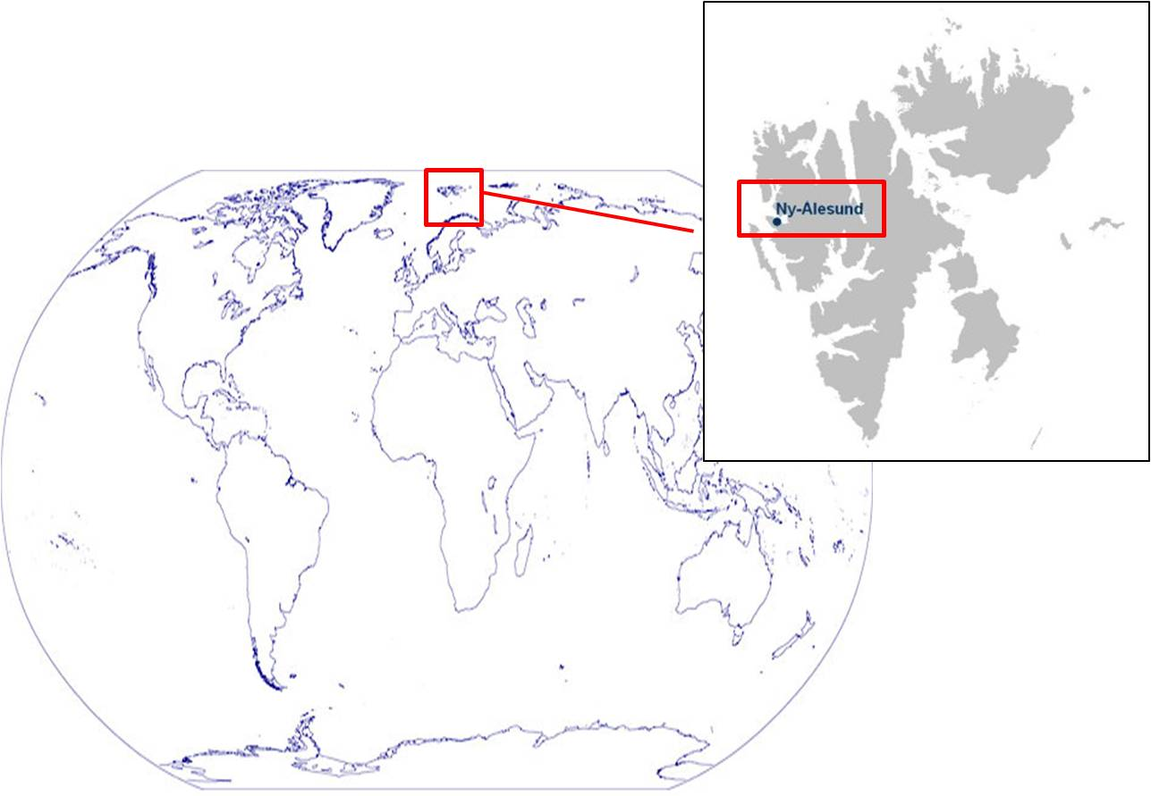
Figure 1: Location of Svalbard archipelago on world atlas and location of Ny-Alesund within the Svalbard archipelago

Figure 2: Satellite view of Kongsfjorden (outlined in red) and surrounding region.
- Oceanography
Spitzbergen acts as a western border of the Fram Strait, which lies between the Svalbard islands and the eastern coast of Greenland. The warm West Spitzbergen Current (WSC) flows poleward along the western coast of Spitzbergen, acting as the northernmost extension of the Norwegian Atlantic Current, shown in Figure 3. The current is largely driven by bathymetry and carries relatively warm, 6-8ºC, and saline waters, 35.1-35.3. The warm, saline waters maintain relatively ice-free conditions off the western coast of Spitzbergen. The East Greenland Current transports colder, arctic, sea-ice laden waters southwards from the arctic basin, flowing down the eastern coast of Greenland and the western side of the Fram Strait. At about 79ºN the WSC splits, partly flowing north and east mainly as an intermediate depth water body. It rejoins with the EGC and is largely modified, eventually flowing around the polar basins back into the Atlantic (Gyory et al., 2008). As both volume and topography of arctic sea ice have diminished over recent years it has been estimated that the temperatures of Atlantic waters in the WSC has increased (Svendsen et. al 2002).
The area of study, Kongsfjorden, is located around the divergence area of the WSC, and is vulnerable to changes in circulation or water mass mixing patterns, and fluxes in glacial melting. Fjord circulation is largely controlled by complex forcing mechanisms and topography. The major forcing mechanisms of mixing are within the fjord are year to year atmospheric climatic conditions and heat transport from the WSC, seasonal radiation changes, and wind and tide variations. Prevalent winds near Kongsfjorden/Ny-Alesund flow from south-east, from the fjord head near the Kongsbreen glacial termini to the fjord mouth, with a secondary north-west mode. Long term tidal patterns are difficult to gauge, tidal patterns in high latitudes are subject to polar movement, short term seasonal tidal variations, air pressure, isostatic rebound, and bathymetry changes from sediment deposition, acting as a major control on tidal amplitude. During the time of the study, tides were approaching the spring maximum; the tidal phase difference was around 170 cm on average in Kongsfjorden. Tidal data is sourced from a tidal gauge station located in Ny-Alesund, operated by Norsk Polar Institut.
Kongsfjorden is roughly 20 km long and spans from a variable 4-10 km in width, oriented from south-east to north-west. The inner basin of Kongsfjorden is separated from the main basin by a shallow sill and marked by the islands of Lovenoyane and Blomstrandoya (Elverhoi et. al, 1983). There are 4 active marine glaciers in Kongsfjorden; Kronebreen and Kongsbreen form the largest and most active front, Kongsbreen, located at the head of the fjord. The Kongsbreen front has been measured to release 138 m³/s during peak meltwater season in July, supplying the majority of the turbid meltwater to Kongsfjorden. The other two glaciers, Blomstranbreen and Conwaybreen, are less active and are located on the eastern shore of Kongsfjorden. An outer sill, closer to the ocean front and characteristic of fjords, is noticeably absent in Kongsfjorden (Zajaczkowski 2008). Fjord basins are typically 200-300 deep, this study focused on depths less than 70 m in the most inner basin, roughly 200 -1000 m proximal to the glacier face.
Previous measurements have been performed on the seasonal temperatures of Kongsfjorden waters, revealing more homogenous cold saline waters in the late winter/early spring through hypothesized cooling and convection. During spring and summer seasons, at heightened melt water maximums, North Atlantic water penetrates into Kongsfjorden at intermediate water depths along the southern side. The prior hypothesis for the driving mechanisms behind this force is the outflow of meltwater as a brackish surface plume forcing down the northern side of the fjord (Elverhoi et. al, 1983). Ekman drift causes water to either augment the height of surface waters or remove them; altering stratification, creating up-welling or down-welling systems, and building horizontal pressure gradients between the coast and the fjord that can force water in and out of the system (Svendsen et al., 2002). Mid-late summer measurements recorded from this study in the inner fjord basin examine the properties intermediate depth interflow, and the properties of the brackish meltwater surface plume, as well as the underlying, extremely cold and high saline fjord water body. The interflow stratification is most likely facilitated by a lack of forced mixing from the noted absence of a distinct outer sill. Prior studies have measured the 5-10 m thick summer surface layer of Kongsfjorden to have a salinity of 31-32 and temperatures between 2-4 ºC, with a more defined halocline near the surface (Zajaczkowski 2008). Salinity has been hypothesized to increase from the fjord head to the inner fjord.
Recent hypotheses have investigated the inflow of warming North Atlantic waters drawn into Greenland marine glacier fjords through convective processes as an intermediate water mass (Rignot et al., 2010).This circulation is balanced by a fresh outflow layer supplied by the glacial meltwater loads from the fjord head. Discharged fresh water and sediment instigates turbulent mixing and circulation of warmer oceanic saline waters with fresher fjord waters. The mixing layer outflows as a surface plume through density contrasts.
These proposed mechanisms are similar to the circulation patterns delineated and examined in research on Kongsfjorden and other Svalbard glacimarine systems. It has been proposed that these warming intermediate waters may melt the glacial termini, thinning submerged fronts, and decreasing stability of tidewater glaciers. With increasing water temperatures, proposed rate of melting mechanisms can also be estimated to increase, acting as a probable accelerated positive feedback cycle. The discharge source of freshwater and sediment in active marine glacier systems are often englacial and subglacial streams, where meltwater and sediment are released in enough volume to interact with local water inflows to create turbulent surface plumes. Two of these turbulent upwelling systems were regions of focus in this study.
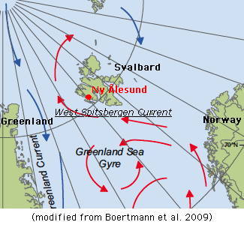
Figure 3: Illustration of circulation system around Svalbard. WSC is demonstrated in red. EGC is shown in blue. Source this

- Glaciology and Climate
The climate of Svalbard is considered mild arctic, and is largely controlled by variations in light, atmospheric circulation, ocean currents, and sea ice extent. The mild climate is sourced from the Icelandic low and high pressure regions which force warmer and humid air over the North Atlantic to the Norwegian Seas. A result of this mild oceanic air can be seen through the frequency of arctic fog, the milder air advects over colder glacial surfaces- creating a low, thick, dense fog. The mean annual temperature ranges from -4ºC to -6ºC depending on region of the archipelago. The highest annual temperature measured is 21.3ºC and the lowest is -46.3ºC (NPI Webpage). Large fluctuations are seen from coastal to inland regions from warmer coastal air and currents. Precipitation ranges from 300-400 mm with variability from east to west, with the western side of the archipelago receiving higher amounts of precipitation on average (NPI Webpage). Katabatic winds blowing towards the coast or inlet fjords from inland glaciers can instigate drastic drops and variability in temperature for short periods of time (Svendsen et al. 2002).
The polythermal glaciers in Kongsfjorden are vulnerable to seasonal and temporal changes. Basal temperatures and active calving rates contribute to the flow of glaciers and act as controls on the position of the termini. Glaciers in the Kongsfjorden area are estimated to be retreating at rates of between zero and 300m per year, with a 200 m per year as calculated by Lefauconnier et al. (1994). Information on the glaciology of the Kongsbreen complex is crucial to evaluating the data yielded in this study. The Kongsbreen glacier complex is comprised of 3 congruent glaciers, Kronebreen, Kongsvegen, and Infantfonna, that flow together to form a unified calving front at the head of the fjord. Kronebreen and Infantfonna are both commonly referred to as Kronebreen; the glaciers are separated by medial moraines. Kronebreen is a fast flowing glacier with a topographic high separating it into two calving fronts, is 50 km long and 590 km² total in area. Kongsvegen is a surging glacier and last surged between 1935 and 1956, approximately 27 km long and 189 km² total in area. The calving rate of the Kongsbreen complex is .25 km³, and as mentioned Kongsbreen contributes the majority of the meltwater source, 138 m³/s during peak meltwater season, and acts as the primary sediment source to the region (Zajaczkowski 2008). Meltwater and sediment is delivered directly from the ice face by englacial and subglacial outlets (Zajaczkowski 2008).
Blomstranbreen and Conwaybreen, tidewater glaciers located on the eastern coast of Kongsfjorden closer to the fjord mouth, see figure, deliver substantially less turbid meltwater. The current mean annual total meltwater run off to the Kongsfjorden basin from all collective glaciers has been estimated to be .33 km³ (Zajaczkowski 2008). The main freshwater sources are glacial ablation, snowmelt, summer rainfall, and ice calving. Freshwater runoff peaks during summer seasons as snow and ice melt reach a maximum. Runoff estimates are derived from meteorological data, mass balance studies, and runoff volume estimates.
- Sediment dynamics
The density and stratification of local waters, as well as local bathymetry/topography, is significantly affected by the sediment flux released from meltwater discharge systems. When glaciers retreat from marine to terrestrial systems, outwash sediment is deposited in the proglacial area and transported by fluvial systems, often forming structures like tidal flats and deltas (Zajaczkowski 2008). An example of this is the Kongsvegen delta, which has been estimated to have formed between 1975-1983, when the average sediment discharge from the Kongsbreen glacial complex was .25 x 10⁶ m³ (Elverhoi et al. 1980). Sedimentation rates are believed to have increased since then. The delta is thought to have formed as a grounding line fan that developed over time by accumulating sediment and eventually aggrading above sea level through described submarine discharge processes and medial moraine dumping (Trusal et al., in press). Sedimentation rates and bathymetric profiling techniques examine the effect of sediment discharge on bathymetric and topographic features.
Meltwater plumes serve as primary sources of sediment discharge beyond grounding lines, sediment accumulation can range from 200-2000 cm/yr within 1 km of grounding lines, which is within the range of this study (Smith and Andrews 2000). Sediment accumulation at grounding line fans can reduce submerged surface area exposed to fjord waters, reducing surface area vulnerable to submerged melt and calving, and can temporarily stabilize from glacial surging. Sediment discharge dynamics provide insight into topographic and bathymetric processes that control and happen within deglaciation. Tidewater glaciers in Svalbard are similar to those in Alaska, where the climatic regime is warm enough to induce glacial meltwater acting as the primary sediment delivery source, as opposed to East Greenland where sediments are largely derived from iceberg melt (Smith and Andrews 2000).
Sediment settling and dispersion mechanisms are attributed to salinity, tidal forcings, particle size, and velocity. In glacially dominated fjords, suspended particulate matter is transported farther into fjords in buoyant brackish hypopycnal flows than non-glacial contact fjords (Svendsen et al., 2002). The low density glacial outwash carries the suspended particulate matter over higher density bodies of water until tidal pumping and water mixing induces settling and deposition. Mixing between turbid meltwater and suspended particulate loads contained within other water mediums are often limited because of density differences. Meltwater currents have carried particulate matter up at an estimated 5-6 km from the point source (Zajaczkowski 2008).
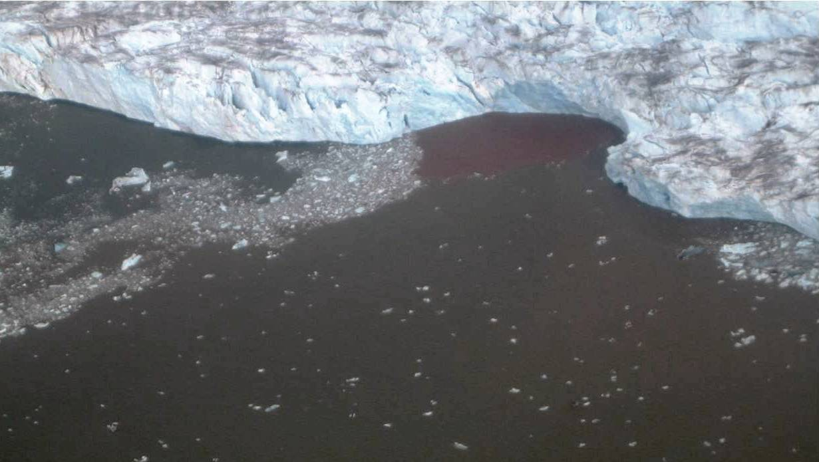
Figure 4: Aerial view of turbulent surface plume, sourced from subglacial upwelling
- Methodology
Samples and data were collected from July 29th 2009 to August 13 2009, yielding supreme weather conditions for oceanographic measuring techniques, with maximum melt conditions due to seasonal warming, and local tidal cycles approaching the spring maximum. Mixing properties and water column stratification are maximized during summer months from melt water runoff and particle transport through exaggerated semi-diurnal tidal cycles Samples were collected out of two 6 meter skiffs, sited using standardized GPS units. GPS coordinates were used to repeat measurement sites for different sampling days over the field period, sampling locations can be seen in Figure 5. A 3 station transect was the objective, targeting a sampling location proximal to the glacial termini, an intermediate station, and a distal station. These stations were ideally 300 m apart, yielding a transect of roughly 200 m, 500 m, and 800 m, but field sampling in hazardous conditions in front of an actively calving glacier subject the accuracy of ideal sampling locations. Sources of error include high velocity currents, winds, and drift, often causing actual measurements to be taken while experiencing slow velocity drift, and finishing sampling farther back from the targeted location. Ebb and flood tidal phases were targeted for initial comparison.
The devices used to profile the water column and record salinity, temperature, depth were a SeaBird SBE CTD 19 V Plus Profile and a Seabird SBE CTD 19 Profiler with an attached SEACAT D&A OBS 3+ Turbidity Sensor optical backscatter devices (OBS) to measure suspended particulate load. Water sampling utilizing a remote triggered alpha bottle was completed to quantify the concentration of suspended particulate matter at depths of hypothesized interflows, distinct bodies of water within the water column with noticeably different optical backscatter properties. Water samples were filtered onto 63 micrometer Millipore filters using a vacuum pump, particulate matter was left to dry at room temperature, 70ºC, for 24-48 hour periods, then weighed. Sampling focused on two specific areas of the glacial front, a high velocity subglacial upwelling plume and current system located on the north side of Kronebreen, and an upwelling system induced by a an ice marginal stream on the Kongsvegen side of the glacier located in a semi-enclosed sedimentary yielded delta, shown in Figure 5. Fjord bathymetry was completed by members of the research project with a Knudsen 320BP echosounder and subbottom profiler, targeting transect lines perpendicular to the disparate upwelling systems and parallel to glacial termini, augmenting mixing analyses. Quantitative analyses were performed on the data collected to compile oceanographic profiles and suspended sediment profiles. Results were compared to findings from a similar study performed in 2005.

Figure 5: GPS coordinates of sampling locations for CTD measurements shown on the upper image. Sampling locations concentrated in the Kronebreen upwelling system and near the ice marginal stream proximal to the Kongsvegen delta. The Kongsfjorden and Kongsbreen complex are outlined in the lower image.

The two areas of the upwelling systems of the Kongsbreen glacial complex are labeled below in Figure 6 as Area 1 and Area 2 for simplistic reasons, and will be discussed as such in the results and analysis.

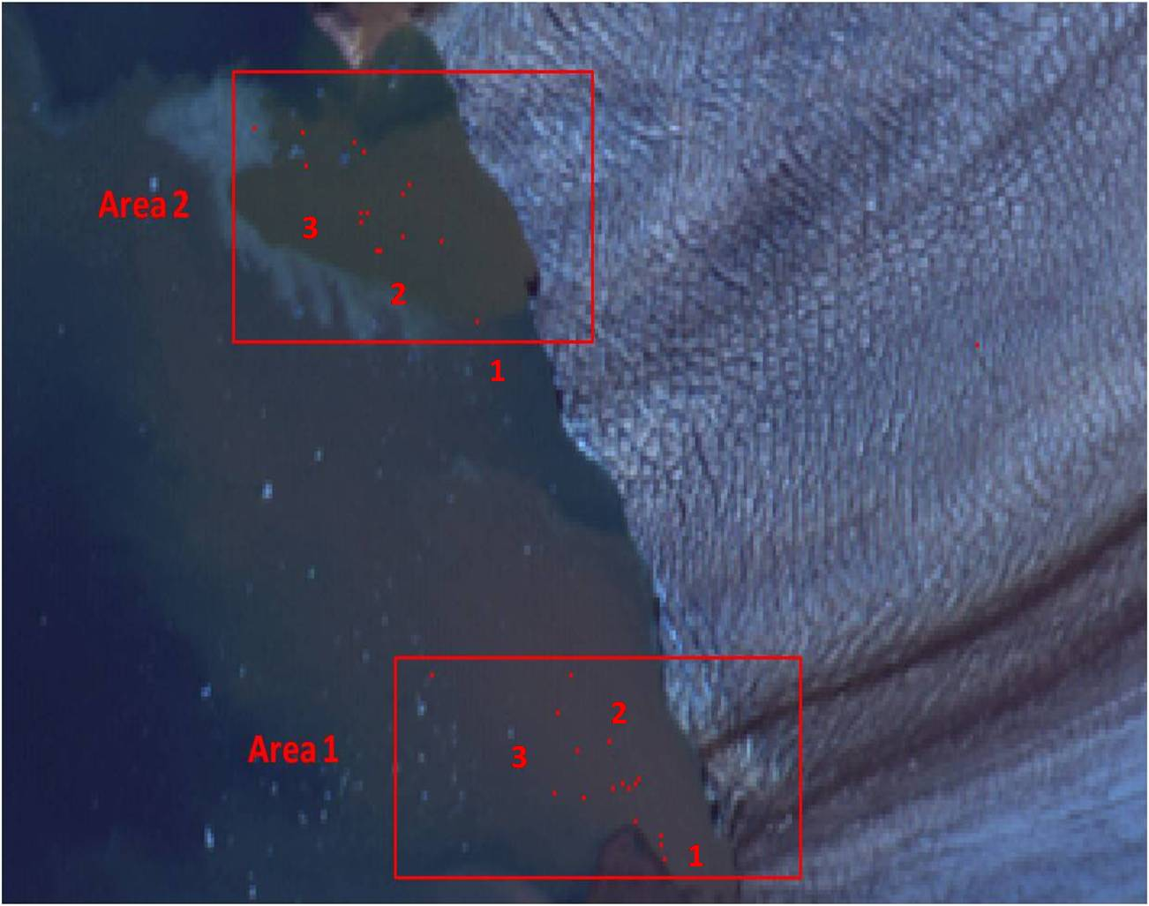

Figure 6: GPS coordinates shown again, Area 1 is upwelling system located near Kongsvegen delta complex. Area 2 is the subglacial upwelling system located on the north side of Kronebreen. 1, 2, and 3 signify the objective points on each transect, 1- proximal sampling location, 2- intermediate sampling location, and 3- distal sampling location. Both meltwater sources are subglacial in origin.

- Results

- Oceanographic analysis:

An oceanographic profile was compiled for the general Kongsbreen glacial termini, for Area 1 and Area 2, and along each station on the 3 point transects- a sampling location proximal to the glacial termini, an intermediate station, and a distal station. Compiling results from all scans across the field sampling period yields a general Temperature- Salinity profile, through data clusters distinct water masses can be identified. A turbid surface mixing layer was identified, with salinity ranging from 14-34, temperatures ranging on average from 2.5 to 4.0 ºC, and density ranging from 12 to 27 kg/m³. Higher temperature and saline define intermediate waters, and cold high saline waters define more stagnant bottom water masses.
Results are shown in the T-S diagram in Figure 7. T-S diagrams for Area 1 and Area 2 are shown in Figure 8. There is very little deviation in the characteristics of the 3 water masses from Area 1 to Area 2.

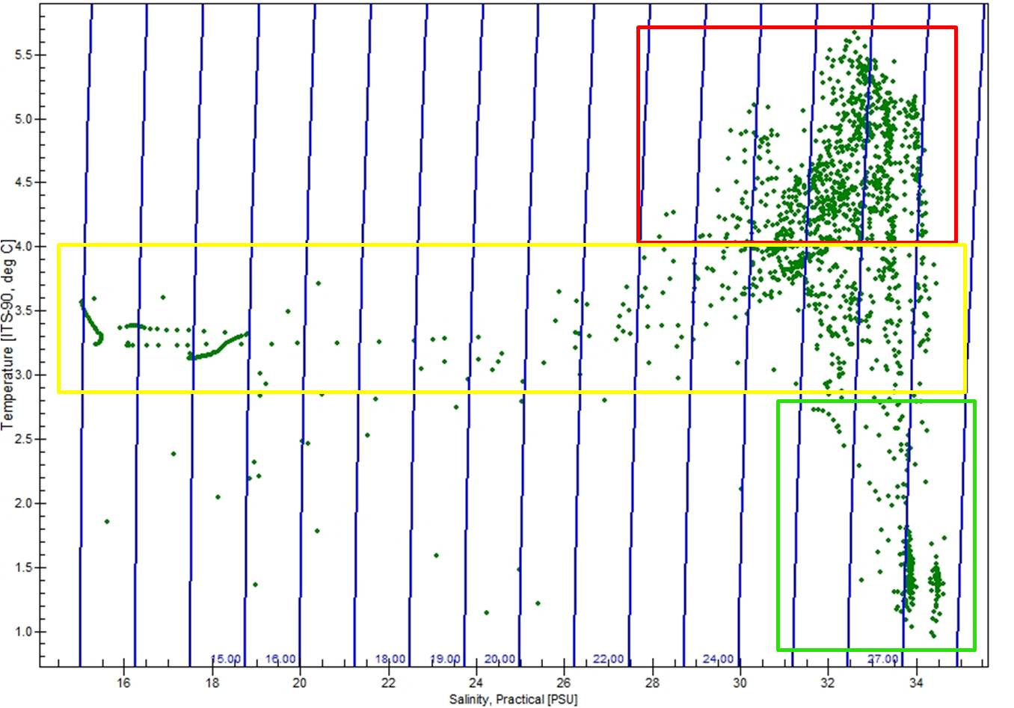

Figure 7: T-S diagram demonstrating collective oceanographic characteristics of Kongsbreen glacial complex. Blue vertical lines are density contours in sigma theta, numerically identified at the bottom. The upper red box signifies the Intermediate Atlantic Interflow Water- IAW, the central yellow box is denoting the Surface Mixing Water- SMW, and the bottom green box signifies the Fjord Bottom Water- FBW.

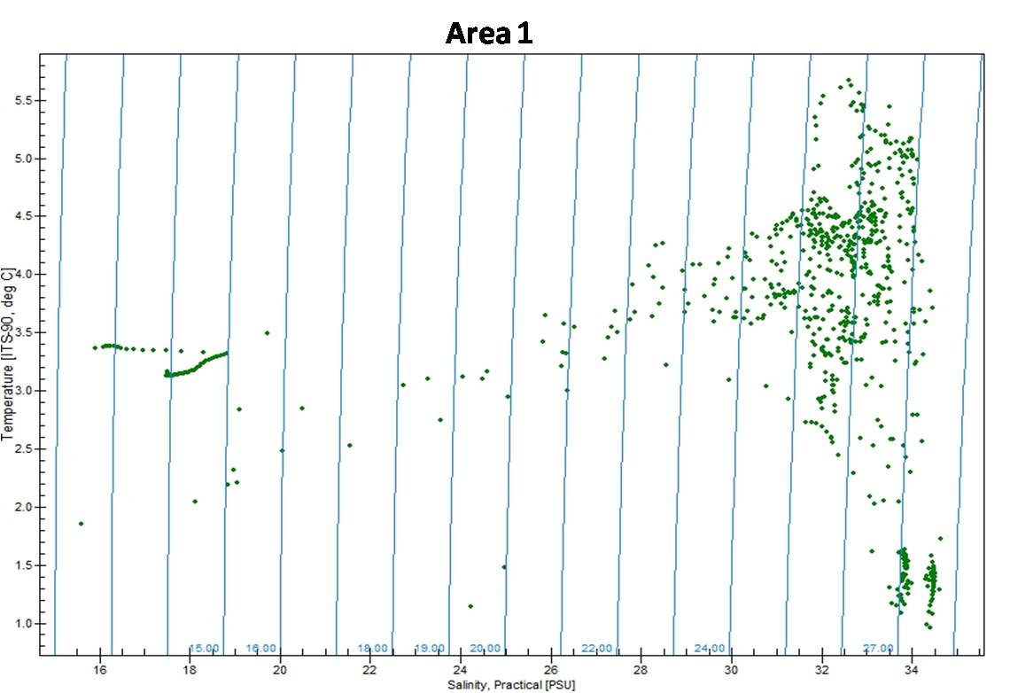
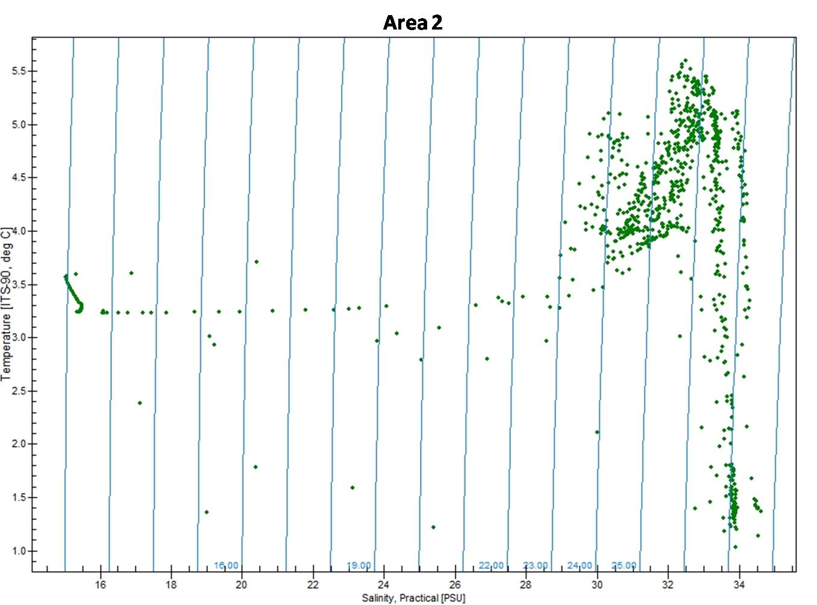

Figure 8: T-S diagrams for Area 1 and Area 2. Water retains similar characteristics; the SMW, AIW, and FBW are clearly defined.

Thermoclines and haloclines demonstrate the interflow stratification and were compiled for each of the 3 stations of the transects for Area 1 and Area 2, shown in figures 9 -13 below. Area 2 proximal and intermediate stations are hard to distinguish and exhibit similar properties, thus are both labeled on Figure 12. High velocity currents carrying large amounts of brash and calved ice made it difficult to access the proximal distances to the glacial termini.

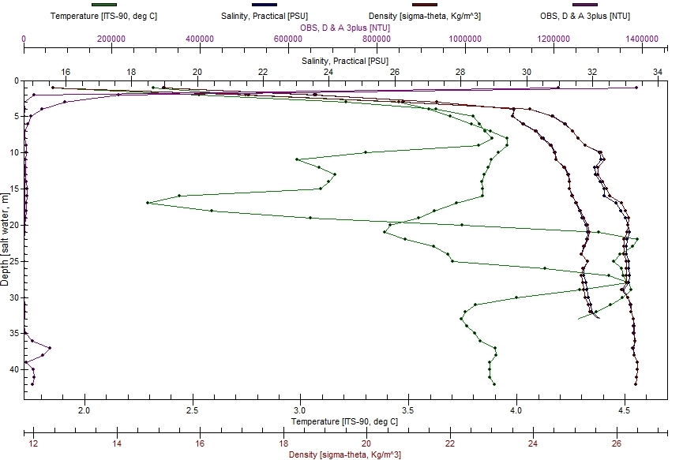

Figure 9: Profile for all Area 1 oceanographic scans taken at the most proximal transect station. Temperature is labeled on the bottom axis in ºC, showing the greatest variability. Salinity is shown in blue and labeled on the top axis. Density is in dark red on the bottom axis. Density and temperature are hard to distinguish, following almost identical trends. Optical Back Scatter, OBS values in NTU, labeled on the top axis, is also shown.

The majority of these scans terminate from 20-30 m, with one anomalously terminating at 40 m, which could be a result of faulty GPS recording or drift to an area with a greater depth farther from the original deployment site. The surface layer demonstrates an increase of temperature from about 3.0 to 4.0 ºC in 0 to 10 m, with salinity ranging from 29 to 32, density between 24 and 26 kg/m³. OBS values have a large range of variability, from 140,000 to 0 NTU in 5 meters, sediment that is released from point sources concentrates at the surface and shows almost no visible mixing within the water column. The AIW layer is evident mainly through the large temperature spike from 15 to 30 meters, 2.5 to 4.5 ºC, salinity ranging from 31-33, a slight density increase from 25 to 26, and optical properties remaining consistent. The FBW is not really present at this proximal transect, at shallow depths greater mixing from deep upwelling waters prevents a stagnant cold layer from developing. The optical back scatter shows a small spike to 800 NTU at depths at 35-40 m, where low energy bottom sediment transport occurs.

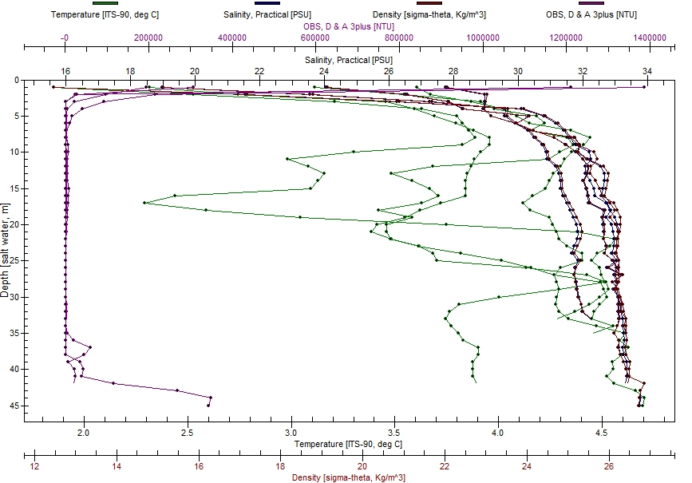

Figure 10: Area 1- intermediate transect station. Labeled in units and axes detailed in Figure 9.

This transect retains similar characteristics as the area 1 proximal station. The surface layer shows a slight increase from 3.5 to 4.5 ºC, salinity ranging from 28 to 33, density between 23 and 25 kg/m³, and OBS values decreasing from 140,000/120,000 to 0 NTU in about 5 meters. The AIW is distinguished by a large temperature spike between 15 to 30 meters, from 2.2 ºC to 4.5 ºC, salinity increase from 30 to 33, density roughly between 24 and 26 kg/m³, and NTU relative to 0. The FBW is again, not really evident in this transect station. OBS values show a spike between 35- 45 meters from 0 to around 3500 NTU.
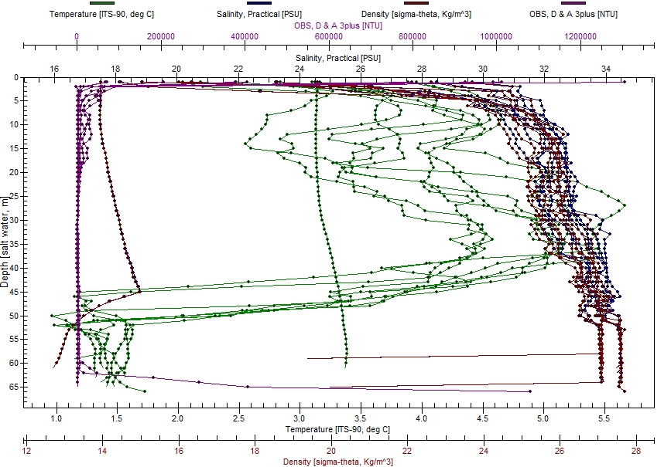
Figure 11: Area 1 distal station

The distal transect point shows the stratification of the 3 layers more clearly. The SMW from 0 to 20 m exhibits a slight temperature variation from about 2.5 to 4.5 ºC, with salinity ranging from about 2 to 32, and density between 22 and 26 kg/m³. OBS values show variation from 120,000 to 0 NTU, with most variation occurring from 5 – 20 meters between 0 to 10,000 NTU. The AIW is evident from 20- 45 meters. A large temperature spike begins at around 20 m depth, increasing to 5.0-5.5 ºC, and then decreasing slightly to 4.5 ºC at 40 meters. Salinity shows an increase from around 32 to 34, with density following a similar trend and increasing from 25 to 27kg/m³. Optical properties stay relatively constant at 0 NTU. The FBW is evident from 40 to 65 meters by the large temperature decrease. Temperature decreases from 4.5/5.0 ºC to 1.5 ºC in a 15 meter interval, and then remains constant to the bottom. Salinity increases to 34 and remains constant, density increases to high 28 kg/m³. OBS values show a very small amount of variation at the bottom signaling low levels of bottom particle transport.

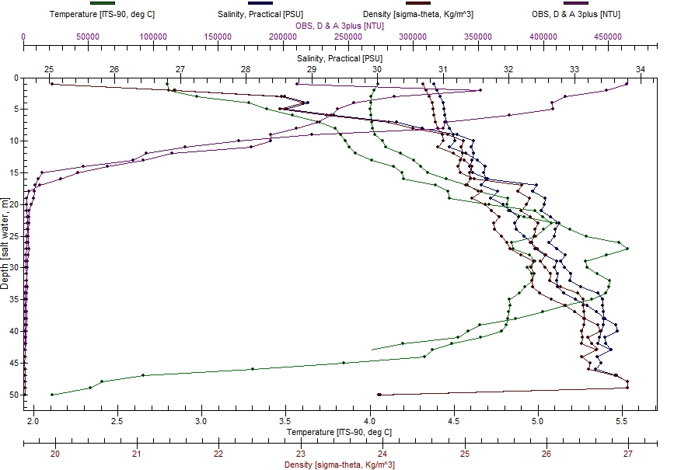
Figure 12: Area 2 intermediate/ proximal station

Area 2 is subject to high mixing forces, stratification is less evident closer to the glacial termini where calving rates are high, and brash ice causes mixing within the water column. Variation in the optical properties are extremely evident in the first 20 meters, suggesting that most of these scans were taken during periods of high outwash of glacial meltwater and sediment flux. After 20 meters NTU decreases and remains constant at 0. The AIW interflow temperature spike to 5.5 ºC is still evident at 30 m; the FBW is slightly visible through the decrease to 2.0 ºC. Salinity shows a constant increase with depth, from 30 to about 33, with density following a similar trend from 24 to 27 kg/m³.
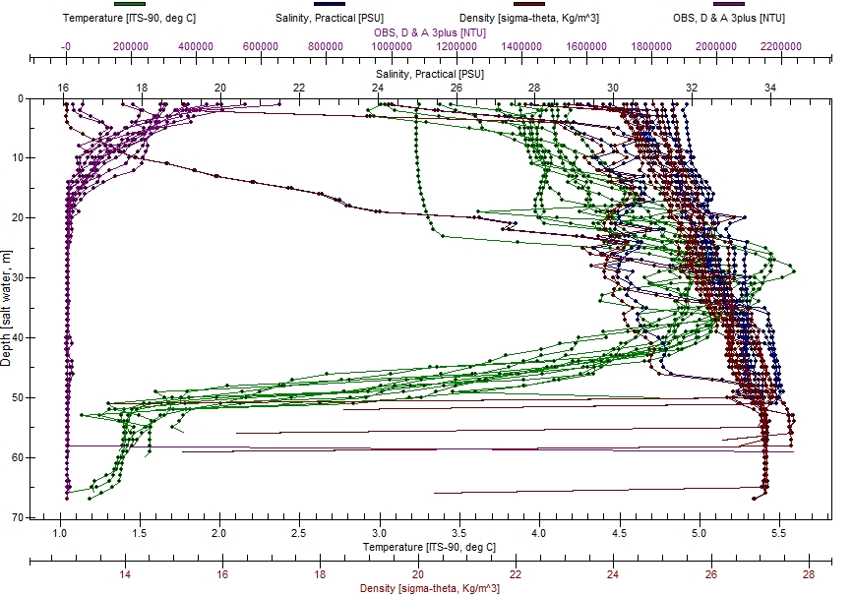

Figure 13: Area 2 distal transect station.

The 3 layer stratification system is evident in this transect location, the AIW and FBW interface is the most prominent feature in this profile. The surface mixing layer is relatively consistent with temperature, salinity, and density, but shows variability in turbidity/optical properties from 0-20 m, again demonstrating the high quantity of sediment concentrated in the surface layer. Temperature for the SMW is constant around 4.0-4.5 ºC, with salinity ranging from 30-31 and density between 25-26 kg/m³. The AIW spike is between 20 -40 m, from 4.0 to 5.5 ºC, with salinity up to 33, and density increasing to 27 kg/m³. The temperature interface between the AIW and FBW is extremely well defined, decreasing from 5.5 to 1.5 ºC in 10 meters (40-50 m depth). Temperature, salinity, and density are consistent with greater depth. OBS values show small variability at the defined AIW and FBW interface, suggesting a sediment mixing/transport layer.

A similar study conducted in 2005 completed in the Kongsbreen inner basin yielded similar results, but with some noticeable differences in major water column properties for the entire glacial termini. The surface outflow, characterized at depths up to 12 m was reported to be much colder, cited as 0.5-1 ºC in (Trusal et. al, in press) and colder than bottom fjord ambient water. Measurements and profiles yielded over the 2009 field sampling season on average measured the surface plume to be 20 m deep on scans over 30 m, and with mean temperatures between 3.0-4.0 ºC, with over-all variability ranging from 2.0-5.0 ºC. This is a remarked increase from 2005-2009 in surface temperatures for the outwash layer. High temperature variability is a result of the release of large volumes of meltwater and brash or calved ice. This also can interfere with underwater instrumentation methods, which is not visible above surface.
The defined, intermediate depth, warm saline interflow was characterized in 2005 as well as in 2009. Similar studies have also concluded that the intermediate water body is an interflow of local waters, yielding high temperatures induced by elevated levels of absorbed solar radiation. The water although warmer than surface water, and with considerably less sediment concentration, is much higher in salinity and therefore density, facilitating the outflow of the surface plume. The mixing interface between these two water masses is less defined than the one distinguished in sampling between the AIW and FBW. 2005 measurements also show intermediate waters exhibiting temperatures in excess of 5.0 ºC, the defining characteristic of the interflow. The fjord bottom water is proposed as local waters formed through convection (Svendsen et. al 2002), with a constant value in previous studies around 0ºC and a salinity of 34. The quantitative values for the fjord bottom water generated in this field season did not measure the water mass on average to be below 1.0 ºC, although the value is relatively consistent.
Although the mean oceanographic characteristics of Area 1 and Area 2 are very similar, shown in the T-S diagrams in Figure 8, the two upwelling systems demonstrate differences in water mass stratification at different transect stations. For Area 1 the proximal transect site, Figure 8, and the intermediate transect site, Figure 10, do not exhibit a strong AIW/FBW interface or defined cold bottom water mass. As shown on the figures, the majority of these individual measurements terminated at around 30-35 meters depth, where subglacial upwelling sources create strong intermixing at shallower depths, and the semi-enclosed sedimentary delta provides a barrier for the bottom water mass exchange with Kongsfjorden waters. At more distal stations in Area 1, located farther outside of the delta, these mixing controls are not exerted and the 3 water mass stratification system is more evident.
The subglacial upwelling system in Area 2, the northern side of Kronebreen, is subject to high velocity currents sourced from a jet stream of meltwater, often carrying large turbulent ice streams and volumes of sediment. This induces large quantity mixing on the upper water column, which is evident through the relatively constant values of temperature and salinity from 0-20 m for the oceanographic profiles in Area 2 compared to Area 1.Sediment variations and mixing interfaces will be discussed more in depth below in the suspended sediment analysis section.
- Suspended sediment analysis

Sediment concentration of the water taken from alpha bottle samples and OBS values were plotted to yield correlation values for Area 1 and Area 2. The R² values did not show very strong signals of correlation, yielding values of 0.7207 for Area 1, and 0.2416 for Area 2. The low significance attributed to these values may suggest that the volume of sediment flux to the water column isn’t the strongest control of the turbidity of the water column, or other mechanisms, possibly tidal forcings and water mixing patterns, exert significant controls on turbidity. In further examination of optical back scatter properties, a turbidity anomaly was defined at each identified mixing interface, shown in Figures 14, similar to the 2005 study. These sediment layers suggest that this is a possible transport or settling layer, forcing the sediment to remain in suspension because of density differences between the water mass. The fjord bottom water is the most dense water mass, forcing the sediment to remain in suspension. This concept is examined in Figure 17, comparing salinity against optical backscatter characteristics. Figure 17 demonstrate that high saline waters retain larger volumes of suspended particulate matter. The largest amount of sediment is concentrated in the between salinities 30-34, peaking at 31.
Sediment concentrations were highest in the surface outflow plume, decreasing logarithmically to sea floor. The similar study in 2005 reported the highest measured load of suspended sediment concentration to be 0.39 kg m³, (Trusal et. al, in press). The highest values in the 2009 field season were significantly higher, 0.5737 kg m³ (29007AB005a). The highest measured OBS reading was 246.1491 NTU. The mean suspended sediment measured was 0.1058 kg/m³, with a standard deviation of 0.0130 kg/m³ and a variance of 0.1055 kg/m³. For Area 1 the mean suspended sediment concentration was 0.0839 kg/m³ with a standard deviation of 0.0717 kg/m³ and a variance of 0.00551 kg/m³. The OBS values for Area 1 range from 6.813 to 246.149 NTUs, with a mean of 53.5, and a standard deviation of 66.8 NTUs. For Area 2 the mean suspended sediment concentration was 0.1374 kg/m³, with a standard deviation of 0.1362 kg/m³, and a variance of 0.0186 kg/m³. The OBS values for Area 2 range from 167.029 to 142.33 NTUs, with a mean of 77.4, and a standard deviation of 48.8. The optical back scatter was only utilized for the second half of the 2009 field season because of technical malfunctions, the data distribution between Area 1 and Area 2 is uneven, with 24 separate readings for Area 1 and 12 for Area 2. This is a source of error that also lead to extremely large variances and a larger than expected range of values. The suspended sediment concentration values for Area 2 are much higher than Area 1; the subglacial jet stream in Area 2 most likely has a higher discharge volume, the high surface variability in Area 2 from a likely higher discharge volume in comparison to Area 1 is shown in the OBS values in Figures 15/16. The turbidity/optical properties of the general water column is demonstrated below by Figure 14. High surface variability in suspended particulate matter, representing the turbid surface outwash layer (SMW) terminates at 20 m. Between 40 and 45 meters an anomaly is demonstrated, the mixing interface between the AIW and FBW is at this depth, an anomaly is again seen at the bottom layers.
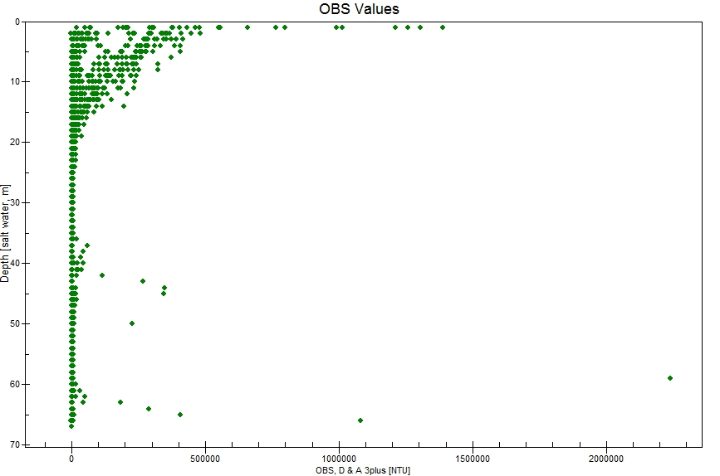
Figure 14: OBS values for both Area 1 and Area 2

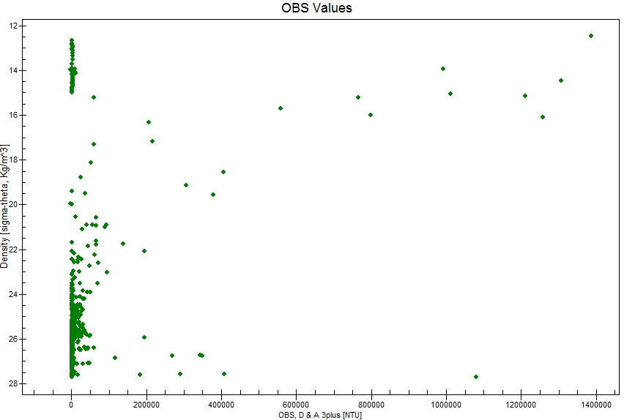
Figure 15: OBS Values for Area 1

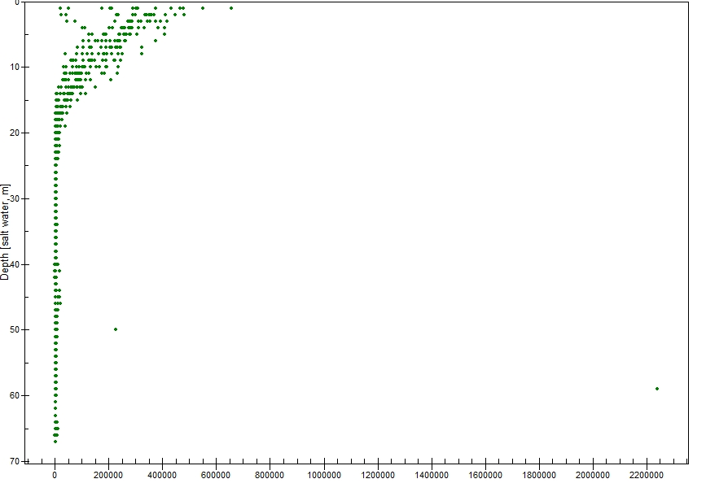
Figure 16: OBS values for Area 2.

The suspended sediment in the surface plume in Figure 16 is much more evident than in Figure 15, where highest variability occurs at the bottom where hypothesized low energy sediment transport takes place. Figure 15 also shows a sediment anomaly at the interface between the surface mixing plume and the intermediate interflow, which is absent in Figure 16 below the highly variable SMW layer. OBS measurements taken in Area 1 terminated before reaching lower water masses and mixing interfaces.
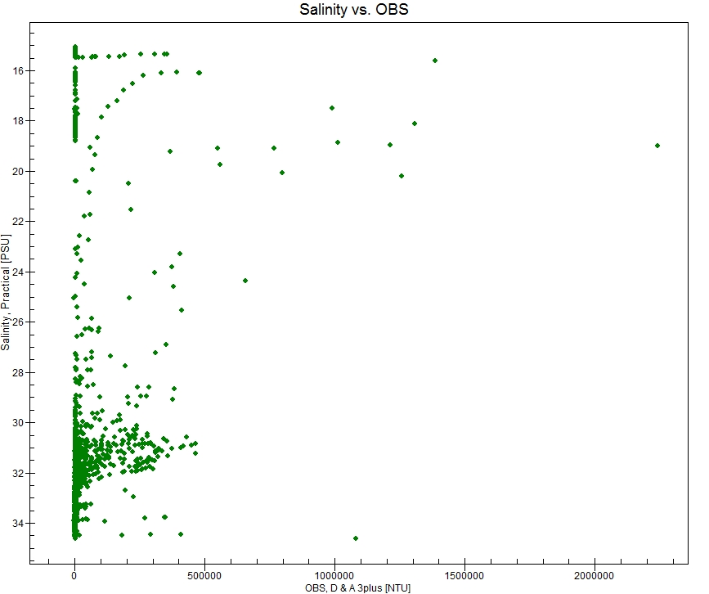
Figure 17: Salinity versus OBS values for both Area 1 and Area 2.
Sub-bottom profiling and bathymetric studies yielded in the 2009 field season by Laura Kehrl of Dartmouth College produced the bathymetric profile shown in Figure 18. The bathymetric high, outlined in yellow, is believed to be a grounding line fan proposed in 2005, sourced from subglacial upwelling.
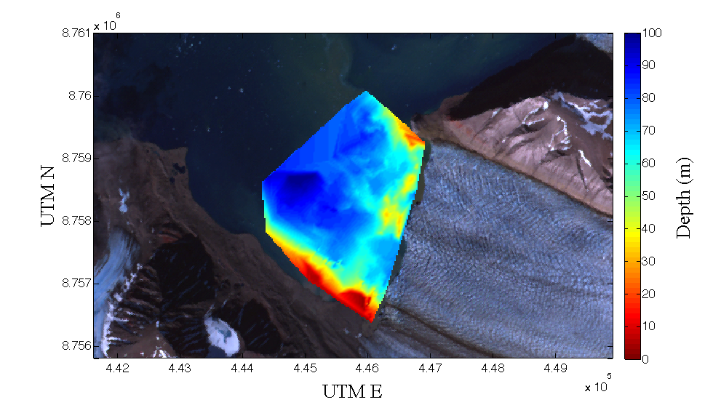

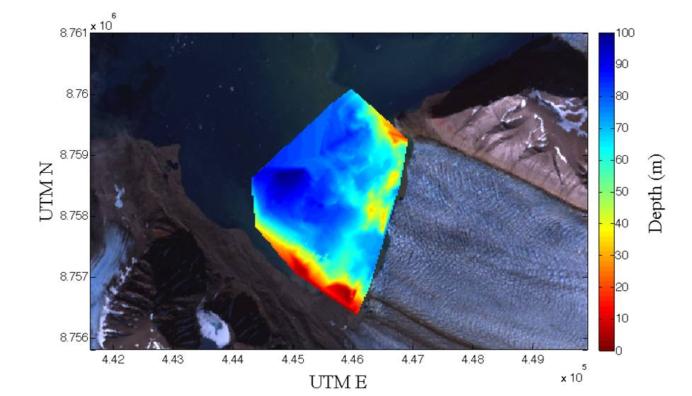
Figure 18: Bathymetric profile of Kongsbreen system
The bathymetric high and proposed grounding line fan separates the defined turbid surface plumes of Area 1 and Area 1, shown in Figure 6. The separations between the two sediment sources and the different bathymetric features specific to each subglacial upwelling plume are representative of the different processes occurring across the glacial termini.
- Discussion
An original focus of the measured oceanographic and sediment dynamics was to compare
data taken on opposing semi-diurnal tidal phases, targeting disparities between water column stratification and suspended sediment load between ebb and flood tidal phases. The ideal was to obtain an equal amount of measurements on each tidal phase, but sampling limitations forced the data set to concentrate more heavily on flood tidal phases, yielding an un-equal amount of data for comparison. Small amounts of reduced water stratification in the water column on low tide measurements between the water masses were evident, with reduced characteristics of the SMW, the surface plume. With surface waters being drawn gravitationally to the mouth of the fjord, the upper water masses are subject to forced mixing, yielding a more homogenous upper water column. This was more evident in Area 2 then Area 1, the delta prohibits tidal forcings through mixing in comparison to the region of Area 1. OBS characteristics and suspended particulate concentrations were analogous on ebb and flood tidal phases.
Kongsfjorden bathymetric profiles of the central basin have revealed the absence of a shallow sill that inhibits warm intermediate water mass circulation into fjord waters. This intermediate water mass was the most clearly defined and constant layer of water within the Kongsfjorden water column. The AIW was the most evident water mass in both Area 1 and Area 2. The general characteristics, as evident by Figures 7 and 8 were consistent between Area 1 and Area 2. The surface turbid outflow/mixing layer had variable salinity and temperatures, but was generally warmer than the very cold and high saline fjord bottom water. The AIW was very warm and high saline. The minimal variability between these mean characteristics between Areas 1 and 2 indicates that the characteristics defined in Figure 7 are the more general characteristics of the inner Kongsfjorden basin, largely defined by the induced meltwater and sediment from the Kongsbreen glacial termini. The deviations between the two disparate upwelling systems and between the different transect stations are controlled by daily and locational forcings, such as precipitation, solar radiation, meltwater induced from solar radiation, and wind forcings.
Salinity and density follow parallel trends, indicating that salinity is the major control of the water column density. These variables showed highest deviation in the surface layer, where released freshwater from meltwater and ice greatly alter salinity. A defined saline spike between at the interface between the AIW and FBW was evident, at 40-45 meters depth. Although these characteristics are constant across the glacial termini, some discrepancies along the transects in both Area 1 and 2 were apparent. The FBW did not exhibit cold and high saline characteristics at distances, on average, shorter than 500 meters from the glacial termini. The delta semi encloses the area preventing the diffusion of fjord waters at bottom depths within range. Upwelling forces here could also potentially be strong enough to prevent definite formation of bottom waters.
Intermediate transect stations (<500 m) in Area 2 also lack a fjord bottom water mass. The high velocity of the subglacial streams here induce high mixing conditions, also releasing large amounts of brash ice that can discharge high volumes of meltwater, and transporting the instruments within freshwater conditions. With reduced salinity, density is reduced and the high saline, high density characteristics of the fjord bottom water are absent. At more distal transect locations, the effect of ice is more minimal and the fjord bottom water is clearly defined. The surface meltwater layer shows a less temperature and salinity variability in Area 2, in Area 1 smaller amounts of ice are released and thus, when large calving events occur meltwater induces greater amounts of mixing. Surface waters in general were measured to be warmer than 2005 readings, which can be attributed to increased absorption of solar radiation, also evident through accelerated retreat levels, and local climatic changes.
The salinity properties of the water column are significant and analogous to the optical properties and turbidity of inner Kongsfjorden. The largest optical anomalies were seen in bottom and surface layers. Sediment volume is high at the surface, where the turbid surface outflow plume carries large volumes into fjord waters. Sediment is also directly released subglacially, and retained by high saline waters; high bottom spikes are interpreted as layers of low energy bottom sediment transport. Area 2 exhibits an extremely defined turbidity plume in surface waters, extending to 20 meters depth, which is representative of the large amount of sediment being released from the north Kronebreen upwelling system at depth. The sediment transport processes are supported by sediment salinity analyses, shown in Figure 17. The most saline waters, which are characteristic of the FBW, lower AIW, and the FBW-AIW mixing interface. These high saline waters keep sediment in suspension through higher density values, water circulation and mixing transport them farther into the fjord where they eventually settle through suspension in lower density water masses that are subject to higher levels of mixing. The consistency of the optical properties in Area 2 in comparison to Area 1 demonstrate the inconsistency of sediment discharge in Area 1, where suspended particulate loads and optical properties demonstrate that there is no strong signal of a constant volume of sediment flux. These values have most likely changed as the terrestrial retreat of Kongsvegen has continued.
The grounding line fan documented through bathymetry close the submarine meltwater discharge source was estimated in 2005 studies to be actively building at more than 300 mm (Trusal et. al, in press). Higher average OBS values and suspended sediment values yielded in this study support 2005 findings and estimated sediment flux rates (Trusal et.al, in press) that Kronebreen is now the major sediment source as opposed to Kongsvegen, a relationship that has reversed in the last 25 years (Elverhøi et al. 1980). The emerged Kongsvegen delta and grounding line fan are estimated to temporarily increase stability of the glacial complex but not necessarily prevent it from its next major surge. Variability in surface suspended sediment layers through calibrated OBS values also supports the daily fluctuation of overflow plume positions. Sediment flux to polythermal glacial complexes is variable with season, largely subject to season and climate, and therefore in relation to glacial stability, can be hypothesized to change under projected warming temperatures. The quantitative data from both sources, compiled to represent the majority of the sediment source, is useful in evaluating these parameters in context of glacial stability. 2005 data estimated that glacial deltaic runoff from Kongsvegen contributes 20-25% of the total volume of sediment to the inner fjord, with Kronebreen making up the majority (Trusal et. al, in press).
Oceanographic profiles in relation to submarine melt and warming water masses that were documented in this study, may also increase in their importance to de-stabilizing glacial complexes under projected oceanic and climatic changes. As mentioned, with increasing atmospheric and oceanic temperatures, the temperature of penetrating oceanic water masses into glacial fjords can also be expected to increase. These water masses are expected to accelerate submarine melting and de-stabilize grounding line fans, with increasing temperatures these processes can also be expected to increase. The penetration of these water masses is facilitated by the outflow of the turbid, fresh, surface layer, therefore if melt rates increase, thereby increasing meltwater volumes, dense warm oceanic waters can penetrate into glacial fjords more readily, expediting these processes and generating a positive feedback cycle. The overarching trend yielded from comparing data from this study to a previous study in 2005 was an increase in sediment volume in water, and variances in oceanographic characteristics that are most likely attributed to warming oceanic waters and amplified meltwater volumes.

- Future Research
Further quantitative studies on convective interactions between glacial fjords and larger circulation systems are necessary to link the properties characterized in this study to glacial de-stabilization. To accurately gauge the hypothesized effect of accelerated subglacial melting from the penetration of warm oceanic waters into fjord, melt rates and currents need to be extensively documented in proximity to the Kongsbreen glacial termini. Turbidity values and oceanographic properties can be linked to estimated sediment volume and meltwater fluxes. Sediment volume and meltwater fluxes need to be extensively monitored over the summer meltwater season when sea ice content in Kongsfjorden is low enough to permit access to the inner basin. Quantitative data generated in hazardous glacial environments in close proximity to actively calving glaciers that was generated in this study is extremely difficult to obtain because of environmental hazards. Research records in inner glacial fjords are thus limited, making modern hypotheses difficult to prove without extensive data.

- Acknowledgements
This research was conducted through the National Science Foundation Svalbard REU program, and made possible through the cooperation of Norsk Polar Institut, Kings Bay AS, and UNIS. I would also like to thank the collaborating members of my field research group for their help with data collection and their cooperation in general.
Laura Kerhl- Dartmouth College
Theodore Barnhart- Whitman College
Laura Poppick- Bates College
Hector Zamora- University of Texas El-Paso
Phaedra Tinder- Bryn Mawr College

I extend my gratitude and thanks to the leaders of the Svalbard REU for their guidance in the field and in science research.
Julie Brigham-Grette- University of Massachusetts-Amherst
Ross Powell-University of Northern Illinois
Steve Roof- Hampshire College

- References
Elverhøi, A., Liestøl, O. & Nagy, J. 1980. Glacial erosion, sedimentation and microfauna in the inner part of Kongsfjorden, Spitsbergen. Norsk Polarinstitutt Skrifter, 172, 28-61.

Elverhøi, A., Lønne, O. & Seland, R. 1983. Glacio-marine sedimentation in a modern fjord
environment, Spitsbergen. Polar Research, 1, 127-149.

Gyory, Joanna, Mariano, J.A., Ryan, E.H. The Spitzbergen Current. Ocean Surface Currents. (). http://oceancurrents.rsmas.miami.edu/atlantic/spitsbergen.html

Lefauconnier, B., Hagen, J. O., Pinglot, J. F. & Pourchet, M. 1994. Mass-balance estimates on
the glacier complex Kongsvegen and Sveabreen, Spitsbergen, Svalbard, using radioactive
layers. Journal of Glaciology, 40, 368-376.

Powell, R. D. 1991. Grounding-line systems as second-order controls on fluctuations of
tidewater termini of temperate glaciers. Glacial Marine Sedimentation; Paleoclimatic
Significance, Geological Society of America Special Paper, 261, 75-94.

Norsk Polar Institut. Svalbard Climate. http://npiweb.npolar.no/

Smith, L.M., Andrews, John T. 2000. Sediment Characteristics in iceberg dominated fjords, Kangerlussuaq region, East Greenland. Sedimentary Geology, 130, 11-25.

Svendsen, H., Beszczynska-Møller, A., Hagen, J. O., Lefauconnier, B., Tverberg, V., Gerland,
S., Ørbaek, J. B., Bischof, K., Papucci, C., Zajaczkowski, M., Roberto, A., Bruland, O.,
Wiencke, C., Winther, J.-G. & Dallmann, W. 2002. The physical environment of
Kongsfjorden-Krossfjorden, an Arctic fjord system in Svalbard. Polar Research, 21, 133-
166.

Trusal, Luke, Cumpston, R.M., Powell, R.D., Brigham-Grette, Julie. Modern Glacimarine Processes and Potential Future Behaviour of Kronebreen and Kongsvegen Polythermal Tidewater Glaciers, Kongsfjorden, Svalbard. In press.

Zajaczkowski, Marek. 2008. Sediment supply and fluxes in glacial and outwash fjords,
Kongsfjorden and Adventfjorden, Svalbard. Polish Polar Research, 29, no. 1, 59–72.

